Connect more than one directory
Yes — Offision connects to as many directories as you need: a second Microsoft 365 organisation, Google Workspace beside Microsoft 365, more Exchange servers, LDAP and ADFS. Each connection keeps its own sign-in, people, rooms and booking agent account.
2026-09-02 · https://offision.com/help/en/integrations/connect-more-than-one-directory/
Two Active Directories? Yes — and it is not a special mode. Every directory
connection in Offision is a card in a list, and under the last card sits a
button that says exactly what it does: Connect to another Microsoft 365
Directory.
So one Offision tenant can hold a second Microsoft 365 (Entra ID) organisation,
Google Workspace running beside Microsoft 365, more than one Exchange server,
an LDAP or on-premises Active Directory, and an ADFS sign-in — in any mix, all
at the same time. Companies that merge, share a building, or run regional
organisations connect each directory as its own card and stop there.
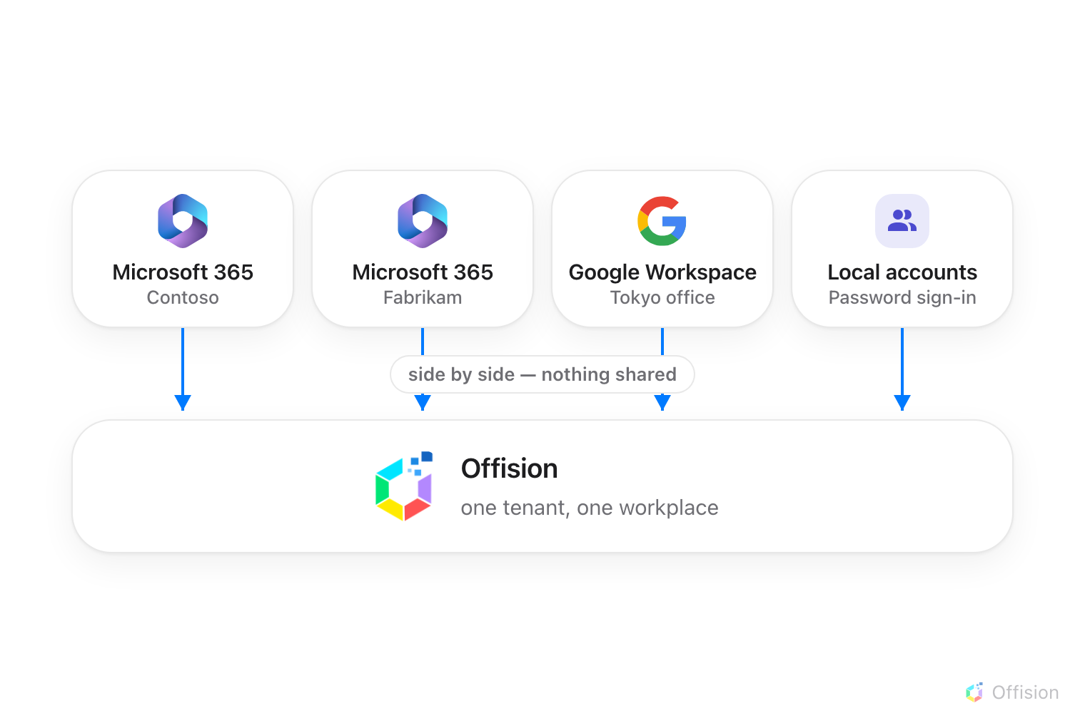
Directories and local accounts sit side by side in one Offision tenant — nothing is shared between them.

Every connection stands alone
Each card carries its own settings, end to end: its own connection mode, its
own connected rooms, its own user synchronisation, its own sign-in button and
its own booking agent account. Nothing is shared between cards, which is why
two organisations never have to agree on anything — one can be in
application mode while the other signs in
a delegated account.
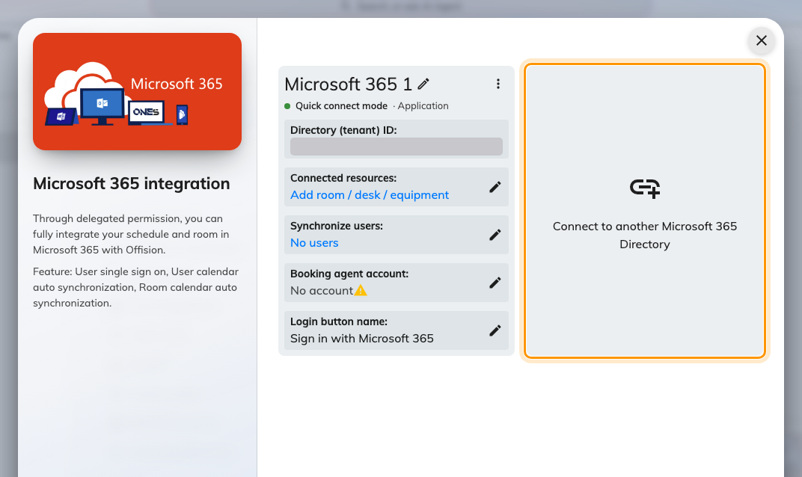
The Microsoft 365 connection list — Connect to another Microsoft 365 Directory adds a second organisation beside the first.
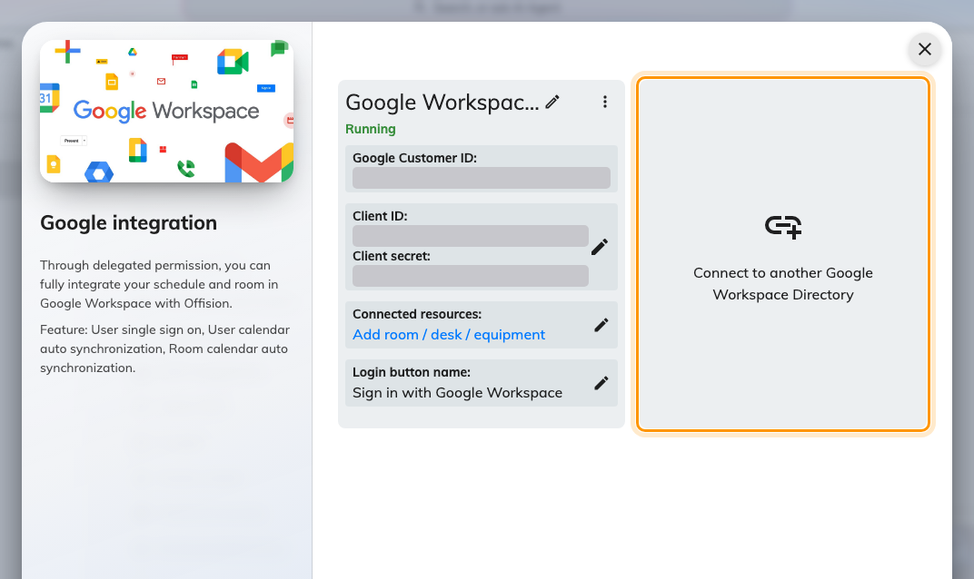
Google Workspace keeps its own list — Connect to another Google Workspace Directory works the same way.

Signing in
Each connection puts its own button on the sign-in page. With two Microsoft 365
organisations that means two Microsoft buttons, identical until you name them —
so name each one on its card, under User login: "Contoso staff",
"Fabrikam staff". People who already signed in once are recognised by their
address and sent to the right directory on their own.
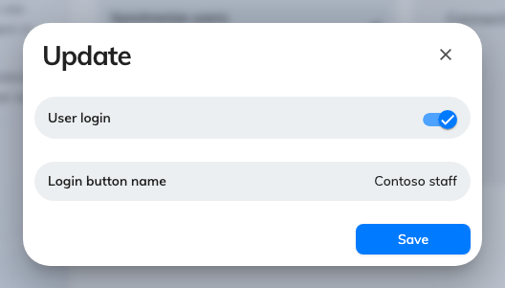
Each connection names its own sign-in button — the only thing that tells two directories' people apart on the login page.
The details are in Let people sign in with Microsoft 365
and Let people sign in with Google Workspace.

People belong to one directory each
User synchronisation runs for every connection that has it turned on, and each
connection's sync only ever touches its own people — directory A's sync never
deletes directory B's users.
Local accounts live alongside all of them: people created directly in Offision
sign in with a password and belong to no directory at all, so a contractor or a
front-desk account never needs a Microsoft or Google licence.
The one rule: a person belongs to exactly one connection, so the same email
address must not exist in two connected directories. If it does, each sync
re-points the account at whichever directory synced last, and signing in from
the other one fails with user with the same email address already exists.
Keep the two address sets disjoint, or leave the overlapping people out of one
side's sync scope.

Rooms belong to one directory each
A room's calendar syncs with exactly one connection — but different rooms can
belong to different directories, even different vendors: Contoso's meeting
rooms in Microsoft 365, the Tokyo office's in Google Workspace. Two limits
follow, both per booking:
- one booking cannot combine rooms from two different connections, and
- one booking cannot combine a synced room with an Offision-only room.
Book them as two bookings instead.

Booking across directories
What makes several directories work as one workplace is each connection's
Booking agent account. Microsoft 365 and Google Workspace refuse bookings
from accounts outside their own organisation — so when someone from directory A
(or an Offision-only account) books a room that lives in directory B, Offision
makes the booking on behalf of directory B's agent account. The booker is added
as an attendee, and the calendar invitation arrives from the agent's mailbox.
Without an agent account the connection blocks instead: only its own directory's
people can book its rooms, and everyone else silently cannot. So in a
multi-directory tenant, set one on every connection that has rooms — a new
account created for the purpose, not a real person's — as part of
Sync rooms from Microsoft 365 or
Connect rooms from Google Workspace.
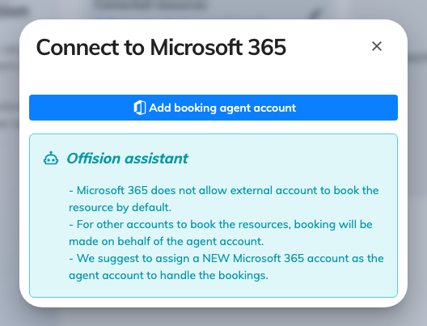
The Booking agent account — the account a connection books on behalf of, for everyone outside its own directory.

Where to start
Where in Offision: admin app → marketplace/apps (Integrations)
Connect the second directory exactly the way you connected the first —
Microsoft 365 or
Google Workspace — then walk the
same rooms, people and sign-in setup on its card.
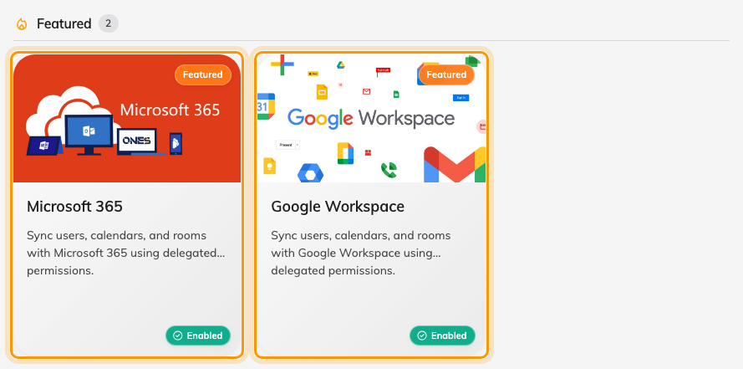
Microsoft 365 and Google Workspace side by side in the marketplace — connect both, and each holds its own list of directories.

