Connect Microsoft 365 with your own Entra ID app
Register the application yourself, choose exactly which permissions Offision gets, and hand it the credentials. For security policies that will not accept a third-party app registration.
2026-09-04 · https://offision.com/help/en/integrations/connect-microsoft-365-with-your-own-entra-app/
Most organisations should connect with
application mode or
delegate mode, which use Offision's own
app registration and need no credentials at all.
Use this path when that is not acceptable — when your security policy requires the
application to be registered in your own Microsoft Entra ID, with permissions you
choose and a secret you control and can revoke.
Before you start:
You need someone who can create an app registration in Microsoft Entra ID, grant it
API permissions, and grant admin consent for those permissions. That is usually not
the same person who administers Offision, so expect this to take two people and more
than one sitting.

What to have ready
- An app registration in Microsoft Entra ID, or the ability to create one
- Its Directory (tenant) ID and Application (client) ID
- A client secret value — copy it when it is created, because Microsoft will not
show it again
- Somewhere to paste two redirect URIs back into that registration
- Half an hour, and patience with Microsoft's permission propagation

1. Open the customize path
Where in Offision: admin app → marketplace/apps (Integrations)
Open the Microsoft 365 tile, choose Connect to Microsoft 365 account, then below
the separator choose Customize — Bring your own Microsoft Entra ID app or
customize permissions.
The wizard has two steps, listed down the left: Mode, then Credentials.

2. Choose the mode
Modes are laid out in two columns, Application and Delegated. The column
decides how Offision acts against Microsoft: an application-family mode acts as the
application itself, so one admin consent covers the organisation and there is no
mailbox to keep alive. A delegated mode acts as a signed-in account, and reaches only
what that account can reach.
Family | Mode | Room calendars | User sign-in | People sync | Use case
Application | Complete mode | yes | yes | yes | all staff
Application | Resource only mode | yes | no | no | higher security
Delegated | Complete mode | yes | yes | yes | all staff
Delegated | Standard mode | yes | yes | no | one department
Delegated | Resource calendar mode | yes | no | no | higher security

Functions under the matrix shows the same three capabilities for whichever mode is
selected, so you can check your choice before moving on.
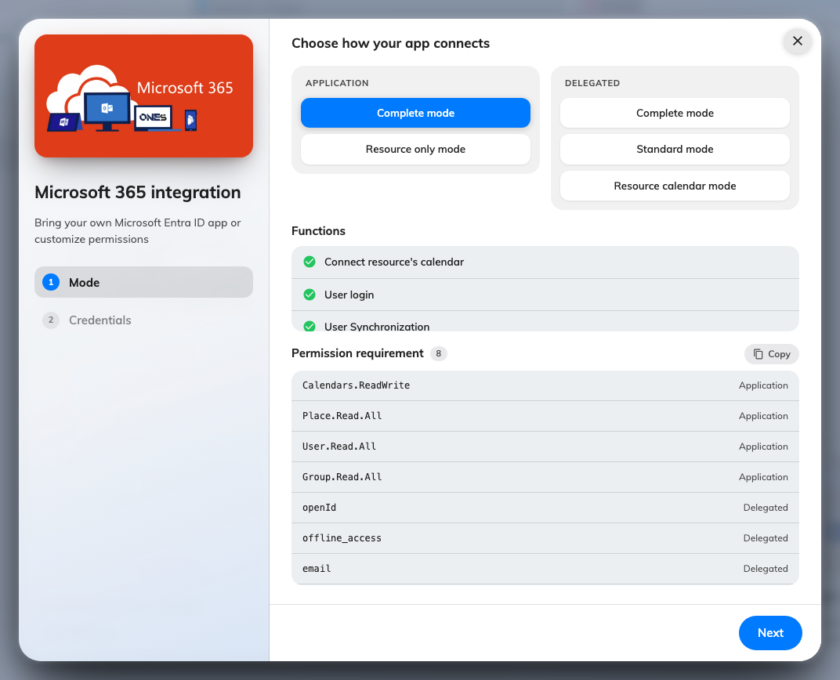
The mode step, with its function list and required permissions.

3. Grant the permissions the wizard lists
Below the mode matrix, Permission requirement lists exactly what that mode needs,
each marked Application or Delegated — which is the kind of permission to add
in Entra ID, not a detail you can ignore. Use the Copy button and send the list to
whoever owns the app registration.
For the application family:
Mode | Permission | Type
Complete mode | Calendars.ReadWrite | Application
 | Place.Read.All | Application
 | User.Read.All | Application
 | Group.Read.All | Application
 | openId, offline_access, email, User.Read | Delegated
Resource only mode | Calendars.ReadWrite | Application
 | Place.Read.All | Application
 | User.Read.All (optional) | Application

For the delegated family:
Mode | Permission | Type
All delegated modes | Calendar.ReadWrite.Shared | Delegated
 | openId, offline_access | Delegated
Complete mode also | User.Read.All, Group.Read.All | Application

Note:
Complete mode in the delegated column still needs two application permissions.
People sync always runs as the application, never as the signed-in account — so a
delegated Complete mode that was granted only delegated permissions will sign people
in correctly and then fail to sync anyone.
Grant admin consent for the permissions in Entra ID. Adding them is not the same as
consenting to them, and a registration with permissions listed but not consented
behaves exactly like one with no permissions at all.

4. Enter the credentials
Move to Credentials and fill in:
Field | Where it comes from
Microsoft 365 service operator | Microsoft, or 21Vianet if that is who operates your Microsoft 365
Directory (tenant) ID | The registration's overview page. It must be a GUID
Application (client) ID | The registration's overview page
Client secret (Value) | The value of the secret, not its ID

Then copy the two redirect URIs Offision shows and add them to the app registration.
Sign-in will fail later if they are missing, and the failure looks like a bad password
rather than a missing URI.
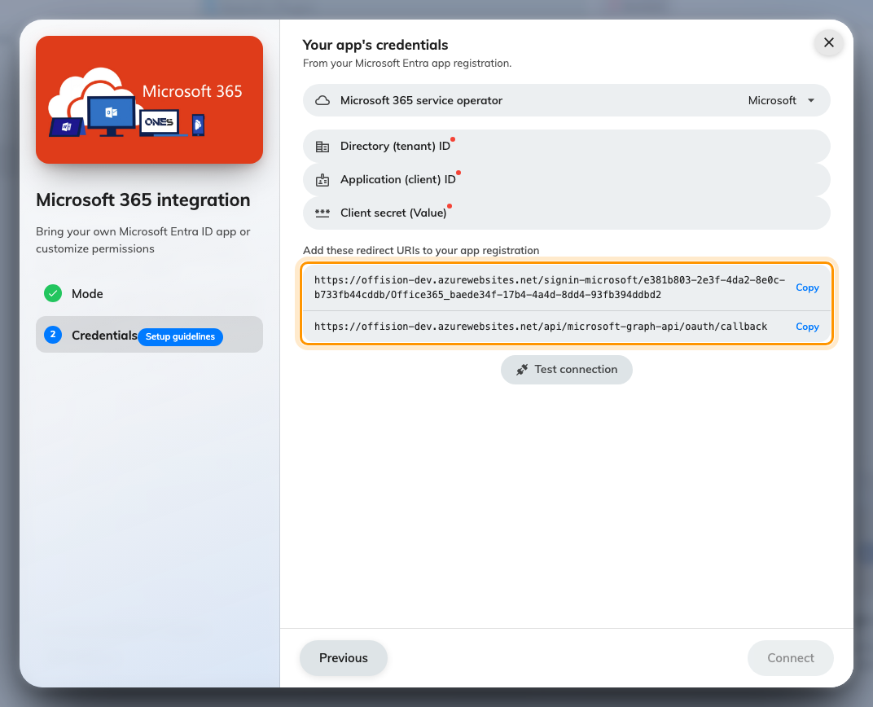
The credentials step, with the redirect URIs to add in Entra ID.

5. Test the connection
On an application-family mode, use Test connection before saving. A green result
means Offision could actually get a token with your credentials — which is a much
better place to find a typo than three screens later.
On a delegated mode there is no Test connection button, because nothing has signed
in yet and there is no token to test. Its absence is expected.
Save, then set up rooms,
people and
sign-in.

When it goes wrong
What you see | Usual cause
Connection failed, please check the information provided | Wrong tenant or client ID, a secret that has expired, or the secret's ID pasted instead of its value
Connection failed although the credentials are right | The permissions were added in Entra ID but admin consent was never granted
No Test connection button | A delegated mode is selected — there is nothing to test until an account signs in
Sign-in bounces back to the login page | The redirect URIs are not in the app registration
People never sync on delegated Complete mode | User.Read.All and Group.Read.All were granted as delegated rather than application permissions
It worked, then stopped months later | The client secret expired. Create a new one and update the credentials
Permissions look right but calls still fail | Microsoft takes five minutes to two hours to apply a permission change
Only the credentials step appears | Offision Hub, where the mode is fixed

