Choose which websites may embed Offision
Turn embedding from open to a named list: what the three choices stop, what an entry in Allowed websites may look like — wildcards, ports, and the plaintext address of a portal on your own network — and what a rejected entry does to the save.
2026-09-01 · https://offision.com/help/en/integrations/choose-which-websites-may-embed-offision/
A tenant that has never opened Security setting lets any site in the world
hold the user app and the visitor app in a frame. That is rarely wrong on its
own — a page held in a frame still asks whoever is looking at it to sign in, and
still shows them only what their permissions allow — but it does mean anyone can
present Offision as part of their own site. Naming the sites you actually embed
into closes that.
Where in Offision: admin app → system-account/security-settings (Security setting)

Pick the choice, per app
Can be embedded in carries three, and the two apps are set separately.
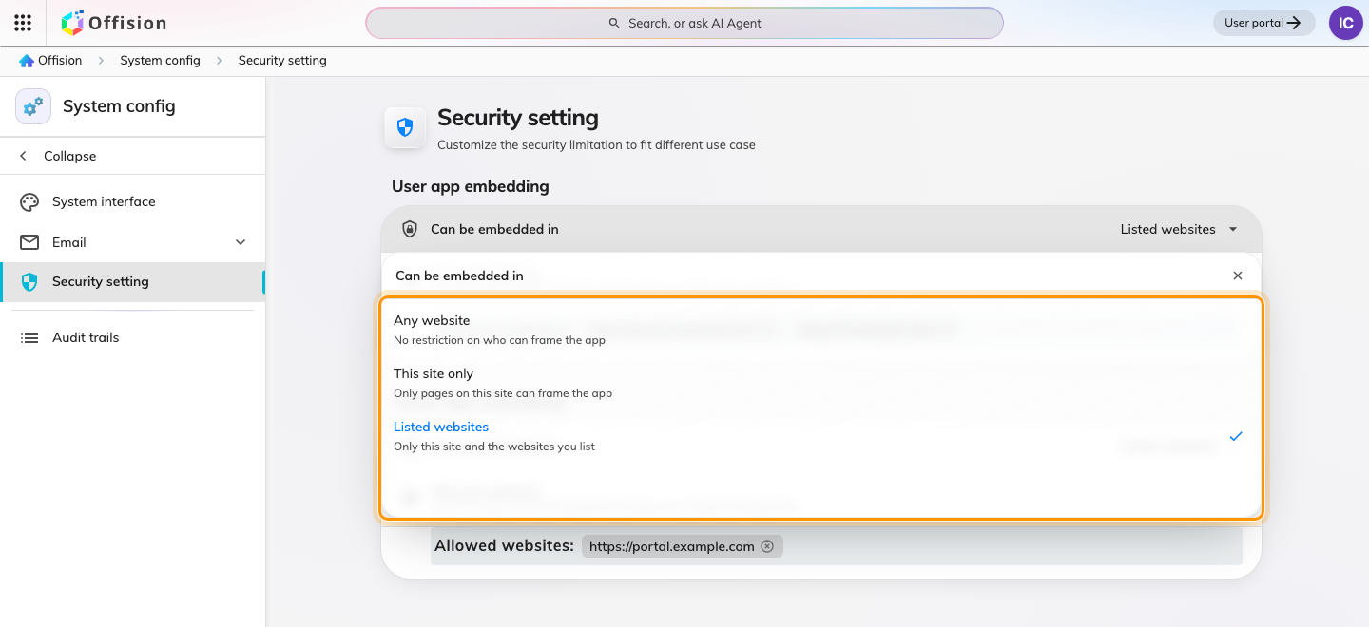
Any website, this site only, or the websites you list.
Choice | Who may hold the app | Choose it when
Any website | anyone | nobody embeds Offision, and you have not thought about it yet
This site only | Offision's own address, and Microsoft Teams and Office | nobody embeds Offision, and you want that enforced
Listed websites | the above, plus the sites you name | you embed into a portal of your own

Microsoft Teams and the Office surfaces are allowed under all three, so you
never list them yourself and no choice here can break a Teams deployment.

Name the sites
Listed websites reveals Allowed websites — one address per row, up to 32
per app.
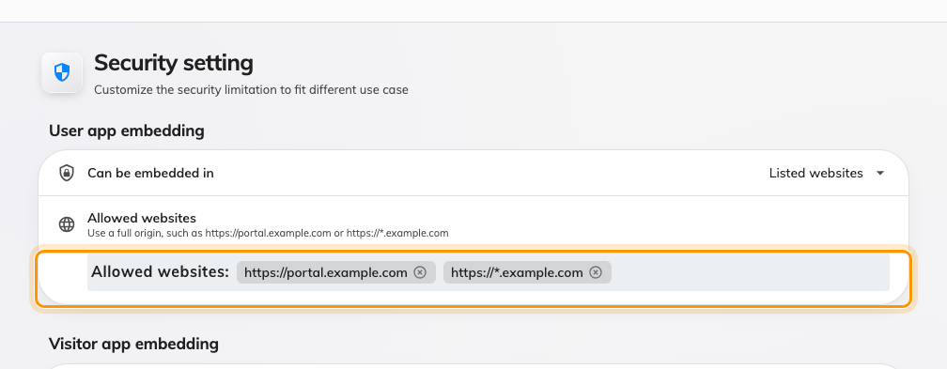
Allowed websites: the portals permitted to hold the user app.
Each row is an origin — where the page comes from, not which page it is:
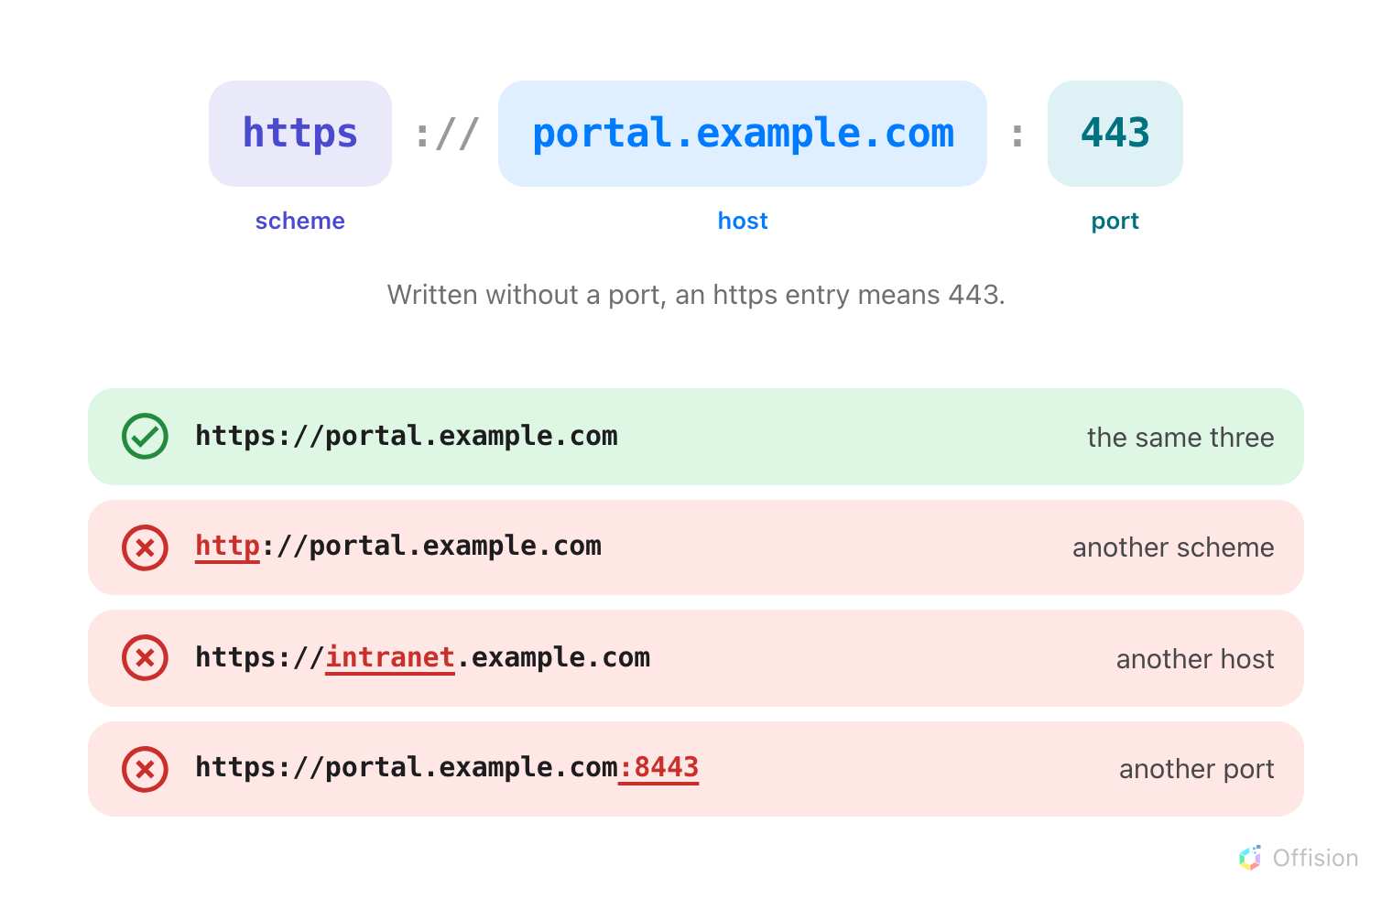
All three parts are compared. Change any one and the page is refused.
What you enter | What happens
portal.example.com | accepted, and stored as https://portal.example.com
https://*.example.com | accepted — any host one level under example.com
https://portal.example.com:8443 | accepted — that port and no other
http://192.168.10.20 | accepted — a plain address on your own network
http://intranet | accepted — a single-word intranet name
http://portal.example.com | rejected — plaintext on a public domain
https://portal.example.com/rooms | rejected — a page, not a site
* | rejected
https://a.*.example.com | rejected — a wildcard is the whole first label or nothing

So a portal that lives only on the office network is listed by its own
address — http://10.4.0.9, http://192.168.10.20:8080 — and nothing outside
that network can reach it anyway. Anything with a public name must be https.
One bad row fails the whole save:
The screen refuses the save rather than quietly storing the rows that were
valid, so nothing is half-applied. Fix the row it names and save again.

After you save
The list applies to the next page load, not to a frame already open — reload the
portal page to see it. Removing a row takes effect the same way, so a site
dropped from the list stops working on its next load.
Setting Visitor app embedding does nothing to the user app, and the reverse.
A portal that embeds both needs its address in both lists.
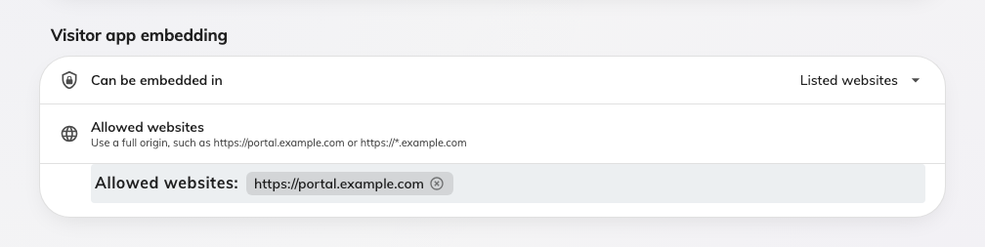
Visitor app embedding: its own choice, and its own list.

