A meeting booked in Outlook never appears in Offision
Offision mirrors the room's own calendar, so a meeting the room declined — or never answered — leaves no booking at all. How to tell that apart from a stopped sync or an unconnected room.
2026-09-02 · https://offision.com/help/en/integrations/a-booking-is-missing-in-offision/
Where was it booked?:
This page is for a meeting created in Outlook or Teams against a room
connected to Microsoft 365. A booking made in Offision that could not stand is
not missing — it shows as Booking failed; see the booking status article.
Offision mirrors the room's own calendar. A meeting reaches Offision only
after the room has accepted the invitation and it is sitting on that calendar.
A meeting the room declined never lands there — so there is nothing to mirror,
and Offision has no record of it at all. That is not a lost booking; it is a
booking that never existed on the room.
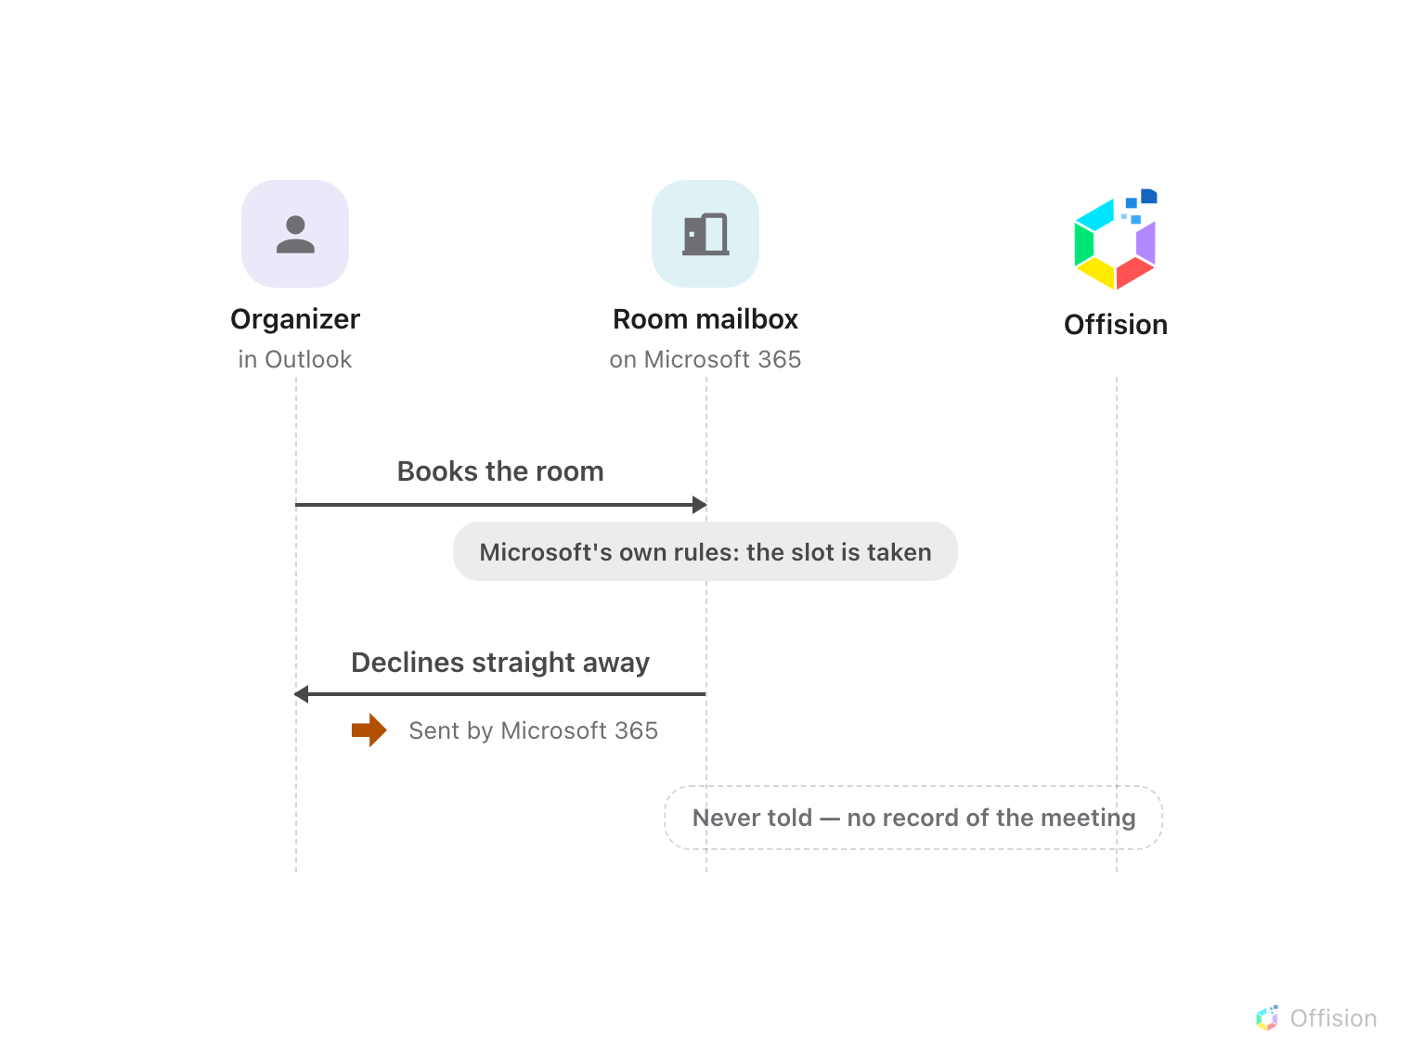
A declined meeting never reaches the room's calendar, so nothing syncs — Offision is never told, and there is no booking record.
Solution 1 — The room declined the meeting (most common)
The slot was already taken, so the room's mailbox declined the invitation and
the meeting never reached its calendar. The proof is in the organizer's inbox:
a decline reply ending in Sent by Microsoft 365 — see The rejection email
says it was sent by Microsoft
365.
Book again at a free time, or in Offision, where the conflict is shown before
you confirm.
Solution 2 — The sync is behind or stopped (common)
The room accepted — the meeting is on its calendar in Outlook — but it still
does not show. New meetings normally arrive within a minute; if nothing has
crossed over for hours, the connection's sign-in has usually lapsed. See
Bookings stopped syncing with the
calendar.
Solution 3 — That room isn't connected to Offision (less common)
Only rooms added to the Microsoft 365 connection are mirrored. If the room is
missing from the connection — or was deactivated — its meetings stay in
Outlook only. See Sync rooms from Microsoft
365.
Solution 4 — The room never answered (rare)
No decline reply and no acceptance either: the room's mailbox is not
processing invitations, or a person moderates its requests and hasn't acted.
Offision waits for the room's answer, so the meeting stays invisible until one
arrives. Check the room mailbox's booking settings in Microsoft 365.
Before you open a ticket:
Check three things: whether the organizer's inbox has a decline reply, whether
the meeting shows on the room's calendar in Outlook, and whether the room is
listed in the Microsoft 365 connection. Each cause above answers differently.

