The admin console will not open inside our own site
Adding your portal to Allowed websites does not make the admin console embeddable. The console refuses every site but its own, always, and no setting changes it — what to do instead.
2026-09-01 · https://offision.com/help/en/faq/the-admin-console-will-not-open-inside-our-site/
This is about the console, not the apps:
The user app and the visitor app can be embedded, and their setting works. This
page is only about the admin console — the screens administrators configure
Offision in.

What happens
A portal page is added to Allowed websites, the embedded user app starts
working, and the same portal's frame around the admin console stays empty. The
browser's developer console says it refused to display. Nothing in Offision
reports an error, and adding more entries to the list changes nothing.

Where it comes from
The admin console answers every request with an instruction that only pages on
its own address may hold it. That instruction is fixed: it is not read from
Security setting, so the choice and the list on that screen never reach the
console. The screen names two apps — the user app and the visitor app — and
those two are the whole of what it controls.
It is deliberate. The console is where an administrator changes permissions,
deletes people and opens doors, and a page that can be framed by another site
is a page whose clicks can be steered by that site.

What to do instead
Link to the console, rather than frame it. Copy the Admin Console URL
from System URLs, under Marketplace, and put it on the portal page as an
ordinary link that opens in a new tab. Administrators reach it in one click and
sign in with their own account, exactly as they would otherwise.
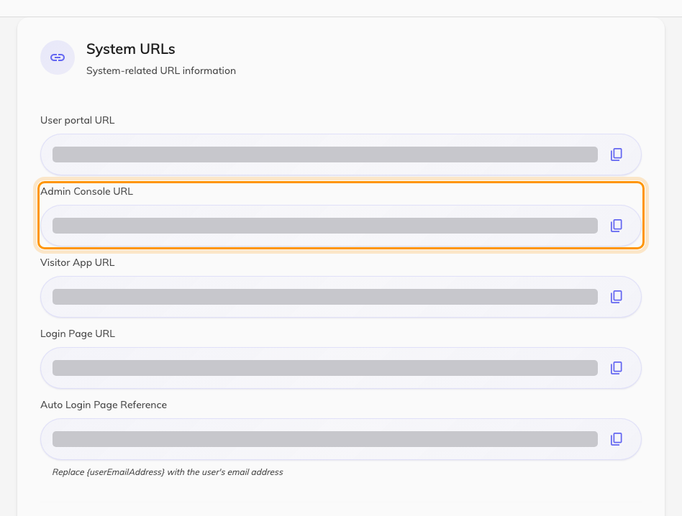
System URLs. The second row is the console address to link to.
If what the portal actually needs to show is a room's availability or somebody's
bookings, embed the user app instead — that is the app the setting supports,
and it is set up in
embed Offision in your company portal.

