What Offision emails a participant
There are only two event emails, the invitation is one of them, and both ride on the wallet pass — which is why some people who registered never hear anything.
2026-08-30 · https://offision.com/help/en/events/what-offision-emails-a-participant/
An event sends two emails, and no others. There is no separate invitation
mail, no acceptance mail and no cancellation mail — knowing that saves a long
hunt for a template that does not exist.
- Event registration confirmed — the participant's ticket. It carries their
QR code and the links that add the pass to a phone.
- Event reminder — sent before the event, as many times as the organiser set
up, or not at all.
Both arrive with the event's own name in front of the subject, so a person signed
up to several can tell them apart in a full inbox. An event with no name at all
sends the plain subject instead, rather than one that opens with a stray divider.

The invitation is the registration email
Send invitation does not send a third kind of mail. It sends the registration
email — and if the person already had one, it mints their pass again and sends
the same thing afresh. That is also how you resend to somebody who deleted it.

The email hangs off the pass
This is the mechanism worth understanding, because it explains every case of
"they registered and heard nothing". The registration email is not sent by
registering. It is sent as part of issuing the wallet pass, so wherever no
pass is minted, no email follows.
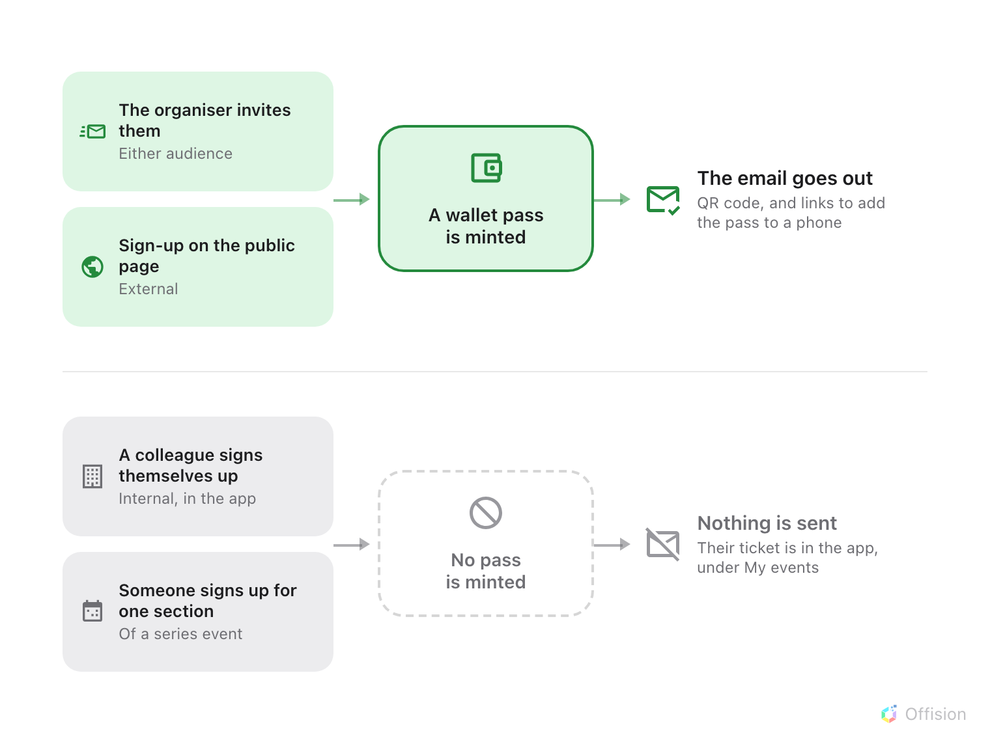
The email is issued with the pass, so the two routes that mint no pass send no mail either.
Two consequences follow, and both are usually reported as faults:
- A colleague who signs themselves up gets nothing. No confirmation, no pass.
Their ticket is in the app, under My events. The same colleague invited
by the organiser gets both — the difference is the route taken, not the person.
- Signing up for one section of a series event sends nothing, whichever
audience the person belongs to.
Turning the pass off silences the mail:
Because the two travel together, an event with the pass switched off sends no
registration email either. If a whole event's registrants heard nothing, that is
the first thing to check — not the mail server.

Who gets a reminder
Reminders go to everybody still expected: people who have been invited, people
who have had their invitation sent, and people already marked as attended.
Anybody cancelled or marked no show is left out, which is what stops a
reminder chasing somebody who told you they were not coming.
Reminders also need the event to be published when the reminder falls due. One
paused overnight will not send that morning's reminder, and will not send it
late afterwards either.

Which language they are written in
Neither email is written in the recipient's language. Both render in the
company's email language, set once in System ▸ Email settings — so a Japanese
guest and an English one get the same words.
An event can depart from that. The Email language card on the event's
Public design page takes a Primary language and an optional
Secondary one; leave Primary on Same as system and the event simply
follows the company setting, which is what every event created before this does.
The choice covers the invitation, the reminders and the wallet pass together, so
a ticket can never come out in a different language from the mail that delivered
it. The event's own name and venue follow it too — before, whichever translation
happened to be stored first could surface, which is how a confirmation could
arrive with an English title over a Chinese address.

What this does not control
- What the pass looks like. The colours and logos are a company-wide design
that an event can override.
- Whether the email carries a link to the event page. That link only appears
where the public event pages are switched on.
Where in Offision: admin app → activity/mobile-pass (Mobile pass)

