See who changed what on an event
The audit trail for every event: who did it, from which app, and what the record looked like before. Including a naming quirk to expect when you read it.
2026-08-27 · https://offision.com/help/en/events/see-who-changed-what/
Every change to an event is recorded — created, edited, published, paused,
closed, cancelled, deleted — and so is every change to the people on it:
invited, attended, no-show, cancelled, deleted, and each of the two kinds of
self-registration.
It is the page for questions with a who in them. Who cancelled it. Who took
that person off the list. Whether somebody registered themselves or was added.
Where in Offision: admin app → activity/log (Event log)
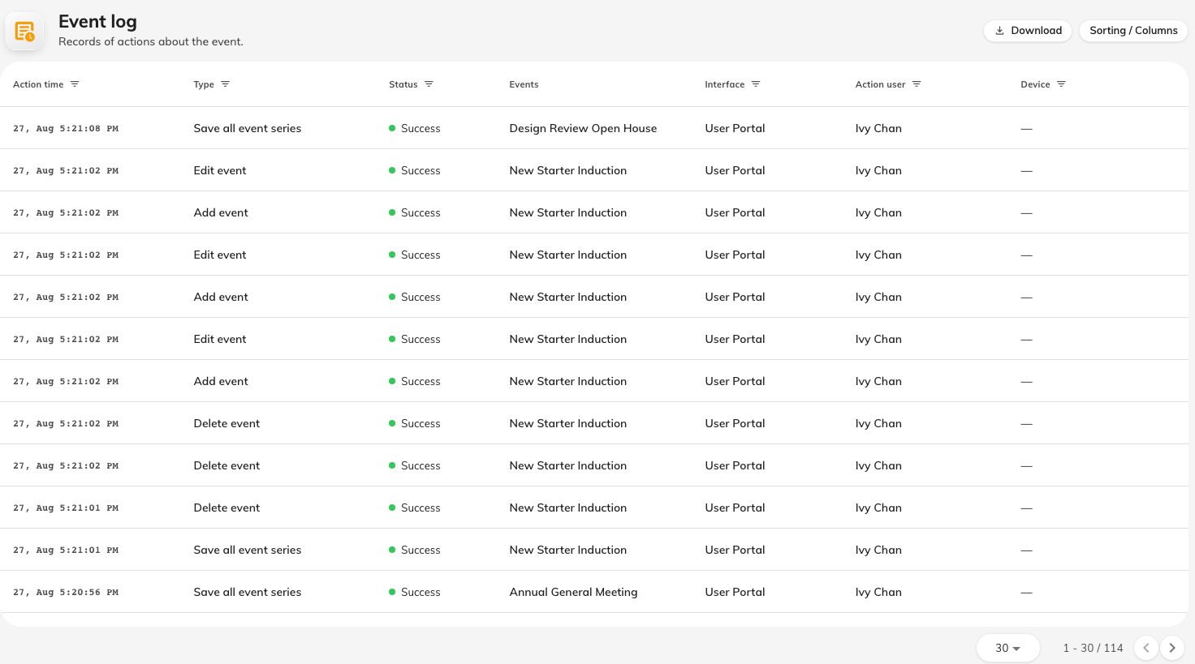
The audit trail: who did it, from which app, and when.

What each entry tells you
Column | What it holds
Action time | When it happened
Action user | Who did it. Blank where the actor was an external visitor, who is named in their own column instead
Interface | Which app it came from — the console, the app, or a public page
Access from | Where the request came from
Original snapshot | What the record looked like before the change
Request | What was asked for

Original snapshot is the column that earns the page. A log saying an event
was edited answers very little; the snapshot is what lets you see what it was
before somebody edited it.
The Interface column is what separates a self-registration on a public page
from an organiser adding the same person by hand, which is often the real
question behind "did they sign up, or did we put them down?".
The log's words are not the editor's words:
The log calls an event a series and calls each of its sections an event —
so Publish event in the log is publishing one section, and Close event series
is closing the whole thing. The editor uses event and section for the same
two ideas. Read the log's wording as one step more granular than you expect, and
the entries line up.

What is not here
- Reading. The log records changes, not who looked at something.
- Emails. Whether a message was sent, and whether it arrived, is not recorded
here.
- Anything about the event's content. The log tells you a description was
edited, not what it now says.

