See how the programme is doing
Attendance and no-show rates, registrations, and the status breakdown — with a note on the one split the dashboard deliberately does not make.
2026-08-27 · https://offision.com/help/en/events/see-how-the-programme-is-doing/
The dashboard answers how the programme as a whole is going, rather than how one
event went. It is where the question "are people actually turning up?" gets an
answer with a number on it.
Where in Offision: admin app → activity/dashboard (Dashboard)
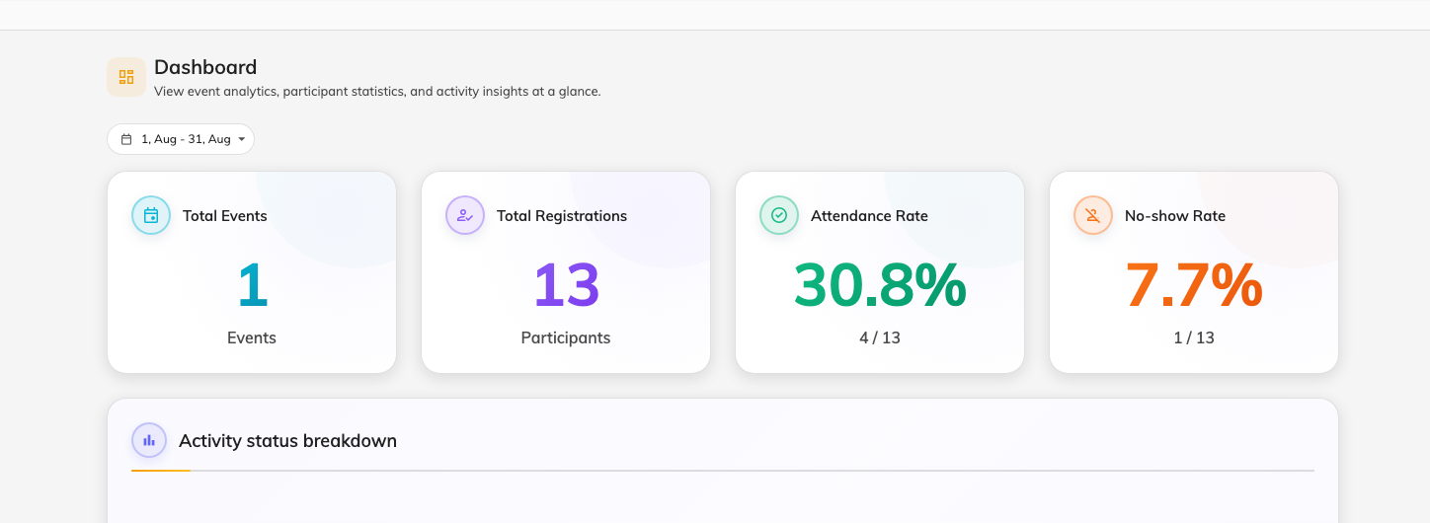
The four figures and the status breakdown. The range defaults to this month.

What each figure counts
Figure | What it is
Total Events | How many events exist
Total Registrations | Every registration across them
Attendance Rate | The share of registrations that were checked in
No-show Rate | The share marked as not having turned up
Activity status breakdown | How the programme splits across draft, published, paused, closed and cancelled
Participants by category | Which kinds of event draw people
Upcoming events | What is coming next

Two things to know before you quote a number
Attendance rate is only as good as your check-in. It counts people marked as
attended, and that mark comes from somebody scanning at the door. An event nobody
took attendance at reads as nobody having come — which looks like a catastrophic
event and is really an unattended door.
The same applies in reverse to No-show rate: a no-show is a deliberate mark,
not an absence of a scan. Events where nobody checked anybody in contribute
neither.
There is no internal-versus-external split here:
Every figure on this page counts both audiences together. If you need to know how
many of your guests came from outside the company, that split lives on
Participants, where Type filters the
list — not here.

What this page does not show
- Anything per event. For one event's numbers, open the event.
- Capacity against registrations. How full something is belongs to the event.
- Email or pass delivery. Nothing here reports whether messages arrived.

