See everyone registered, across every event
One list of every participant in the company, what each status means, and the two filters that answer most questions asked of it.
2026-08-27 · https://offision.com/help/en/events/see-everyone-registered/
Every event keeps its own list of who is coming, and the organiser works from
that. Participants is the other view: every registration in the company, on
one page, whoever created the event and whatever it was.
It is the right place for the questions that cross events — has this person
registered for anything, who is coming to everything this month, which of our
guests never turned up — and the wrong place for running a single event, which is
done in the app by the people running it.
Where in Offision: admin app → activity/participants (Participants)
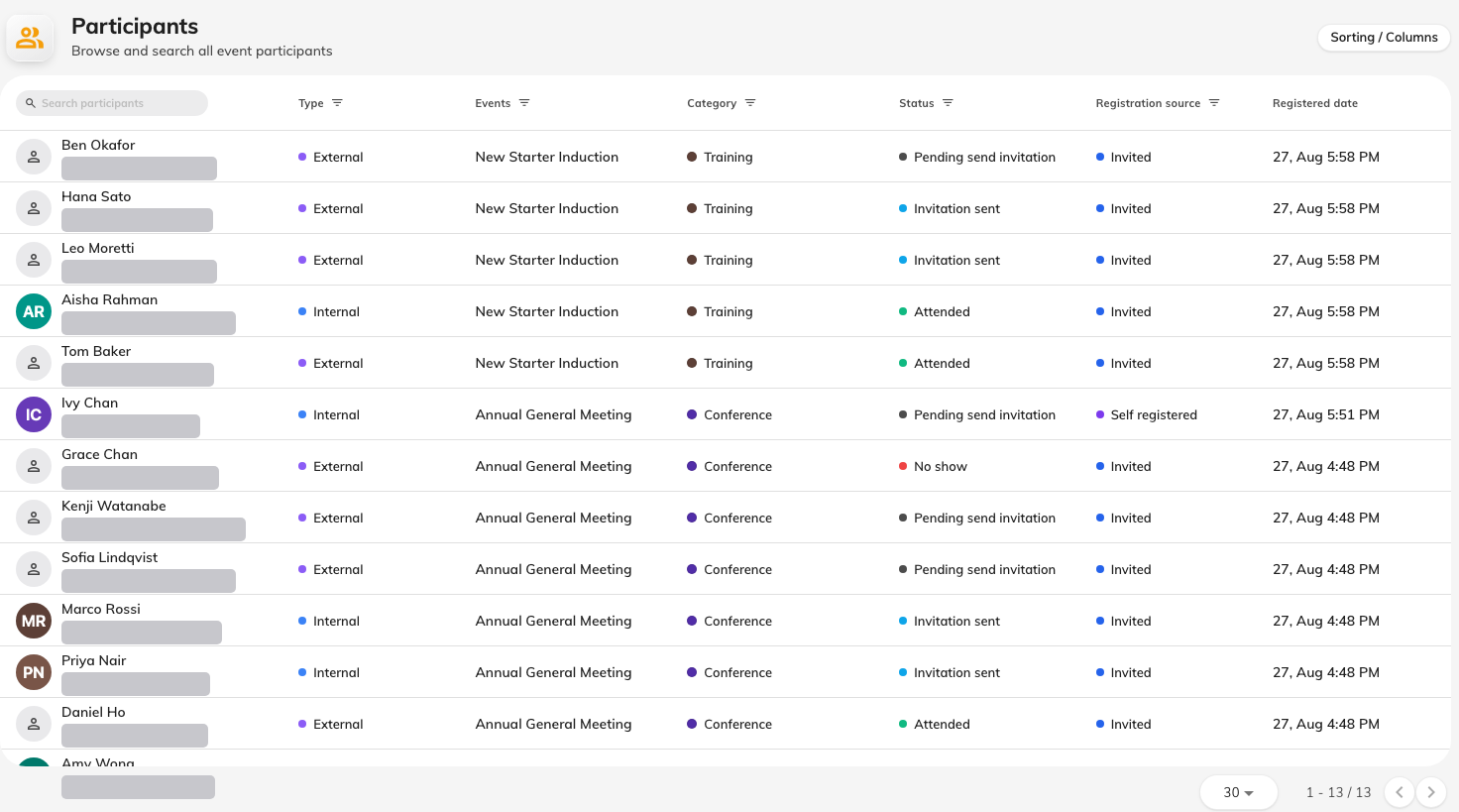
Everyone registered across every event, with the status each one is in.

What a status means
A participant carries an attendance status, and the wording rewards a careful
read.
Status | What it means
Pending send invitation | On the list, but nothing has been sent to them yet
Invitation sent | Their registration email has gone out
Attended | Checked in at the door. The time is stamped once, on the first scan
No show | Marked as not having turned up
Invitation cancelled | Their place was withdrawn. This is the only status that frees up a seat

Two are easy to misread. Pending send invitation is the normal state of
somebody added to an event that has not been published — it is not a failure, and
it clears as soon as invitations go out. Invitation cancelled covers a place
withdrawn for any reason, including a participant asking to be taken off.
Nobody can withdraw themselves:
There is no cancel button for a participant, internal or external. Somebody who
wants out has to ask the organiser, who cancels them here or on the event. Expect
that request to reach you as "the cancel button is broken".

The two filters worth knowing
Type splits the list into Internal and External — colleagues with an
Offision account, and everybody else.
Self-registered splits it by how they got there: people who signed themselves
up, against people an organiser added.
Used together they answer the question this page exists for. Internal plus
self registered is the group that received no confirmation email at all,
because a colleague signing themselves up is the one route that sends nothing.
When somebody reports that a participant never heard anything, that pair of
filters tells you in one look whether it is a fault or the way it works.

What this page does not do
- It does not run an event. Inviting, reminding and checking people in happen
on the event itself, in the app.
- It does not show a seat count. How full an event is belongs to the event.
- It does not create anybody. Participants exist because somebody registered
or was invited.

