Reuse posters across events
Every image, video and document any event has used, in one library — and why deleting from it reaches further than you might expect.
2026-08-27 · https://offision.com/help/en/events/reuse-posters-across-events/
Posters, banners, videos and documents added to events all land in one shared
library, and this page is that library. Organisers upload into it from their own
events; you see everything at once.
Where in Offision: admin app → activity/media (Uploaded media)
It holds images, video, PDFs and data files, in folders. Everything an event
shows — the poster on its public page, the banner on the screens in the lobby,
the image on a wallet pass — comes from here.
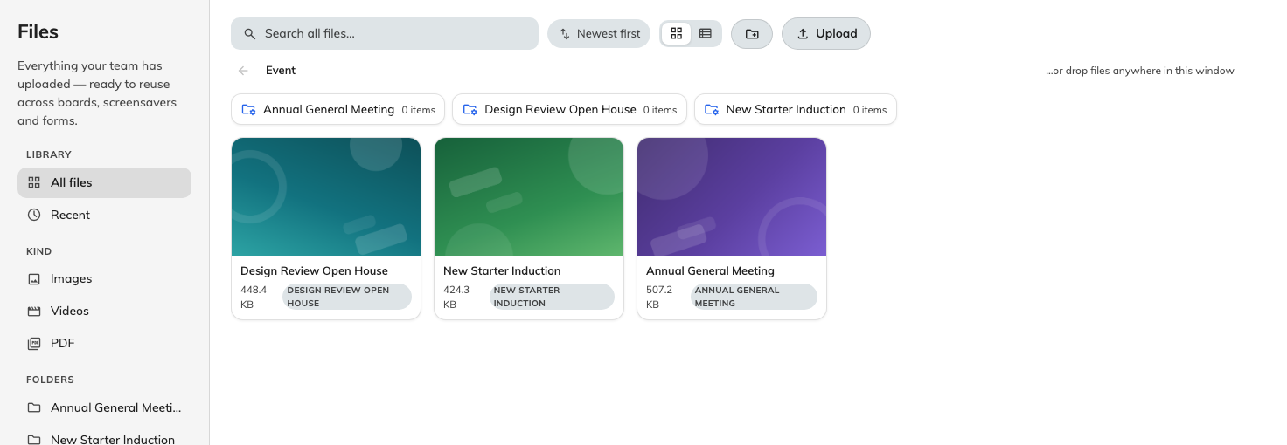
Every image any event has used, filed by kind down the left and by event across the top.

Why it is worth a look
Finding a file to reuse. An organiser building this quarter's event usually
wants last quarter's artwork, and browsing the library beats asking whoever ran
it for the original.
Seeing what has accumulated. A shared library is where duplicates collect —
four crops of the same photograph, uploaded by four people who could not find the
first one. Tidying is cheap here and awkward once passes are pointing at them.
Deleting reaches into live events:
A file here is the file the event uses, not a copy of it. Removing one takes the
poster off any event using it — including published events with a public page —
and breaks the banner on wallet passes already sitting in people's phones,
because a wallet pass fetches its image afresh long after it was issued.
Check what an image is used by before deleting it, and prefer leaving files alone
once their event has published.

What this page is not
- It is not where an event gets its poster. That is chosen on the event, by
whoever runs it.
- It is not general file storage. It is the events folder; other parts of
Offision keep their files elsewhere.
- It carries no permissions of its own. Anybody who can open the Events
section can see everything in here.

