Let somebody create events
Event coordinator takes two things, not one — the permission and a licensed seat — and an account missing either is refused at the same button.
2026-08-27 · https://offision.com/help/en/events/let-somebody-create-events/
Nobody can create an event until you say so. Event coordinator is what lets
somebody build one, and it is deliberately narrow: a coordinator may create
events and manage, edit or delete the ones they created. It gives them
nothing over anybody else's.
Before you start:
The people you are about to add need Offision accounts already — this page picks
from your directory, it does not create anyone. You also need enough Event
coordinator licences for them; the two are counted separately.

1. Open Event coordinator
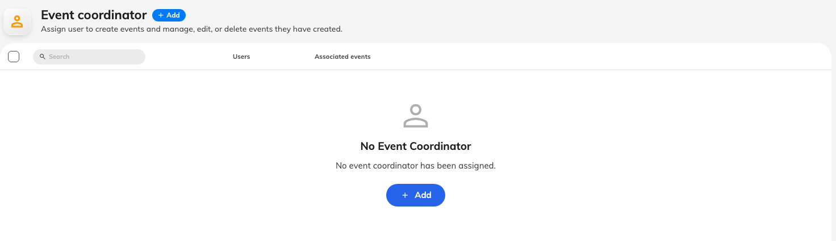
The Event coordinator list, before anybody has been added.
Where in Offision: admin app → activity/activity-coordinator (Event coordinator)
The list shows everybody who currently holds it. On a tenant where nobody does,
it says so plainly — No event coordinator has been assigned — and until that
changes, the only person who can put an event together is somebody who grants
themselves the permission on the way past.

2. Add the people
Add Event Coordinator picks from your directory. Add the person who actually
runs your events rather than the department that owns them: a coordinator is a
job, and the list is short in most companies.
Removing somebody takes the permission away but leaves their events alone. Those
events keep running, keep their registrations, and keep whoever else is on their
team — so check who else is on an event before you remove its only coordinator,
or nobody will be able to edit it.
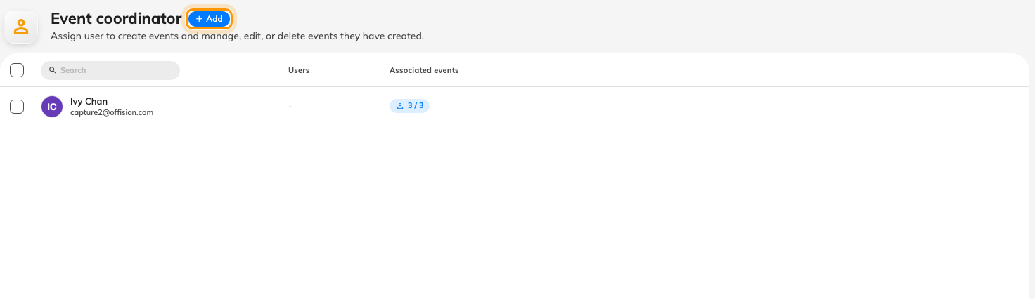
Add takes either people or whole user groups.

3. Make sure they hold a licence too
This is the step that catches people out. Creating an event needs the
permission and an Event coordinator licence, and they are granted in
different places. An account with one and not the other is refused at the same
button with the same dialog, which is why "I gave them the permission and it
still does not work" is the usual way this arrives.
The dialog itself names which half is missing, under What's needed —
Activity coordinator permission and Event coordinator capability are listed
separately, and the one that is not ticked is the one to go and fix.
An Event manager can add themselves:
If you hold Event manager and press Create without being a coordinator,
Offision offers to add you to the list rather than refusing: You're not on the
event coordinator list yet. Would you like to add yourself as a coordinator and
continue? Saying yes grants you the permission permanently — so it is worth
knowing that this is how administrators quietly end up on the list.

What this does not decide
- Who may edit an existing event. That is the event's own team — its owner,
its editors and its assistants — and it is set on the event, not here.
- How many events they may run. That is a licence limit on the whole
company, not on the person.
- Whether anybody can see what they build. A published event still has to be
opened to an audience — see
internal and external events.

Check it worked
Ask the person to open Events in the app and start a new event. Reaching the
form at all is the proof; if the permission dialog appears instead, read What's
needed and grant the half that is missing.

