How Offision tells colleagues from guests
Internal means one thing only — the person has an Offision account — and that has a consequence for anybody invited by email address.
2026-08-27 · https://offision.com/help/en/events/how-offision-tells-colleagues-from-guests/
Offision splits every participant into Internal and External, and the
rule behind it is simpler than people expect: a participant is internal if they
are an Offision user, and external if they are not.
That is the whole test. It is not about which page they registered on, not about
whether they work for you, and not about how they were invited.
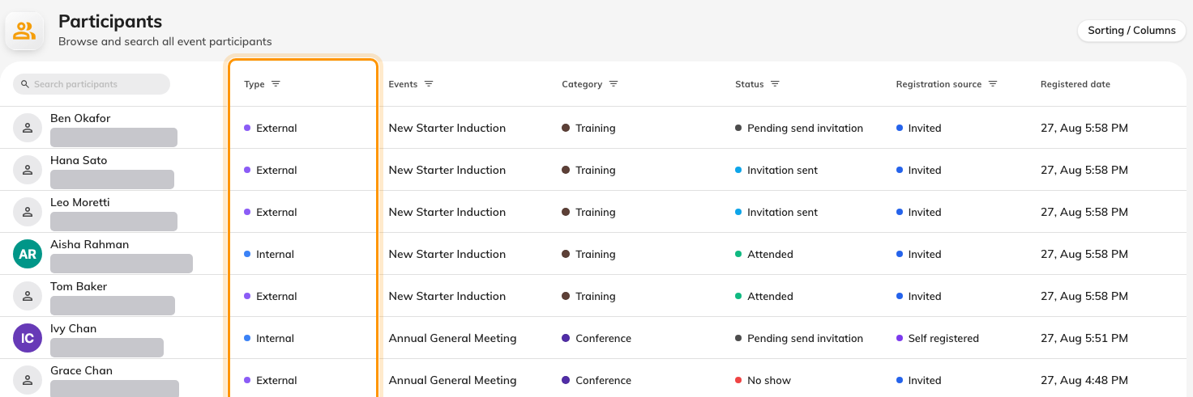
The Type column marks each person internal or external, one row at a time.

Why the distinction is drawn there
An internal participant is a pointer to an account that already exists. Their
name, department and address come from your directory, they are kept up to date
there, and nothing about the registration duplicates them.
An external participant is a set of answers typed into a form. Everything known
about them was collected at that moment, and it belongs to that registration —
which is why the external form asks for company, phone and job title while the
internal one asks for nothing at all.
Registering does not create a visitor record:
An external participant is not added to your directory and is not a visitor in
the visitor-management sense. Their details live with their registration. If you
want somebody in the building on a badge, that is a visitor invitation and a
separate thing.

The case that surprises people
An organiser inviting somebody by email address does not choose which side they
land on — Offision looks the address up. If it matches an existing account, the
participant is internal, even though the organiser was thinking of them as an
outside guest.
That is usually right: a colleague is a colleague however you thought of them.
But it has visible consequences, because internal participants are never asked
the external questions. A guest invited at an address that happens to match a
staff account will never be asked for their company or dietary requirements,
however carefully those were made required.
If someone appears under the wrong type, that is what to check first — not the
event's settings.

Where the split shows
Participants carries a Type column and filters by it, and it is the only
console screen that does. The dashboard counts both audiences together, and the
events list does not mention the split at all.
Where in Offision: admin app → activity/participants (Participants)

