How many events your licence allows
Two separate limits — how many events a month, and how many people in each — and the two different moments each of them refuses you.
2026-08-27 · https://offision.com/help/en/events/how-many-events-your-licence-allows/
Event management is licensed in two dimensions, and they are counted quite
separately: how many events you may run in a month, and how many people may
attend each one. Running out of either is a different message at a different
moment, which is why it is worth knowing both before somebody hits one.
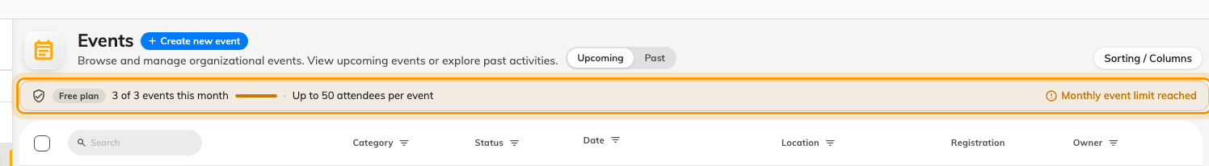
The strip above the list carries both limits: what is left this month, and the ceiling per event.

The two limits
Events per month is counted for the whole company, and it resets. Creating an
event is what consumes one — not publishing it, and not filling it — so a draft
abandoned half-written has still been counted.
Attendees per event is a ceiling on each event's registrations. On a series
event it applies to each section, not to the series as a whole: a course with
four sections may take the cap four times over.
Both grow with the licence. The Event Management SKUs are named for the
attendee ceiling they carry — 200, 500, 2000 — and the unlimited one removes it
entirely.

Where you meet them
Limit | When it stops you | What you see
Attendees per event | When you save the event, if you set a capacity above the ceiling | Your licence allows up to N attendees per event
Attendees per event | When somebody registers and the event is already at the ceiling | The registration is refused as full
Events per month | When you create an event after the month's allowance is gone | Creating is refused

The first two are the same limit caught at two different moments, and the
distinction matters. Setting a capacity you are not licensed for is refused
immediately, at the desk, by the person who can fix it. Hitting the ceiling
through real registrations happens later, to a stranger on a public page, who
sees only that the event is full.
The capacity you set is not the whole story:
Where your own capacity is higher than the licence ceiling, the ceiling wins and
the event says so — Your licence still limits this event to N attendees. Set
capacity to the number you actually want; do not use it to try to buy headroom
you do not have.

What is not limited
- Participants across the company. The monthly figure counts events, not
people.
- Sections. A series event may have as many as you like; each one carries the
attendee ceiling.
- Coordinators. How many people may create events is a separate licence
again, counted per person — see
let somebody create events.

