How events work in Offision
What an event is, how it differs from a booking, the five statuses it moves through, and why publishing is the only one that turns anything on.
2026-08-27 · https://offision.com/help/en/events/how-events-work/
A booking reserves a room for people you name. An event publishes something
people sign themselves up for — a town hall, a training class, a customer open
day — counts how many said yes, and gives each of them a code to show at the
door.
The two overlap in practice. An event usually reserves a room as well, and
choosing an internal room when you set one up creates that booking for you. But
they answer different questions, and the giveaway that you want an event rather
than a booking is a registration list: the moment you need to know who is
coming before they arrive, a booking has nothing to offer you.

An event happens once, or it has sections
An individual event happens once. A series event is one event with
sections under it — the four dates of a training course, the same induction
run every Monday. People can be signed up to the whole series or to one section,
and each section carries its own date, place and capacity.
Pick this when you create the event. It is the one choice that is awkward to
change afterwards, because everything below it hangs off the answer.

Publishing is the switch that turns everything on
An event moves through five statuses, and only one of them does anything. In
Draft it exists for the people building it and nobody else. Publish makes
it real: staff can find it, the public page opens, invitations can go out,
reminders start firing, and attendance can be taken at the door.
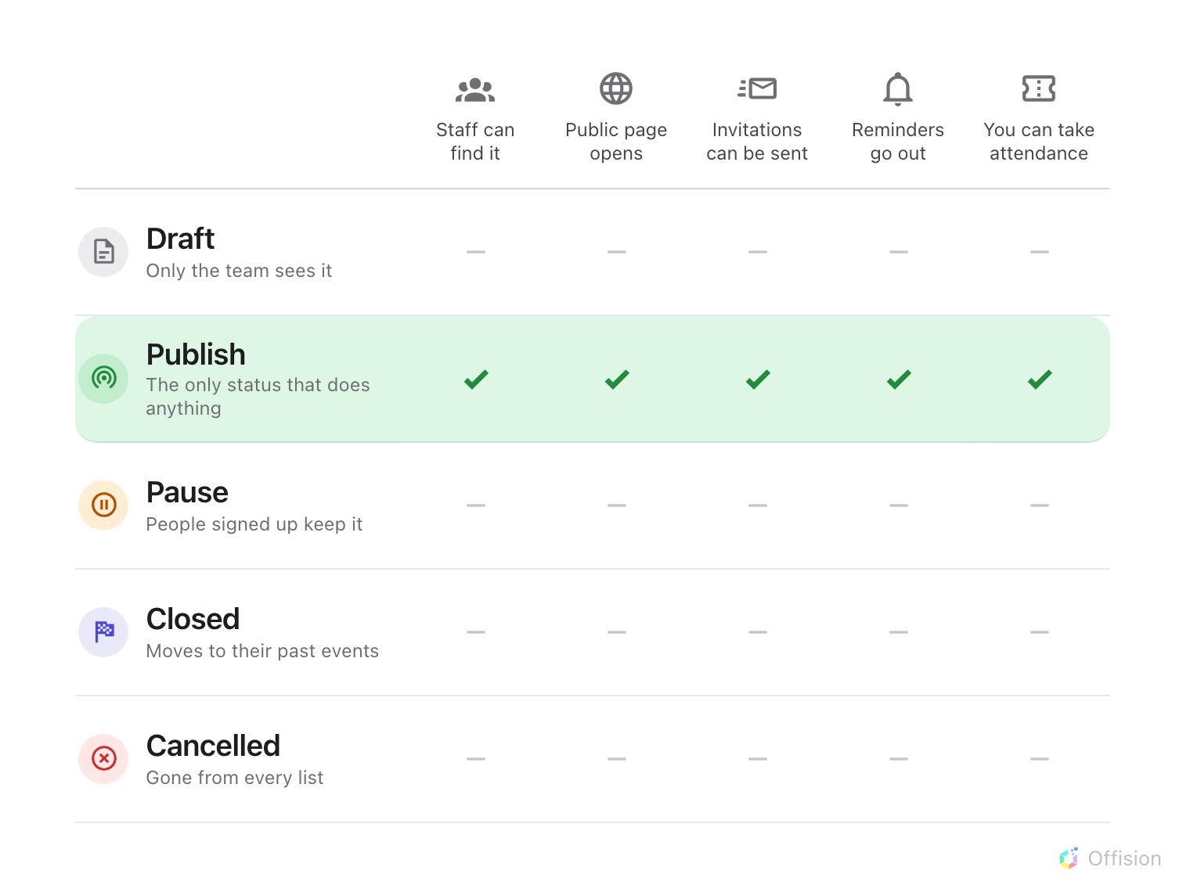
Publish is the only status in which anything happens. The other four differ only in what the people who already signed up still see.
The three ways an event ends differ only in what a registrant is left with.
Pause takes it off both lists but leaves it with the people who signed up —
use it while you rearrange something. Closed is the ordinary end: it moves
into everyone's past events. Cancelled removes it from every list, including
theirs.
Publishing sends nothing:
It is easy to expect publishing to notify people, and it does not. It opens the
event and unlocks the Send invitation buttons — inviting is a separate,
deliberate act, so nothing goes out until somebody sends it.

Creating an event and editing one are different jobs
Event manager lets you see every event, create one and delete one. It does
not by itself let you change one: events are edited by their own team, so
opening one for editing adds you to that team as an editor. Publishing, pausing
and closing happen there too, in the editor, rather than from the list.
Where in Offision: admin app → activity/activity (Event list)

What this does not decide
- Who may create events. That is a permission and a licensed seat, and it is
set per person — see who can create events.
- Who may sign up. Every event is opened to staff and to the outside world
independently, and an event open to neither is invisible to everybody. That is
internal and external events.
- What a registrant is asked for. The registration form is built per event by
the person running it, in the User guide.

