Find any event in the console
Every event in the company on one page, what each column is telling you, and the one column worth switching on before you go looking for a public link.
2026-08-27 · https://offision.com/help/en/events/find-any-event-in-the-console/
Events is every event in the company, whoever built it. It is the page to
start from when you have a name and need the event, and the only place an
administrator can create or delete one.
Where in Offision: admin app → activity/activity (Event list)
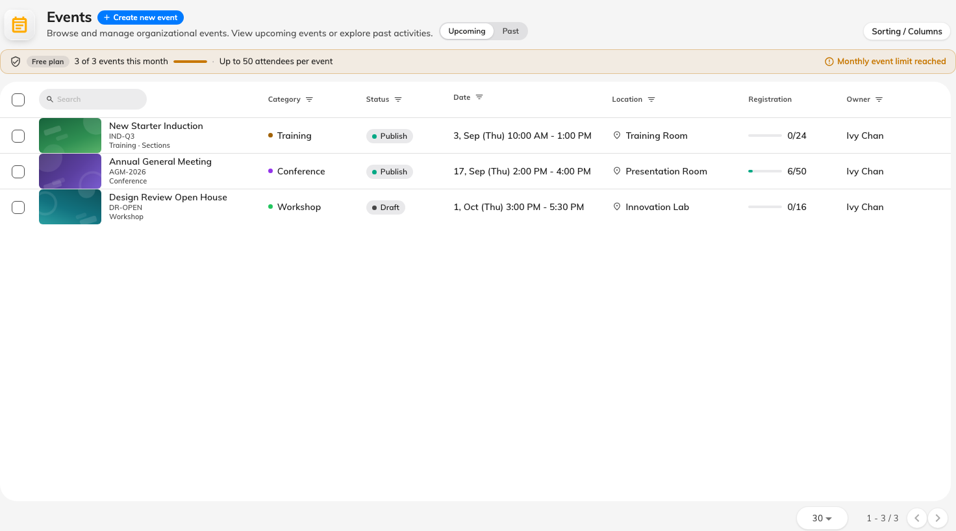
Every event in the company, whoever built it.

The header row is the filter row
The thing to notice first is that most columns have no title. Where you would
expect a heading, the events list puts the filter for that column instead: a
date range over the dates, a status picker over the statuses, a person search
over the owners, and pickers for location, building and category.
So filtering is not hidden behind a button — you narrow the list by typing into
the top of the column you care about. Only four columns carry a plain text
heading: Online meeting, Sections, Registration and Public page.
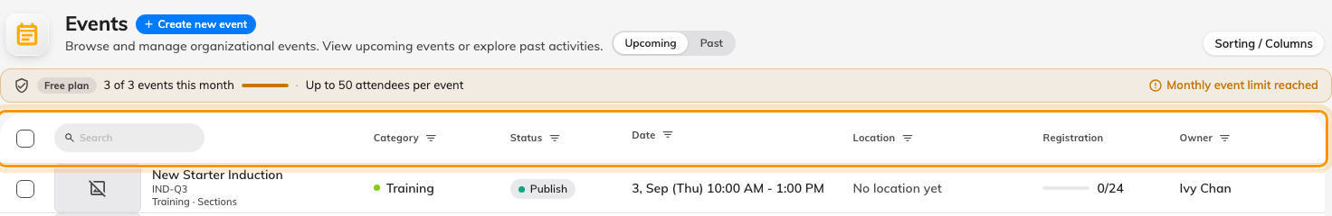
Where a column heading would be, the events list puts that column's filter.

What each column holds
Column | What it tells you
First column | The event's name, with its category colour
Dates | The period it runs for. Its header is a date-range filter
Status | Draft, Publish, Pause, Closed or Cancelled. Its header picks one
Owner | The person the event belongs to — not necessarily who created it
Location and Building | Where it is. An event with an external location shows that instead
Online meeting | Whether it has a meeting link
Sections | How many a series event has. Blank for an individual event
Registration | How the event's registration stands
Public page | Whether it has a working external page right now

Public page is off by default and worth turning on. It is a single yes/no
that folds together everything that has to be true for an outsider to reach the
event — published, visible to external participants, and the company-wide page
switches on. When somebody says their event link is dead, this column answers it
in one glance instead of three.
Open a row and its panel carries the public address itself, ready to copy.

Creating and deleting
Create new event starts an event here, and it is the same event the organiser then
builds in the app — the console gets you as far as the form and no further.
Editing puts you on the event's team:
Opening an event to change something adds you to its team as an editor, after
asking. That is not a side effect to be nervous about — it is how the console
edits anything — but it does mean your name appears on events you only looked
into.
Deleting is permanent and takes the registrations with it. An event that has
happened is better Closed: it leaves the record intact and moves it out of
everybody's way.

What this page does not do
- Publish anything. Status changes happen inside the event.
- Show you who is coming. That is the event's own participant list, or
Participants for the whole company.
- Filter by audience. Whether an event is internal, external or both is not a
column here.

