Export a participant list
Getting the list out for catering, reception or a badge printer — and which columns are empty for which half of your guests.
2026-08-27 · https://offision.com/help/en/events/export-a-participant-list/
Export participants takes the list you are looking at and gives you a file of
it. The filters apply first, so narrowing the list before exporting is how you get
the file you actually wanted rather than the whole company's.
Where in Offision: admin app → activity/participants (Participants)
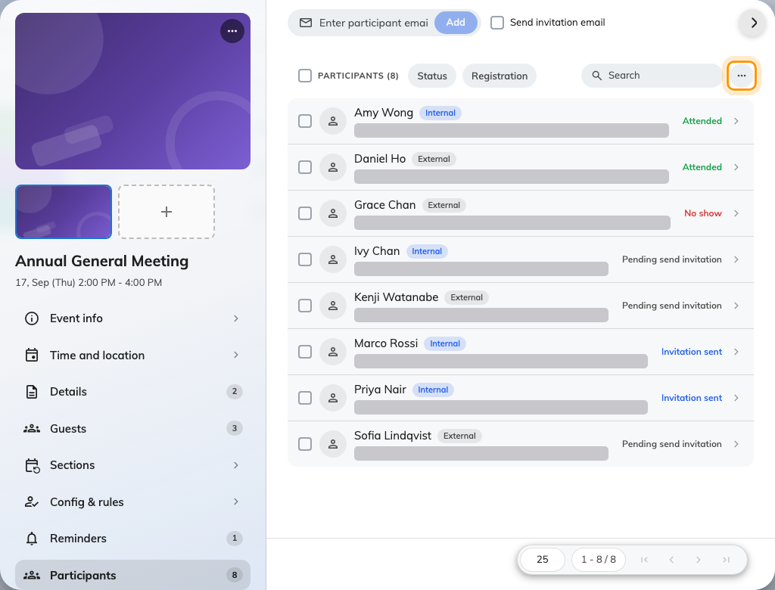
Export sits behind the ellipsis above the event's own participant list.

Filter first, then export
The two filters that matter here are Type — internal or external — and
Self-registered. A caterer wants everybody on one event; a receptionist
expecting guests wants the external half; and the people who received no
confirmation email are internal plus self-registered.

What is in the file
Names, addresses and status, plus Check-in time for anybody who was scanned
in, and the fields an external registration collects: title, department, phone,
dietary requirements, accessibility needs and emergency contact.
Half the columns are empty for colleagues:
Those extra columns exist only on the external side — a colleague is never asked
for their company or their dietary requirements, so those cells are blank for
every internal row. A catering list built from a mixed event will be missing
exactly the people who work for you, and that is the data, not the export.
Where you need dietary requirements from everybody, ask for them with a custom
field on the event, which can be made required for both audiences.

What the export does not include
- Anything about the event itself beyond naming it. It is a list of people.
- Whether their email arrived. Delivery is not recorded.
- Their wallet pass. The QR code is not exportable, and does not need to be —
check-in reads the pass on their phone.

Check it worked
Open the file and count the rows against the number the page showed before you
exported. If they differ, a filter was still applied that you had forgotten
about — which is usually the intent, but worth confirming before it goes to a
caterer.

