Event pass reference
Every field on the mobile pass page, what it changes, and which of them Google ignores.
2026-08-27 · https://offision.com/help/en/events/event-pass-reference/
The company-wide design every event pass starts from. An event can override the
three colours; nothing else here is overridable.
Where in Offision: admin app → activity/mobile-pass (Mobile pass)

Customization
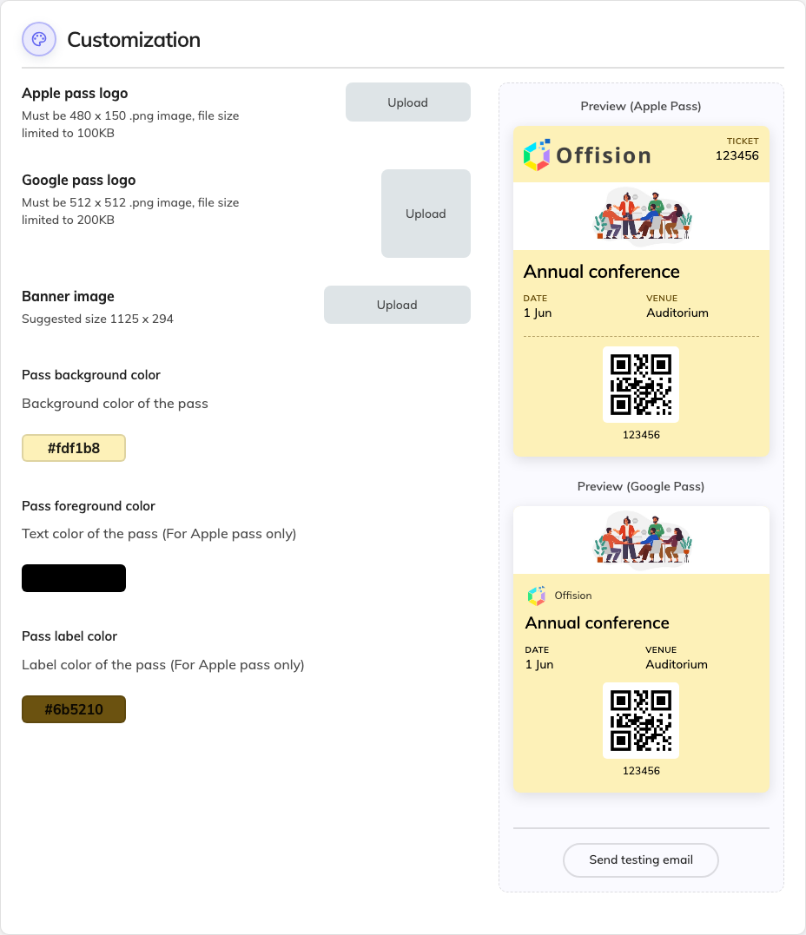
The company pass design, with both previews beside it.
Field | What it does | When to change it
Apple pass logo | The mark at the top of an Apple pass. A .png, 480 × 150, under 100 KB | Whenever your brand changes. A wide lockup suits this shape; a square logo will sit small in it
Google pass logo | The mark on a Google pass. A .png, 512 × 512, under 200 KB | Same, but supply a square version — Google will not use the wide one well
Banner image | The strip across the pass, around 1125 × 294 | Set it once as a company fallback. Most events cover it with their own poster
Pass background color | The colour of the card | To match your brand. Check both previews — this is the only colour Google follows
Pass foreground color | The pass's text colour. Apple only | Whenever the background is dark enough that default text stops being readable
Pass label color | The small caption above each value. Apple only | To soften the captions against the values. Leave it if you are unsure

Preview (Apple Pass) and Preview (Google Pass) show the result on sample
data — Annual conference, Auditorium. Judge every colour on both, because two
of the three do nothing on one of them.
Send testing email posts a pass to yourself, which is the only way to see the
real thing on a real phone before an event depends on it. The previews are
drawings; the phone is the test.
There is no switch to turn passes off here:
Every registration issues a pass; there is no company-wide off. Opting out is a
per-event decision, made by whoever runs the event — and because the confirmation
email is sent with the pass, opting out silences that email too.

What this page does not control
- What is written on the pass. The event's name, times and venue come from
the event; the QR code comes from the participant's registration.
- The image most passes actually show. An event with a poster uses that,
above the banner set here.
- Whether a pass installs. That is the phone's decision — see
a pass won't install, or looks wrong.

