Design the pages guests see
Four console pages, one per public page, each drawing the real page beside the settings — how to work through them, and what the preview will and will not tell you.
2026-09-01 · https://offision.com/help/en/events/design-the-pages-guests-see/
A guest meets four pages, and each one has a console page of its own that draws
it while you work: Event list, Event page, Registration,
Confirmation, under Public page design. They are in the order a guest
meets them, which is also the order worth setting them up in.
Before you start:
You need write access to Event management. Nothing here publishes anything on its
own — an event still has to be shown to external participants, and the two page
switches still have to be on.

1. Open Public page design
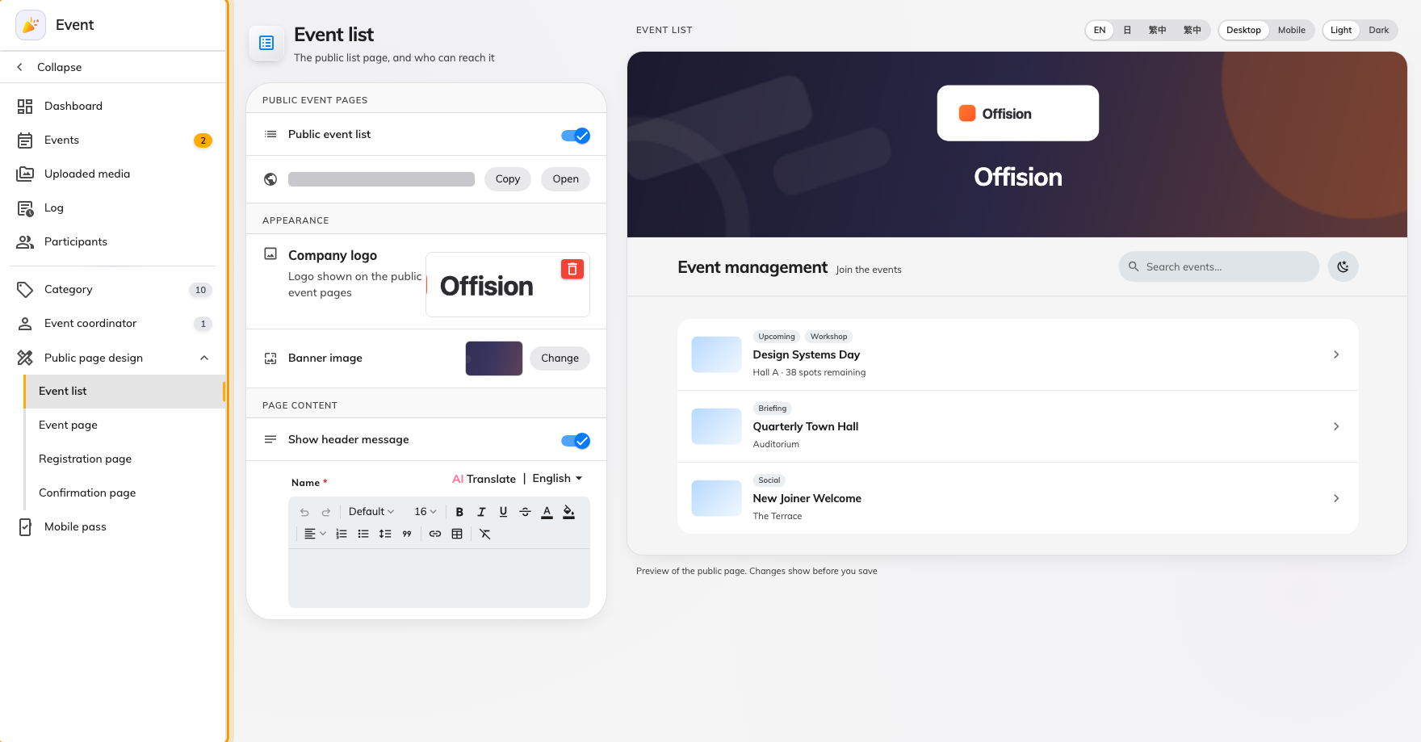
The four pages in the rail, in the order a guest meets them.
Where in Offision: admin app → activity/public-design/event-list (Event list)
If you have an old link or bookmark to Event settings, it still works: it
lands on Event list, the first of the four.

2. Work down the rail, not around it
Each page owns the settings for the page it draws, so there is nothing to hunt
for and nothing to set twice:
Page | What it holds
Event list | Whether the public list exists, its address, the logo and banner, and the line over the banner
Event page | Whether each event gets a page, and the fourteen sections that page can show
Registration | The card beside the sign-up form, and the terms an event falls back to
Confirmation | The wording somebody reads after registering, and the next steps under it

Every field on all four is listed in
the settings reference.

3. Read the preview, not the form
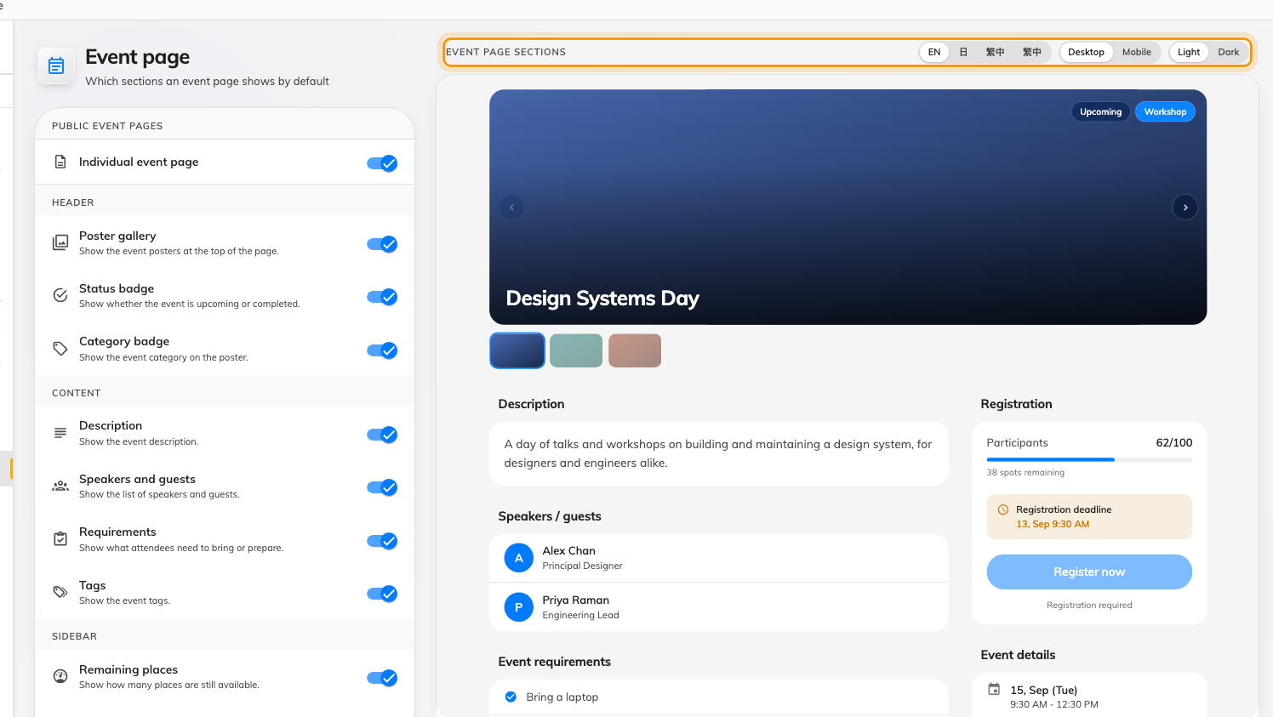
The real page, redrawn from the form. The toolbar switches what you are looking at.
The preview is the page itself — the same components the public site ships, not a
mock-up — and it follows the form before anything is saved: Preview of the
public page. Changes show before you save.
Its toolbar decides what you are checking, and each of those is a real reader:
- Desktop / Mobile — the phone rendering is not the desktop one made narrow.
The mobile action bar, in particular, only exists there.
- Light / Dark — a guest's phone decides this, not you. Check both.
- The language buttons, where your company has more than one enabled. The
preview switches language on its own; it does not change the console's.

4. Save
Each page saves the whole design, so there is no partial save and no order you
have to save in. Save on any of the four and the other three are saved with it.
What the preview cannot tell you:
The registration page's form fields are placeholders — the live form follows each
event's own registration settings. And the sample event in the preview is not one
of yours, so it shows the shape of a page rather than the content of any real
event.

5. Check it worked
Open the public list address in a private browser window, signed in to nothing,
and open one event from it. What you set here is what an event that has not
overridden anything will look like — an event whose organiser has overridden a
section will differ, deliberately.

