Choose what the public event page shows
Fourteen sections you can hide company-wide on the Event page design, grouped the way the page is laid out — and every one of them an organiser can put back.
2026-09-01 · https://offision.com/help/en/events/choose-what-the-public-event-page-shows/
Event page sections sets what every public event page shows by default. It is
the second half of Event page, under Public page design, with the live
preview beside it — switch one off and the section leaves the preview before you
save.
Where in Offision: admin app → activity/public-design/event-page (Event page)

The three groups
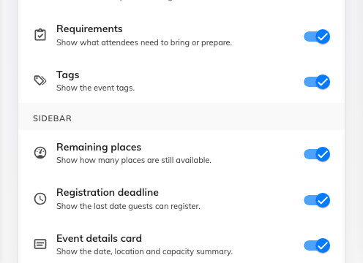
The Sidebar group — each section one switch.
They are grouped the way the page is built, so a switch sits where the thing it
hides sits.
Group | Sections
Header | Poster gallery · Status badge · Category badge
Content | Description · Speakers and guests · Requirements · Tags
Sidebar | Remaining places · Registration deadline · Event details card · Map links · Contact information · Social media links · Mobile action bar

Two more sections belong to the pages that come after this one, so they are set
there instead: Registration information on the Registration design page — the
sidebar of the sign-up form — and Quick actions on Confirmation, the links
offered once somebody has signed up. Both are in
the settings reference.

The three worth thinking about
Remaining places publishes how full an event is. On a popular event that is
useful pressure; on a quiet one it advertises that nobody is coming. It is one
switch for the whole company, so set it for the majority and let organisers
override the exceptions.
Contact information is a real person's address and phone number on a public
page. Turn it off unless somebody is prepared to answer it.
Mobile action bar is the bar pinned to the bottom of the screen on a phone,
carrying the register button. Hiding it does not remove registration, but it does
mean somebody has to scroll to find it — which on a long event page is most of
the reason people give up.
Off here is a default, not a rule:
Every section an organiser can put back on their own event. If you are hiding
something because it must never be published, hiding it here will not achieve
that — the switch is a starting point, not a policy.

What this does not control
- Whether the page exists. That is Individual event page, the switch at
the top of this same design page.
- The order of the sections. The layout is fixed; you decide what is in it.
- What any of them say. The content comes from the event.

