Publish, pause, close or cancel
Publishing is what turns everything on, and it sends nothing. The three ways to end an event differ only in what your guests are left holding.
2026-08-27 · https://offision.com/help/en/event-coordinator/publish-pause-close-or-cancel/
An event you have built is in Draft, and in draft it exists for your team and
nobody else. Publishing is what makes it real.
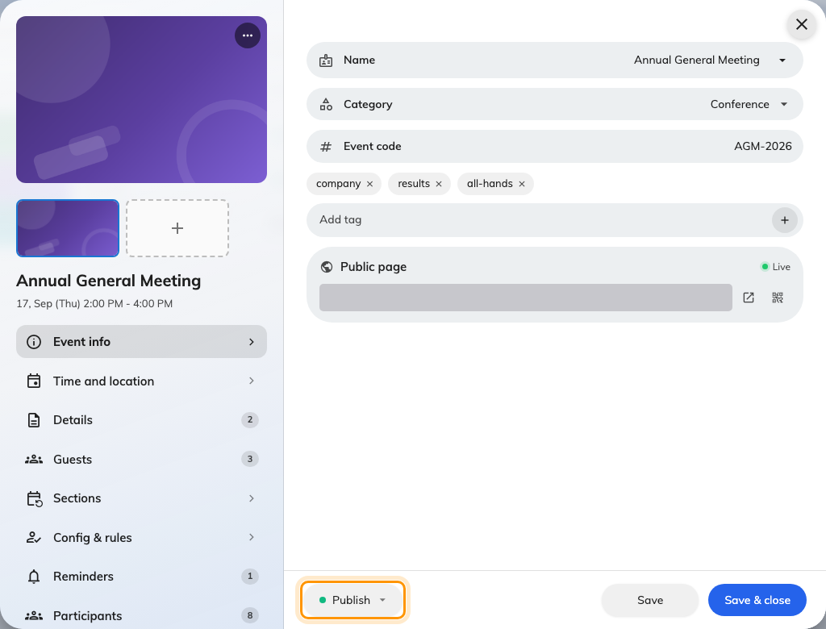
The status pill in the editor footer is where the whole lifecycle lives.

What publishing turns on
Staff can find it. The public page opens, if you have opened the event to
external participants. Invitations can be sent. Reminders start counting down.
And on the day, attendance can be taken.
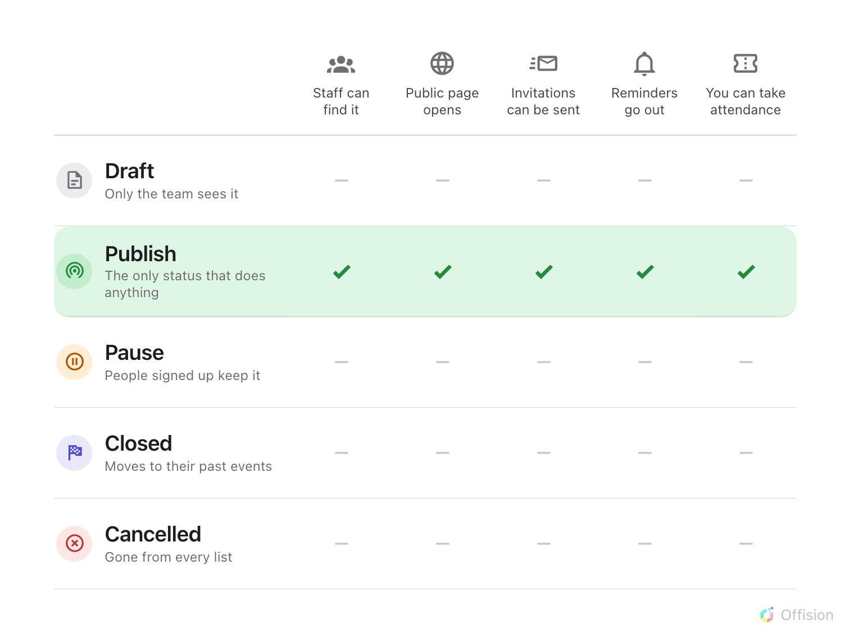
Publish is the only status in which anything happens.
Publishing sends nothing:
Nobody is notified when you publish. It unlocks the Send invitation buttons —
inviting is a separate, deliberate act, and until you do it, nothing has gone out
to anyone.
That surprises people often enough to be worth saying to yourself before you go
looking for a bug: publishing opens the door, it does not knock on any.

The three ways to end one
Pause takes it off both lists but leaves it with the people who already signed
up. Use it while you rearrange something — a venue falls through, a speaker
pulls out — and publish again when it is settled.
Close is the ordinary end. The event moves into everyone's past events and the
record stays intact. This is what a finished event should be.
Cancel removes it from every list, including your registrants'. Use it for
something that is not happening — but tell people yourself first, because
cancelling sends no notification either.
Pausing has a cost:
A paused event sends no reminders, and it does not catch up afterwards. Pause it
overnight and that morning's reminder is simply missed.

Deleting
Deleting is permanent and takes the registrations with it. An event that has
happened should be Closed, not deleted — the record is worth keeping, and it
stays out of everybody's way either way.

Sections publish separately
On a series event, publishing the event does not publish its sections. Each is
published in its own right.

