Open your Events page
Where you build events, how it differs from the page everybody uses to join them, and the two things your account needs before it appears.
2026-08-27 · https://offision.com/help/en/event-coordinator/open-your-events-page/
Running an event happens in the app, not in the admin console. Under Events
you have two pages, and they do different jobs:
- Event list — what everybody has: browsing and joining what is on.
- Event management — yours: building events and running them.
This guide is about the second. If you only ever attend events, the first one is
all you need.
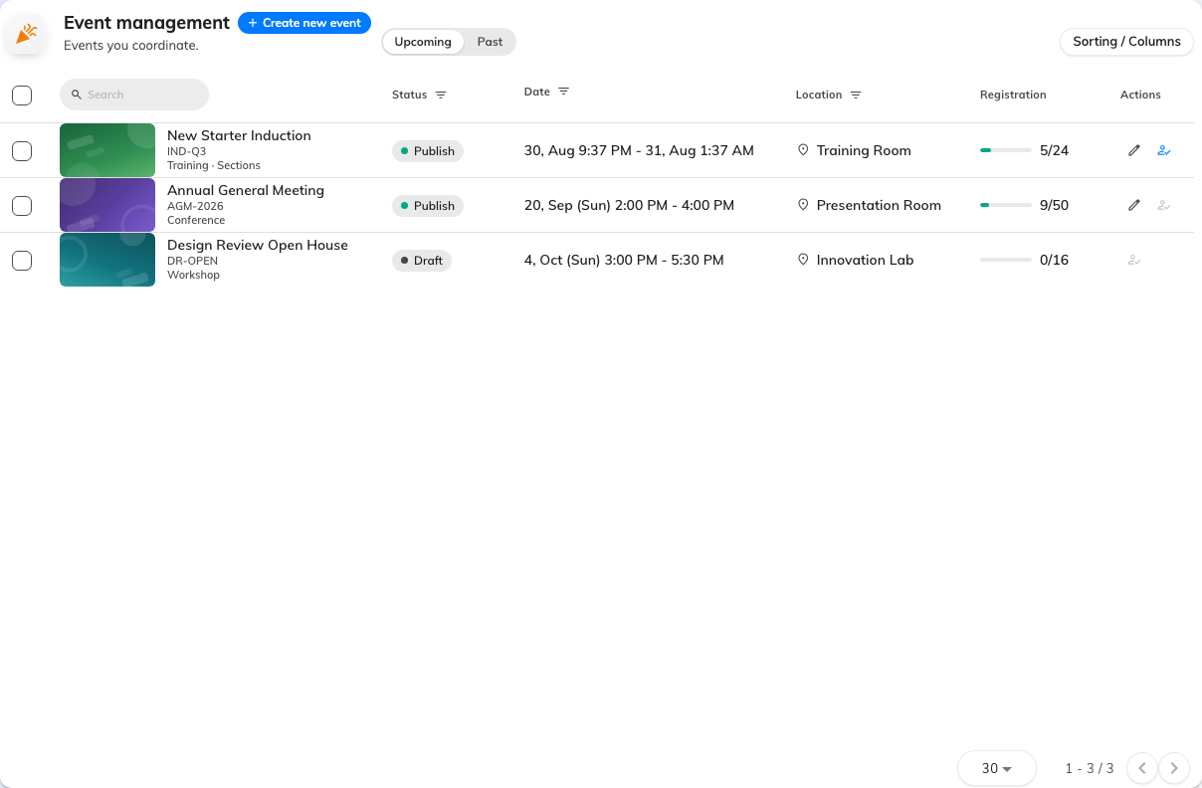
Event management: the events you are on the team of, and nobody else's.

Before it appears
Event management shows up once your account has two things: the Event
coordinator permission, and an Event coordinator licence. They are granted in
different places by an administrator, and having one without the other is the
same as having neither.
If the page is not there:
You are missing the licence rather than the permission — the page itself is what
the licence unlocks. If the page is there but creating is refused, it is the
other way round, and the dialog names which half under What's needed.
Either way an administrator fixes it; there is nothing to do in the app.

What you can see, and what you cannot
Your page shows the events you are on the team of — the ones you created, and any
you have been added to as an editor or an assistant. It is not every event in the
company; that view belongs to an administrator.
That also means an event disappearing from your list usually means somebody
removed you from its team, not that the event was deleted.

The order things happen in
- Create an event — its type, category and name.
- Set when and where, then
fill in the details.
- Decide who your event is open to.
- Publish it — nothing is
visible to anybody until you do.
- Invite people and, on the
day, check them in.

