Limit how many people can join
One number covering both audiences, whether to publish it, and the ceiling your licence puts above it.
2026-08-27 · https://offision.com/help/en/event-coordinator/limit-how-many-people-can-join/
Enable maximum participant limit puts a ceiling on how many people can
register. Leave it off and the event takes as many as turn up.
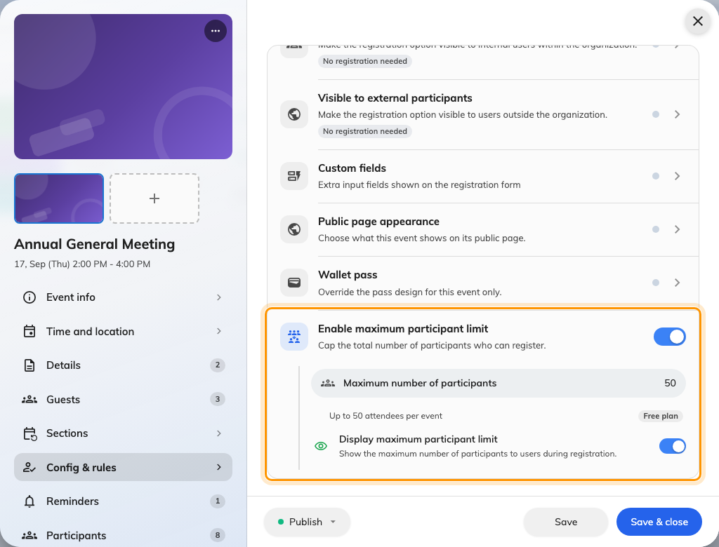
The cap sits at the foot of Config &amp; rules, with its own switch.

One pool, both audiences
The number covers colleagues and external guests together. There is no way to
hold back seats for one side — if you need to guarantee places for your own
staff, invite them before you open external sign-ups, because an invited place is
already taken.

Whether to show it
Display maximum participant limit publishes the count, and guests then see
N places left on the public page.
On a popular event that creates useful pressure. On a quiet one it advertises
that nobody is coming, which is rarely what you want a fortnight out. It is one
switch you can change at any time, so turning it on once the event has filled a
little is a perfectly reasonable tactic.
Your licence has a ceiling of its own:
Your company's licence caps attendees per event, and it wins over anything you
set. Enter a number above it and the event tells you so — Your licence allows up
to N attendees per event — and where your figure is higher, the event says
Your licence still limits this event to N attendees.
Set capacity to the number you actually want. It is not a way to buy headroom you
do not have.

On a series event
Capacity applies per section, not across the series. Twenty on a four-section
course is twenty each time, which is usually right — each session has a room —
but it is not what people assume when they type the number.

Freeing a place
Only cancelling somebody's registration gives a seat back. Marking them as a
no-show afterwards does not, and neither does the event ending.
That matters when a full event has a waiting list: to let the next person in, you
have to cancel the one who dropped out rather than leaving them on the list.

