Invite people and see who's coming
Three ways onto the list, what each one sends, and why inviting is the only way to be sure somebody has a ticket in their inbox.
2026-08-27 · https://offision.com/help/en/event-coordinator/invite-people-and-see-whos-coming/
Participants on your event is who is coming, and where you add people
yourself.
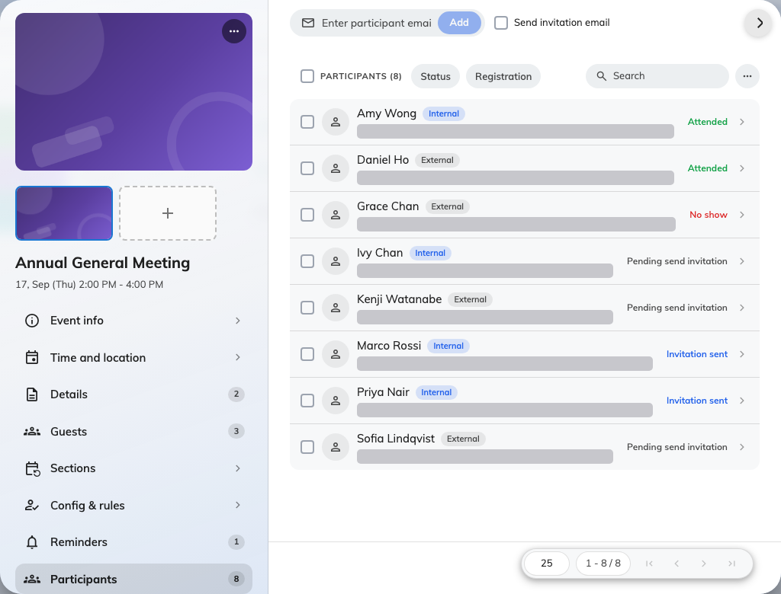
The participant list, with each person marked internal or external and carrying a status.

Three ways onto the list
Add participants picks people one at a time — colleagues from your directory,
or guests by email address.
Import participants takes a file, for a list that came from somewhere else.
It reads email, name, title, department and phone, and skips rows with a bad
address or somebody already on the list — so re-importing a corrected file is
safe.
They sign themselves up, if you have opened the event to them.
Publish before you invite:
The Send invitation controls stay disabled until the event is published. That
is deliberate — an invitation to something nobody can open would be worse than no
invitation — but it does mean the order is publish first, invite second.

What adding somebody actually sends
Adding a participant creates their place and their pass, and sends them the
registration email. Their status then reads Pending send invitation until you
send it — which is the state to expect on an event that is not published yet, not
a failure.
Resend invitation sends the same email again and mints the pass afresh. Use it
for anybody who deleted theirs.
Inviting is the only way to guarantee an emailed ticket:
Somebody who signs themselves up in the app gets nothing by email, whichever
audience they belong to. If you need everybody holding a ticket in their inbox —
because reception will be checking a list, or the venue is off-site — invite them
rather than letting them self-register.

Reading the list
Each person carries a status: Pending send invitation, Invitation sent,
Attended, No show, or Invitation cancelled.
Invitation cancelled is the only one that frees a place. Marking somebody as a
no-show afterwards records what happened but does not give the seat back, which
matters on a full event with people waiting.

Taking somebody off
Cancel them rather than deleting. Cancelling keeps the record — useful when they
ask later whether they were ever registered — and it is what releases the place.

