Fill in the event details
The description, speakers, requirements, tags and contact details — what each is for, and which of them your guests actually see.
2026-08-27 · https://offision.com/help/en/event-coordinator/fill-in-the-event-details/
Everything on Event info and Details is what somebody reads when deciding
whether to come. None of it is required, and an event with none of it filled in
looks exactly as thin as that sounds.
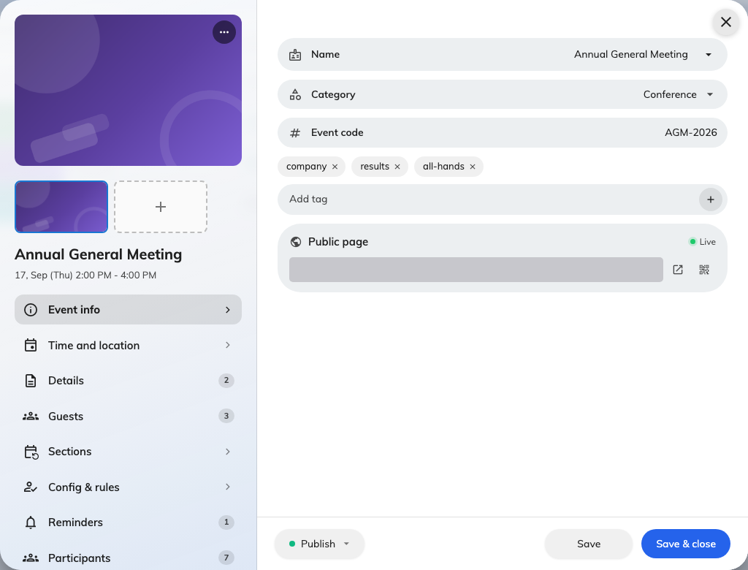
Event info: the name, category, code and tags, with the public link beneath them.

The poster
One image, used everywhere: the top of the public page, the screens in the lobby,
and the banner on everybody's wallet pass. It does more work than any other field
here.
Leave the poster alone once you have published:
A wallet pass fetches that image again long after it was issued, so deleting or
replacing it breaks the banner on passes already sitting in people's phones. Get
it right before you publish rather than after.

Description
The main body of the public page. Write the first line as though it is the only
one anybody reads, because on a phone it very nearly is.
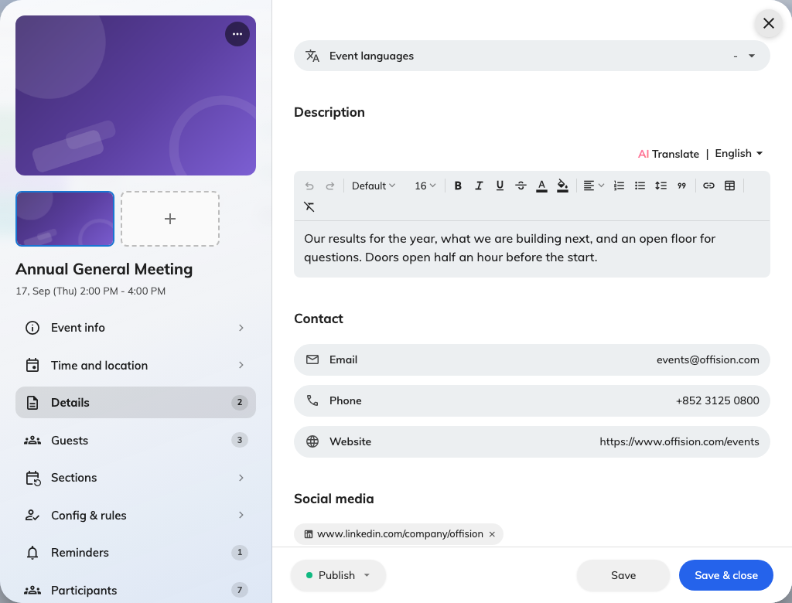
Details: the description, requirements and tags, all on one page of the rail.

Speakers and guests
Names, titles and photographs of whoever is presenting. They appear on the public
page and on the event panels — which is why an email address on a guest is marked
as being for contact only and is never shown.
Each guest carries a role: Organizer, Speaker, Moderator or plain
Event guests.
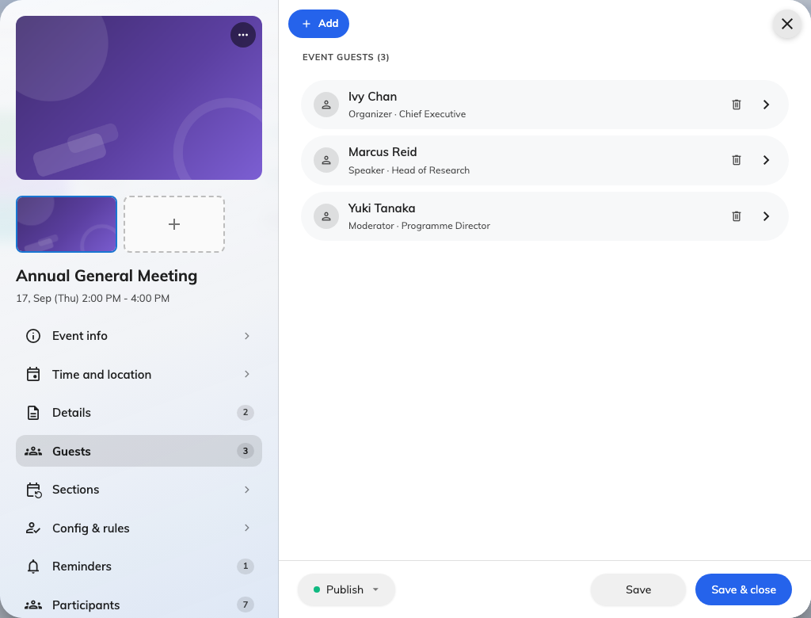
Speakers and guests: one row per person, each carrying a role.

Requirements
What somebody has to bring, know or do beforehand — a laptop, a prerequisite
course, a dress code. These read as a short list rather than prose, so keep each
one to a line.

Tags
Free-text labels for your own classification, beyond the single category. Useful
when you run many events and want to group them your own way.

Contact information
An email address, a phone number and a website, shown to people who have
questions. Put a monitored address here rather than your own if the event is
large — this is published on a page anybody can reach.

Next
Add sections to a series event,
or go straight to who your event is open to.

