Create an event
Four things to settle before anything else exists — and one of them is awkward to change later.
2026-08-27 · https://offision.com/help/en/event-coordinator/create-an-event/
Create new event opens a short form. It asks for very little, because
everything else is added afterwards in the editor.
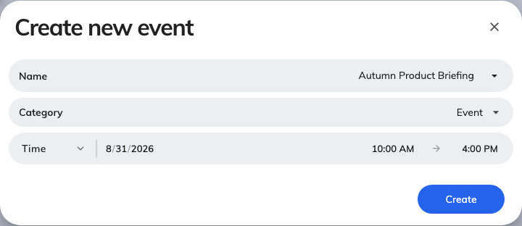
Create new event asks for four things; everything else is added afterwards.

1. Individual or series
Individual event happens once. Series event is one event with sections
under it — the four dates of a course, the same induction every Monday.
This is the one to get right:
Everything below hangs off this answer, so changing it later is awkward. If there
is any chance of a second date, make it a series and give it one section — a
series with a single section behaves almost exactly like an individual event, and
adding the second date later costs nothing.

2. Pick a category
Required, and it is not just filing: the category gives your event its colour
everywhere it appears, and it is what people filter by on the public page.
Your company will have a set already — Event, Lecture, Webinar, Seminar and so
on. Pick the closest; you cannot leave it blank.

3. Name it
The name is what appears on the list, on the public page, on the screens in the
lobby and on everybody's wallet pass. Write it for somebody who has not heard of
it — Q3 all-hands, not AH-Q3.
If your company works in more than one language, give it a name in each. An event
named only in English shows in English on an otherwise Japanese screen, and the
wallet pass falls back the same way.

4. Set the period
The start and end, or All day. This can be changed freely afterwards — but
moving it once reminders are set will drop any reminder that was aiming at the
old time, so reschedule early if you can.

What happens when you save
You get an event in Draft, with you as its owner. Nothing is visible to
anybody else and nothing has been sent. The editor opens on it, and that is where
everything else — details, registration, invitations — is done.

Next
Set when and where it happens

