Your data: retention, export, deletion and backup
How long each kind of record is kept and which of those windows you can set, what deactivating or deleting a person or a visitor really removes, where the export buttons are, and why there is no backup page to look for.
2026-08-26 · https://offision.com/help/en/directory/your-data-retention-export-and-deletion/
Offision keeps most records until a retention window ends, and a few for as
long as the tenant exists. The part that surprises people is which of those
windows an administrator can move: five of them. Everything else runs on a
fixed schedule.
Security setting is not the page:
The Security setting page under System account holds exactly two switches,
both about whether the user and visitor pages may be embedded in another
website. Nothing about retention, deletion or export lives there.

How long each record is kept
Record | Kept for | Set on
Bookings and their appointments | Booking retention period, 3–84 months, 36 by default | Booking › Settings, Data retention
Booking logs | Booking log retention period, 3–36 months, 6 by default | same card
Attendance selfies | Selfie retention period, in days, 30 by default | Attendance settings, Selfie privacy
Visitor identity numbers | Purge visitor identity information — a number of days after the last visit, at a time of day | Visiting › Settings
Visitor and visit records | Purge visitor record information — days after the last visit, at a time of day | Visiting › Settings
Audit trails | 180 days | fixed
Visiting, access and event action logs | 90 days | fixed
Sensor readings | 30 days | fixed
Deleted user groups and deleted devices | 30 days after deletion | fixed
Player and control-processor logs | 14 days | fixed

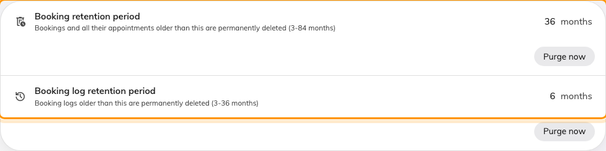
Data retention on Booking › Settings — the two retention periods.
Each of the five settings has a Purge now button beside it that runs the
same clean-up immediately, after showing how many records it will remove. The
two visitor purges differ in kind: the record purge deletes the visits and the
visitors nobody else refers to; the identity purge only masks the ID
numbers on visitors kept for other reasons. Every purge that removes anything
leaves one line in the audit trail.
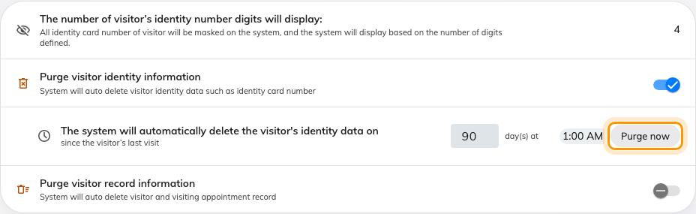
Data protection on Visiting › Settings, with the two purge switches ringed.

Deactivate or delete a person
Where in Offision: admin app → directory/user (Users)
Deactivate user stops them signing in and stops them counting against your
licence. Their name and everything they did stay exactly as they were, and
Re-enable user reverses it.
Delete moves them to the Recycle bin, from which Restore brings them
back. Their external sign-in links are removed at that point. What does not
happen is erasure: a deleted person is kept, deliberately, so that every
booking, visit and log entry that names them can still be traced to a real
name. Nothing is anonymised, and no later job removes them. If a request to be
forgotten reaches you, tell your Offision contact — it is not something the
console does. See Remove someone who has
left for the day-to-day procedure.
The last Global administrator cannot be deleted or demoted.

Delete a visitor
Delete on a visitor's panel is the same kind of soft delete, with a
Deleted items view to bring them back. ID numbers are masked on screen to
the number of digits you allow, from their first day. Real erasure is the
scheduled purge above, or its Purge now; a purged record reads This
visitor data has been permanently deleted. Survey answers have their own
Purge record beside Export.

Where you can export
There is no single "export everything" button. Each list exports itself, as
Excel or CSV:
- Users — Export on the list; needs User manager Write.
- Bookings — the calendar toolbar, the booking list and booking report
dialogs, and the usage and no-show analytics.
- Visitors — Export all on the visiting record list, Export on the
badge and survey lists, and the visiting reports.
- Access cards, quota history and sensor data from their own
pages.
An export that is too large is refused with This export has too many
records. Please narrow the date range or filters and try again — do exactly that.

Backup and restore
There is no backup page and no restore page, because backups are not yours to
run: Offision takes them as part of the service and keeps them in the same
region as your tenant — see Where your data is
hosted. Restoring a single deleted record is
what the recycle bins above are for; restoring a whole tenant to a point in
time is a request to your Offision contact.

What this does not control
- Who may see personal data is the Permissions page, not retention.
- Where the data sits is chosen when the tenant is created and does not
change with any setting here.
- Emails already sent are in your mail system, not in Offision.

