Who can open the management console, and what they can change
The three choices on a person's Permissions page, how a group's permissions add to their own, which combination opens the console rather than only the user portal, and where the reception and service staff roles are switched on.
2026-08-26 · https://offision.com/help/en/directory/who-can-open-the-management-console/
A person's Permissions page decides two separate things: whether they can
open the management console at all, and what they can touch once inside. The
surprise for most administrators is that these are different switches — a
manager who cannot book a room, and a booker who cannot see the console, are
both normal.
Where in Offision: admin app → directory/user (Users)

The three choices on the page
The page is split into User Portal access right and Management console
access right.
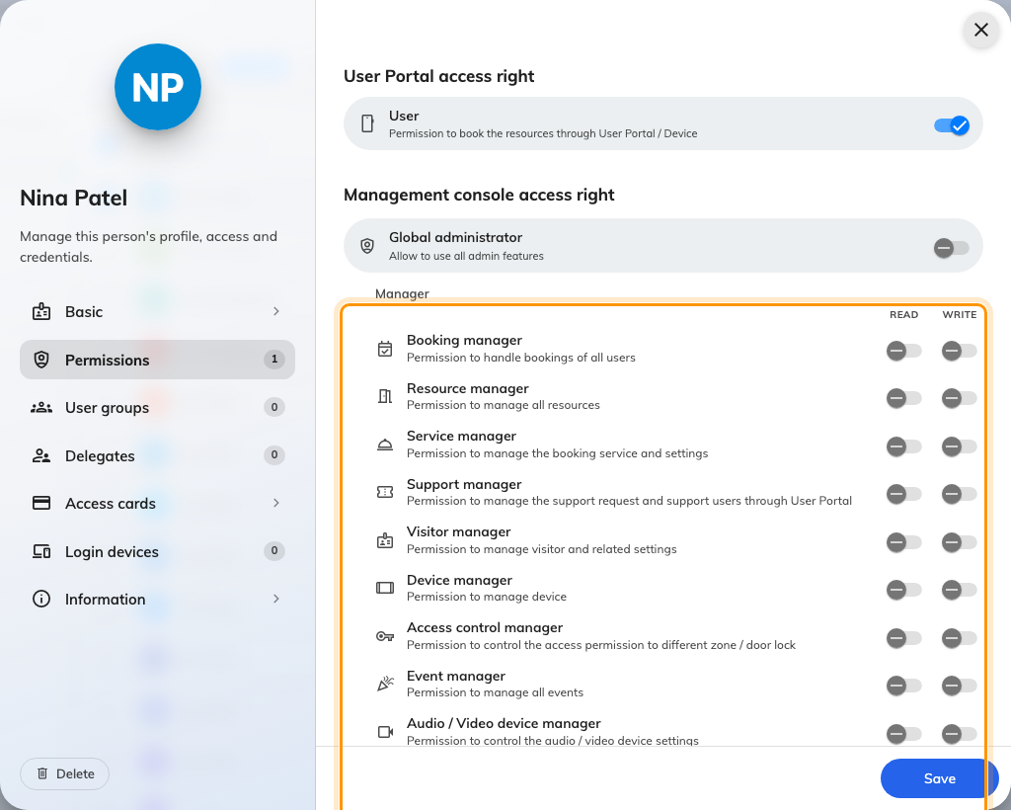
A person's Permissions page, with the manager rows ringed.
- User — the only switch under User Portal access right. It lets the person
sign in to the user portal and book. Without it, they cannot use the portal
even if they are a manager.
- Managers — one row per management area (User manager, Booking
manager, Resource manager, Visitor manager, Device manager and
so on), each with a Read and a Write column. Read opens that area of
the console to look; Write lets them change it. Turning Write on turns Read on
with it, and Read cannot be turned off while Write is on.
- Global administrator — everything, without exception. Turning it on clears
the manager rows, because they are implied; turning it off later does not put
them back, so rebuild the rows you want.
Below the managers sits Staff: Receptionist, Service staff,
Support staff, Event coordinator and Visitor guard. These are not
console roles. They unlock a duty inside the user portal — handling visitors at
reception, taking service requests, answering reported issues — and this page
is the only place they are assigned. There is no separate staff screen.

Groups add, never subtract
A user group has a Permissions page of its own, and whatever it grants is
added to each member's own permissions. The person ends up with the union: a
Read they hold personally plus a Write from a group is a Write. Removing a
permission from the person does nothing while a group still grants it, so when
someone keeps access you took away, check their groups.
A group can grant manager access and staff roles, but not Global
administrator — that switch exists only on a person.

What opens which door
- User or any staff role opens the user portal.
- Any manager Read, or Global administrator, opens the management console.
A person with none of those sees No permissions and is signed out again.
- Global administrator opens both.
Inside the console, each page asks for its own area. A Booking manager sees the
booking pages and nothing of Directory; giving someone the console is a matter
of giving them the areas they need, one row at a time.

Two pages that look like permissions but are not
Assignable roles defines labels you can attach to people on a specific
building or resource — "Floor warden", "AV owner" — through the Roles page
of that building or resource. A role grants no permission. It is a way of
addressing people, and today the support-ticket policy uses it to decide who
receives reports for a room or building.
User security profiles decide where a person may sign in from — desktop
browser, mobile browser, the iOS / Android app, the Outlook / Teams add-in — and
whether two-factor authentication is offered or required. Every person is on
one profile, chosen on their Basic page. A profile never grants console
access; it only narrows how an already-permitted account can arrive.

What this does not control
- Passwords, lockout and session length live on Global password policy,
not on any profile or permission.
- Who may book a particular room is set on the resource, not here. User is
the right to book at all.
- Which areas a manager can see stops at the module. There is no per-building
scope on this page.

