See who has signed in — and who never has
Filter the user list's Activated column to split the people who have signed in from the ones still sitting on an invitation, then send or resend invitations to the stragglers in one batch.
2026-08-21 · https://offision.com/help/en/directory/see-who-has-signed-in/
Before you start:
This page answers "who has ever signed in". If you are asking which devices
someone is signed in on right now, that is step 4.

1. Open the people list
Everyone lands in Directory › Users, and every row carries a status. A
person who has signed in at least once reads Activated; someone still
sitting on their invitation reads Invited or Created.
Where in Offision: admin app → directory/user (Users)

2. Filter the Activated column
The filter lives on the Activated column header itself — the funnel icon
beside the column name.
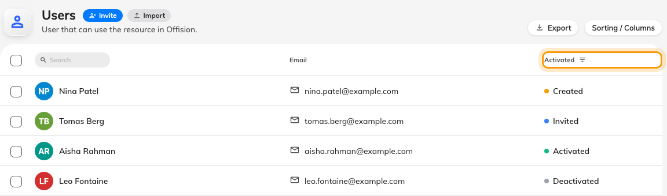
The funnel on the Activated header is the filter.
Click it and tick the statuses you want to see:
- Activated — everyone who has signed in already.
- Invited and Created together — everyone who never has. Both mean
never signed in; the only difference is whether an invitation email went out.
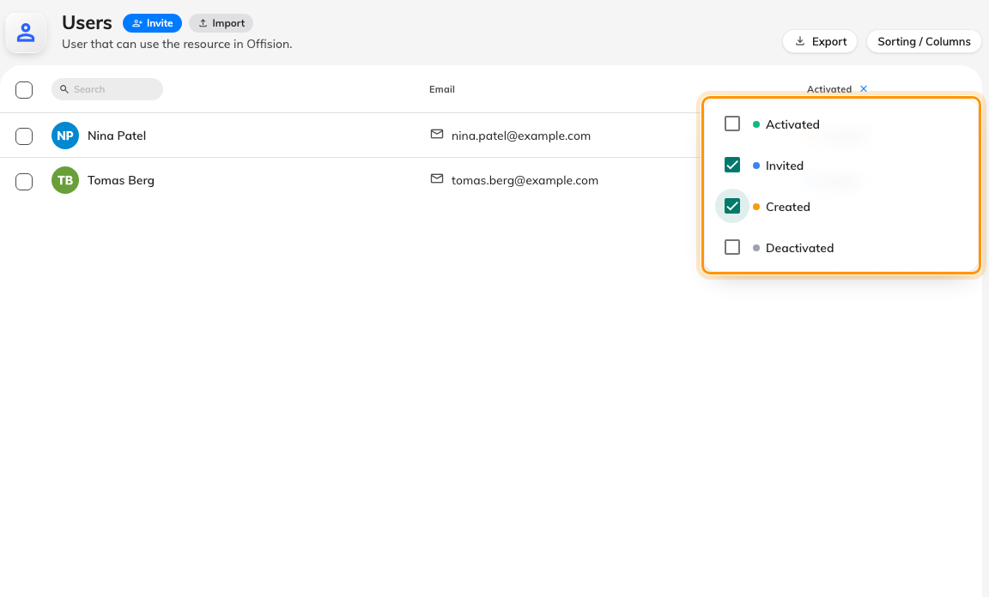
The Activated header filters the list; Invited plus Created is everyone who has never signed in.
Nothing you do here moves anyone's status — Offision sets Activated the
first time the person signs in, not when an administrator approves them. See
How account status works for what each state
means and what moves it.

3. Chase the ones who never signed in
With the list filtered to Invited and Created, select the rows with the
checkboxes on the left edge. The bar that appears offers the right nudge for
each state: Send invitation for Created accounts, Resend invitation
email for Invited ones. The same two actions sit on each person's own panel.
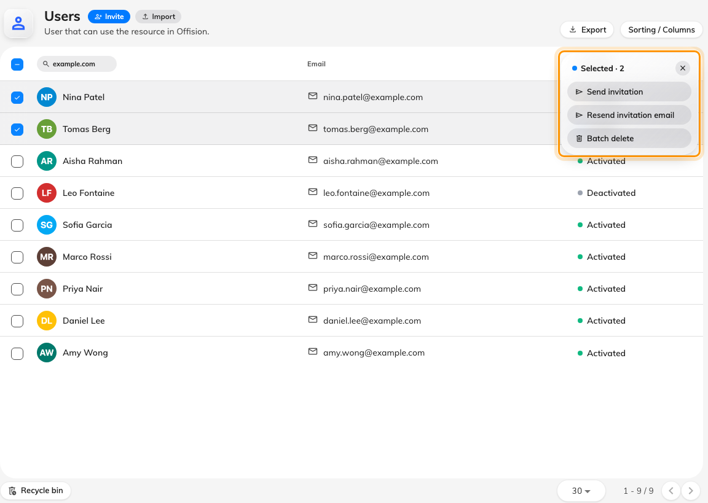
Select the stragglers and send or resend their invitations in one batch.
Resending is safe — an Invited account stays Invited, with a fresh link.

4. Activated is not "signed in right now"
Activated means they have signed in at least once, ever. To see who is signed
in at this moment — and on what — open Directory › User devices,
which lists every live session with its device and last-active time. A person
who signed in once and signed out again appears as Activated in the user list
but has no row there.
Where in Offision: admin app → directory/user-session (User devices)

5. Check it worked
After the invitations land, filter by Activated again a few days later. The
people who followed their link have moved out of Invited on their own — anyone
still there needs a word rather than another email.

