See where your account is signed in
Check every phone, laptop and browser currently signed in as you, and sign out anything you do not recognise. Under a minute, and you need nothing but your own account.
2026-08-16 · https://offision.com/help/en/directory/see-where-your-account-is-signed-in/
Before you start:
Nothing to arrange. This is your own account, and you can do it from any device
you are already signed in on.

1. Open your devices
Open your profile — your picture, top corner on a computer, or the Profile tab
on a phone — and choose Manage devices.
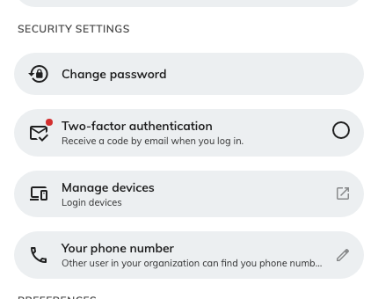
Manage devices sits with the other security settings in your profile.
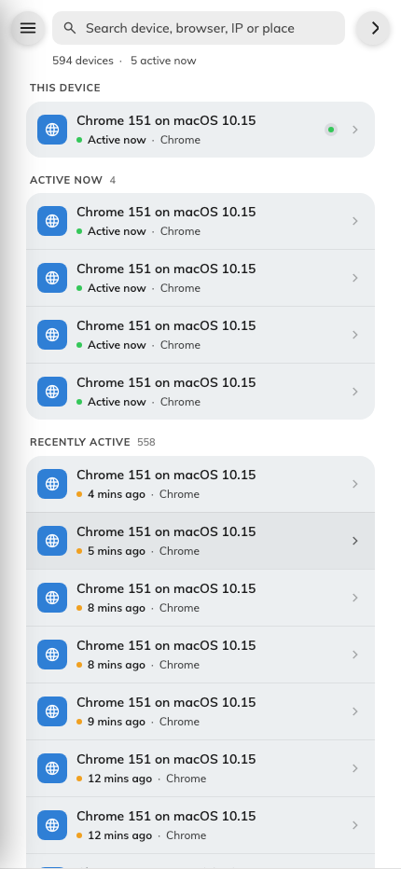
Everywhere your account is currently signed in.

2. Read the list
Everything currently signed in as you appears here, newest activity first, with
the one you are reading this on grouped at the top under This device.
Each row gives you the device, when it was last active, and where it appears to be.
Filter by kind — phones, computers, browsers — from the menu, and use the search
box to find a device by name, browser, IP address or place. On a computer that
menu is a panel down the left; on a phone, open it from the button at the top.
Judge a row on the device and the time, not the place. The location comes from
the network the device is on: the office VPN puts everyone at head office, and
mobile data can land a city or two away. A device you recognise in a surprising
place is almost always fine. A device you do not recognise is the thing to act on,
wherever it claims to be.

3. Sign out anything you don't recognise
Tap the row to see everything known about it — platform, browser, sign-in time,
last activity, IP address — then use Sign out this device.
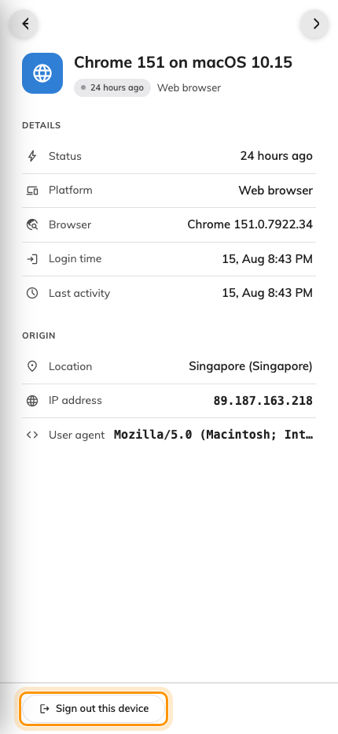
Open a device to see its detail, and sign it out from the foot of the panel.
It goes immediately, and the row disappears. The device you are using now shows
You're using this device right now instead of a button — to end that one, just
log out.
To clear everything else in one go — after losing a phone, or when you simply want
a clean slate — use Sign out all other devices, in that same menu. It ends
every device except the one in your hand.

4. If it was not you, change your password too
Signing a device out ends that sign-in. It does not stop whoever it was signing in
again, because they still have whatever they got in with.
So if a device was genuinely not yours, sign it out and change your password
straight away, from Change password in the same profile panel. Then tell your
administrator — they can see the sign-ins behind those devices, including failed
attempts, which you cannot.
Signing in with Microsoft 365?:
Changing your Offision password will not help, because it is not what you sign in
with. Change your Microsoft 365 password instead, and ask your IT team to review
that account's sign-ins.

5. Check it worked
Reopen Manage devices. The device should be gone from the list.
If it is back, someone signed in again — that is a password problem, not a device
problem. Change your password if you have not already, and tell your administrator.

