Remove someone who has left
Deactivate to stop them signing in while keeping their history, sign out the devices they are still on, or delete and restore from the recycle bin. What each one leaves behind.
2026-08-16 · https://offision.com/help/en/directory/remove-someone-who-has-left/
Before you start:
Cancel or hand over anything of theirs that still matters first. Removing a person
does not touch their bookings — see step 4.

1. Choose deactivate or delete
Two different actions, and reaching for the wrong one is the usual regret.
Deactivate is what you want for someone who has left. They can no longer sign
in, and their record stays in the list reading Deactivated, with everything
they ever booked still attached to a readable name. It is reversible in one click.
It does not sign out a device they are already on — that is step 3, and it is the
step most often missed.
Delete is for a record that should not have existed — a duplicate, a typo, a
test account.
Choose deactivate unless the record itself is the problem.

2. Deactivate
Open the person from Directory › Users and use Deactivate user at the
foot of their panel.
Where in Offision: admin app → directory/user (Users)
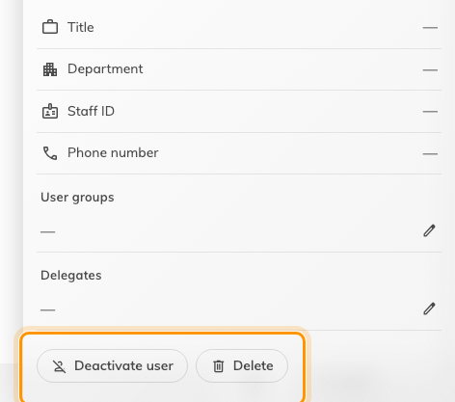
Both actions sit at the foot of the person's panel.
Offision asks you to confirm, and warns that a deactivated person can no longer
sign in. Two things to expect:
- Deactivate user appears only for someone currently Activated, and never
on your own account. You cannot lock yourself out this way.
- To bring them back, Re-enable user appears in the same place and restores
their access.

3. Sign out the devices they are still on
Deactivating stops the next sign-in. It does nothing to a phone or laptop
already signed in, and that sign-in stays valid for up to thirty days.
So finish the job on their record's Login devices page: Force logout all
ends every device they have, in one action. Do it after deactivating, never
before — deactivate first and there is no gap for them to sign back in through.
If they sign in with Microsoft 365 or another company account, disable that
account too. Deactivating in Offision does not reach it, and neither does forcing
a logout.
See Sign out a lost or stolen device for
the whole-tenant list and batch sign-outs.

4. What removal leaves behind
Their bookings stay exactly where they are. Offision does not cancel, release
or reassign anything when a person is deactivated or deleted, and there is no
prompt offering to. A room they booked for next Tuesday is still booked for next
Tuesday.
So before removing anyone, deal with what is still theirs:
- Cancel bookings that should not go ahead.
- Rebook, under a colleague's name, anything that should.
- Check recurring bookings especially — those run furthest into the future and are
the ones people forget.
Their name continues to appear on past bookings after removal, which is what you
want: the history stays readable.

5. Delete, and undo it
Delete sits beside Deactivate user on the same panel, and asks you to
confirm the people it is about to remove.
Nothing is destroyed at that moment. The record moves to the recycle bin, reached
from Recycle bin at the foot of the list; Back to active list returns you.
Select the person there and choose Restore to bring them back, name and email
intact.
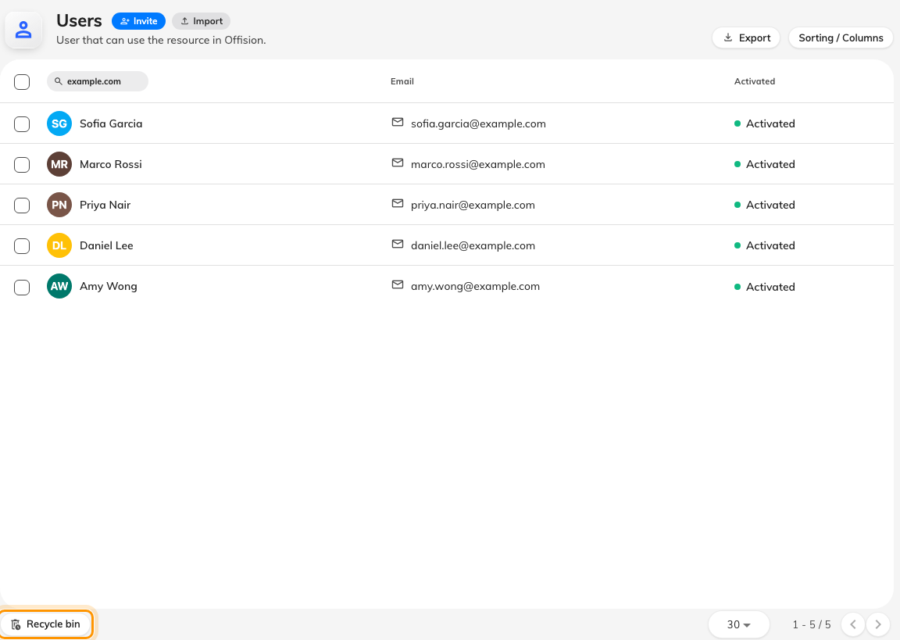
Deleted people stay in the recycle bin, and can be restored from it.
Two limits worth knowing:
- Offision refuses to delete your last global administrator. If a delete fails for
no obvious reason, give someone else that permission first.
- If their email address has been reused by a newer account in the meantime,
restoring renames the restored record to keep both valid. Check the name
afterwards.
The recycle bin keeps deleted people for good. Nothing purges them — bookings,
logs and approvals point at the person, and keeping the record is what keeps
that history readable — so a deleted account can always be restored, and a
deleted person's name never disappears from what they did.

6. Check it worked
Their row should read Deactivated, or the person should appear under Deleted
items rather than in the main list. Their Login devices page should be empty.
Then try their address at the sign-in page. It should be refused. If they can
still get in, the change landed on a different record — search for the address
itself rather than the name, since duplicates are usually why this happens.
If a device is still working rather than a sign-in still succeeding, that is a
different problem — see
Someone still has access after you signed them out.

