Global password policy reference
Every field on the Global password policy screen — password rules, expiry and reuse, auto logout and lockout, self-registration — what each one does and when it is worth changing.
2026-08-17 · https://offision.com/help/en/directory/password-policy-reference/
One screen, four sections, all of it tenant-wide — there is no per-building or
per-group version of these rules. Everything here governs Offision passwords;
a Microsoft 365, Google, LDAP or Active Directory sign-in is not subject to any of
it. See How sign-in security works for
why.

Global password policy
What a password has to look like. These are checked whenever a password is set —
by the person, by an administrator, or through self-registration.
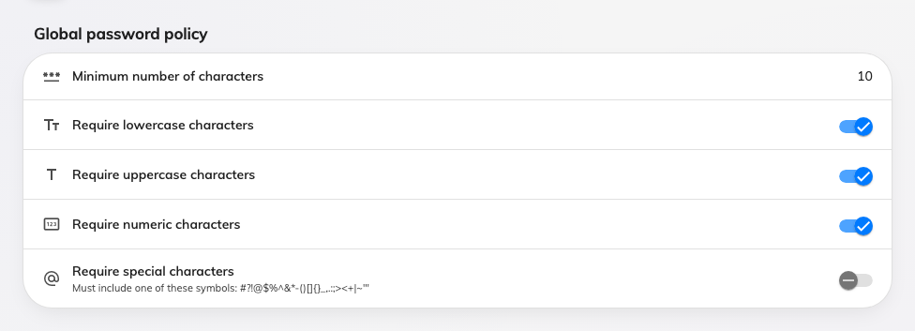
The character rules. Every password Offision stores has to pass all of them.
Setting | What it does | When to change it
Minimum number of characters | The shortest password Offision will store. Between 6 and 30 | Length beats complexity for real security. 12 is a better default than 8 if your people will accept it
Require lowercase characters | The password must contain at least one a–z | Leave on. Turning it off buys nothing
Require uppercase characters | The password must contain at least one A–Z | Leave on
Require numeric characters | The password must contain at least one 0–9 | Leave on
Require special characters | The password must contain one of #?!@$%^&*-()[]{}_,.:;><+|~'" | Turn on where a security policy demands it. It is the rule people most often work around with a trailing !, so raising the minimum length usually does more good

Password change policy
How long a password lasts, and whether an old one can come back.
Setting | What it does | When to change it
Require user to set a new password | Turns on expiry. Off, a password lasts indefinitely | Modern guidance is against routine expiry — it pushes people towards predictable variations. Turn it on when an external policy requires it, not by default
Require a new password every | The number of months, 1 to 12. On the first sign-in past that age the person is sent to the change-password screen and cannot go anywhere else until they finish | 3 months is aggressive; 12 is the gentler choice if you must have expiry at all
Prevent users from reusing previous passwords | Remembers past passwords and refuses a repeat | Turn on alongside expiry. Without it, expiry just makes people alternate between two passwords
Number of previous passwords to remember | How many recent passwords are refused, 1 to 4 | The highest value is the useful one; a person who has to change every 3 months takes a year to cycle past four

Login setting
What happens to an idle session, and to someone typing the wrong password.
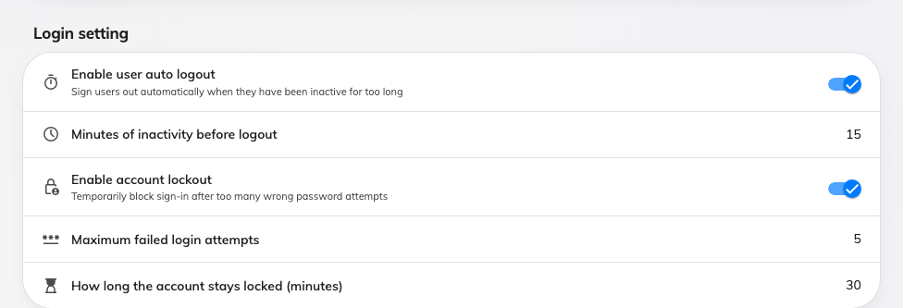
Auto logout and account lockout. Each one's numbers appear once its switch is on.
Setting | What it does | When to change it
Enable user auto logout | Signs a person out after a period with no keyboard, mouse or touch activity. This one does apply to everyone, including single sign-on, because it runs in the app rather than at sign-in | Turn on for shared or public machines. It is the only control here that shortens a session for everybody at once
Minutes of inactivity before logout | Between 5 and 480 | 15 for a reception or shared desk; anything under 10 becomes an irritation on a personal laptop
Enable account lockout | After too many wrong passwords, sign-in is refused for a while even with the right password. Applies to Offision passwords only | Turn on. It is the single most useful setting on this screen for a tenant that uses passwords
Maximum failed login attempts | How many wrong passwords trigger the lock, 1 to 20. A successful sign-in resets the count | 5 absorbs ordinary typing mistakes while still stopping a guessing attack
How long the account stays locked (minutes) | The length of the lock, 1 to 1440. During it the person is told how many minutes remain. An administrator can clear it early from the person's record | 30 is enough to defeat guessing without generating a support call

User self-registration
Whether strangers can create their own account. Off unless you turn it on.
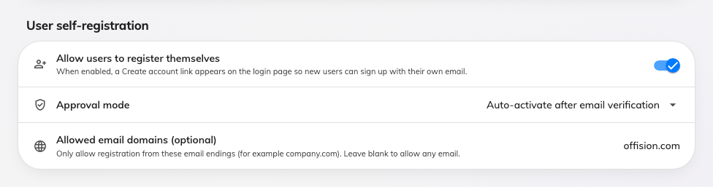
Self-registration, with the domains allowed to use it.
Setting | What it does | When to change it
Allow users to register themselves | Adds a Create account link to the sign-in page, so someone can sign up with their own email rather than waiting to be invited | Turn on for a site where you cannot practically invite everybody in advance. Set the allowed domains at the same time
Approval mode | How a new registration becomes usable. Auto-activate after email verification — they confirm their address and are in | The only mode the screen offers
Allowed email domains (optional) | A comma-separated list, for example acme.com, partners.com. Only addresses ending in one of them may register. Blank allows any address | Never leave this blank with self-registration on: an open form on a public sign-in page will be found

What this screen does not control
- Two-factor authentication is set on User security profiles, not here.
- Where a person may sign in from — desktop browser, mobile, the mobile app,
the Outlook and Teams add-in — and IP restrictions are also per security
profile.
- Ending a session that is already running. None of these settings sign
anyone out; changing them governs the next sign-in. Signing a device out is on
the person's Login devices page.
- How SSO users get in. Lockout, expiry, reuse and the character rules never
reach a Microsoft 365, Google, LDAP or Active Directory sign-in. Set those
rules in that provider's console.
- What someone can do once inside. That is permissions and user groups.
Where in Offision: admin app → directory/password-policy (Global password policy)

