Issue an access card to someone
Get the number off the card, store it against the person from either the Access cards page or their own record, and tap once to prove it. Two minutes, and the same steps take a card back.
2026-09-04 · https://offision.com/help/en/directory/issue-a-card-to-someone/
Before you start:
The person needs an Offision account already. Card slots appear only when you
open an existing record — a brand-new one has no Access cards page at all.
See Add people to Offision.

1. Read the number off the card
Do this before anything else, because the number you need is usually not the
number printed on the card.
Which number goes in the box:
An ordinary MIFARE, NTAG or DESFire card has no printed number — what a reader
sends is the chip's UID, in hexadecimal. An HID Global card read by an iAdea
panel supplies its own encoded card number instead, which is the one printed on
it. Upper and lower case do not matter, so a number enrolled either way matches.
If you are unsure what a batch of cards will produce, enrol one, tap it, and read
what was accepted before you type in the other five hundred.
Tapping a card at a panel that already works is the quickest way to see the real
number; the other way is a USB reader plugged into your own machine, which types
the number into whatever field has focus.

2. Store it against the person
Two screens do this, and they write the same thing. Use Access cards when you
are working through a stack of cards, and the person's own record when you are
already in it.

From the Access cards page
Choose Add, and fill in three things: the Card number, which slot it fills
under Type, and the User who will hold it.
Where in Offision: admin app → directory/access-card (Access cards)
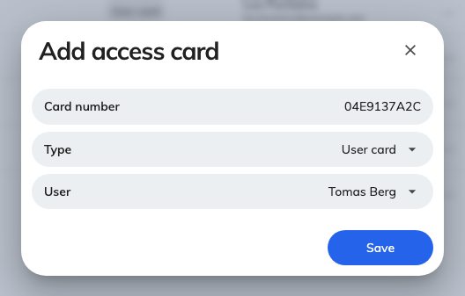
Three fields: the number, the slot it fills, and who holds it.
The type list here is longer than the three slots on a person's record — it also
offers User mobile pass and External sync card, which normally arrive on
their own. Leave it on User card unless you know why you are changing it.

From the person's own record
Open the person and go to their Access cards page. It carries three slots —
User card 1, User card 2 and User card 3 — plus a read-only External
synchronized card underneath once something has filled it. Type the number in
and save the record; nothing is written until you do.
Where in Offision: admin app → directory/user (Users)
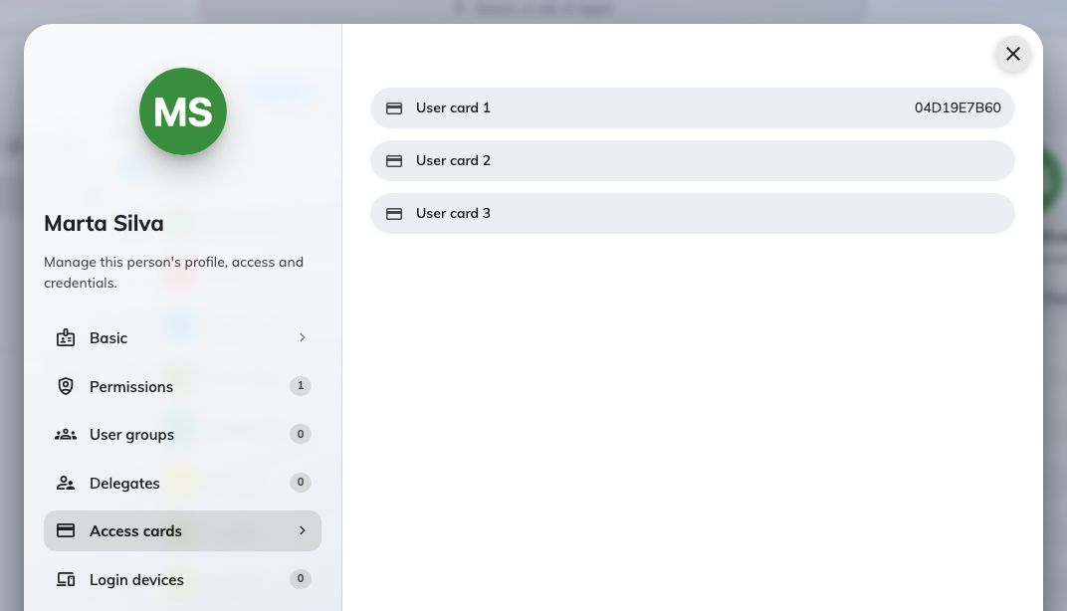
Three slots per person. Most people only ever need the first.
Three slots exist because one person can carry more than one card — an office
badge and a car-park fob, or a replacement issued before the old one came back.
Any of them identifies them equally.

3. Check it worked
Search the number on Access cards. The search box covers the card number, the
holder and the visitor, so typing the number should return exactly one row against
the right person. The number itself is masked to its last three characters; the
control on each row reveals it.
Then tap the card at a panel. If nothing happens at all, work through
Tapping a staff card does nothing.

When the number is already in use
A card number belongs to one person across the whole account, so a number
somebody else already holds is refused as you type it.
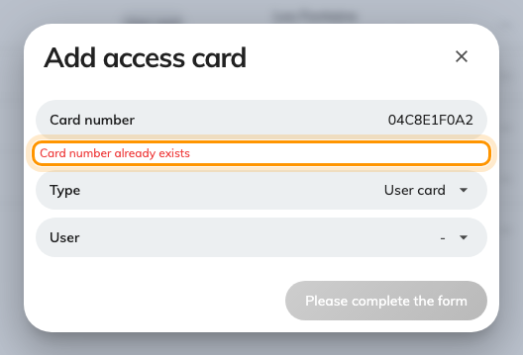
Checked as you type, against every card in the account.
Search the number first: it will show you who is holding it. Usually that is the
last person the card was issued to, and the fix is to take it off them rather than
to invent a new number.
Giving a person a number they already hold in a different slot is not a clash
— it moves the card to the new slot rather than making a second one.

Taking a card back
- One slot on a person's record — clear the box and save. An empty slot
deletes the card.
- One card from the Access cards page — select the row and use Delete on
the panel that opens.
- A lot of them — tick the rows and use Batch delete, or hand back a whole
spreadsheet of them at once with
Import card numbers in bulk.
A deleted card leaves no trace:
There is no recycle bin for a card and nothing about one reaches the audit trail —
not who issued it, not who removed it. Write the number down before you delete it
if you may need to put it back.

