Import card numbers in bulk
Download what you already hold, fill in the numbers, and upload it back. What each preview verdict means, why some rows never appear, and the one checkbox that changes what an empty cell does.
2026-09-04 · https://offision.com/help/en/directory/import-card-numbers-in-bulk/
Before you start:
The people must already have accounts — the file is matched on email address and
creates nobody. Import the people first if they are not there yet, with
Add people to Offision; their card numbers cannot
ride along in that file.
Handing out five hundred cards is a spreadsheet job. Access cards exports what
you already hold, and takes the same file back with the numbers filled in.
Where in Offision: admin app → directory/access-card (Access cards)

1. Get the file
Export downloads every card slot in the account as an Excel file — a row per
person, blank where they hold no card. That download is the template: it already
has everybody's address in it, spelt the way Offision spells it, which is the
thing the import matches on.
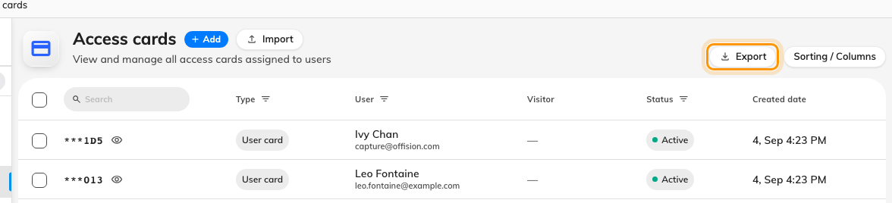
Export first. The file that comes back is the file to send back.
Only two columns matter and they are read by position, not by heading: Email
address first, Card number second.

2. Choose a mode
Import opens on the two modes, and they are not interchangeable.
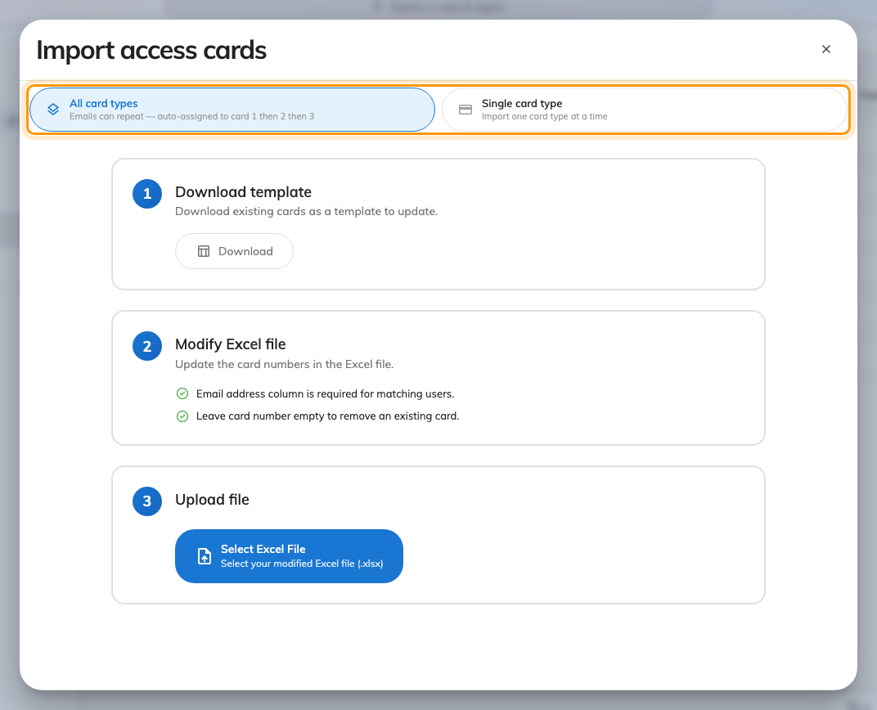
Download, fill in, upload — and the mode decides how a repeated address is read.
Mode | Reads the file as
All card types | An address may repeat; the numbers fill card 1, then 2, then 3
Single card type | One row per person, all writing the one slot you pick

Pick Single card type for the ordinary case — one card each, going into
Access card 1. All card types is for people carrying more than one.

3. Read the preview before you commit
Nothing is written until you say so, and the preview is the part worth reading.
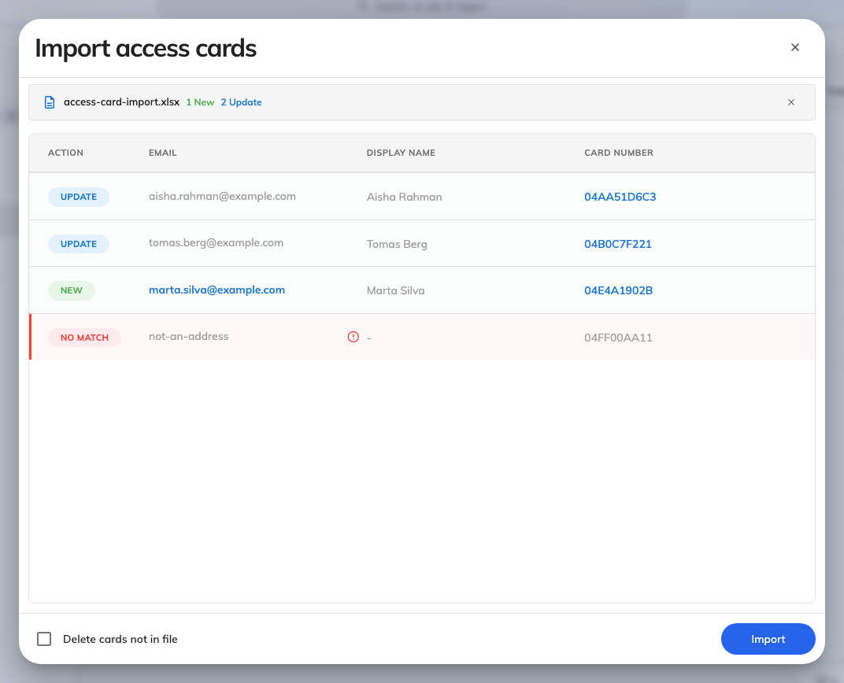
Single card type: a verdict per row, and only rows that would change anything.
Verdict | Means
New | The person holds nothing in this slot yet
Update | They hold a different number, and it will be replaced
Delete | Their card will be removed
No match | The address is not one Offision can read, so the row is skipped
Not in file | They hold a card and the file never mentions them

Rows that change nothing are not listed at all. Neither is a well-formed
address the account simply does not hold — it is skipped in silence rather than
reported. So a preview shorter than your spreadsheet is normal, and a preview
with fewer rows than you expected is worth checking against the addresses in the
file rather than against the count.
Two things stop the import outright, and both name the offending rows: the same
number twice, and the same address twice in a mode that does not allow it.

4. Deleting, which is the part to be careful with
Delete cards not in file, at the foot of the dialog, is off unless you turn it
on — and it changes two behaviours at once, not one.
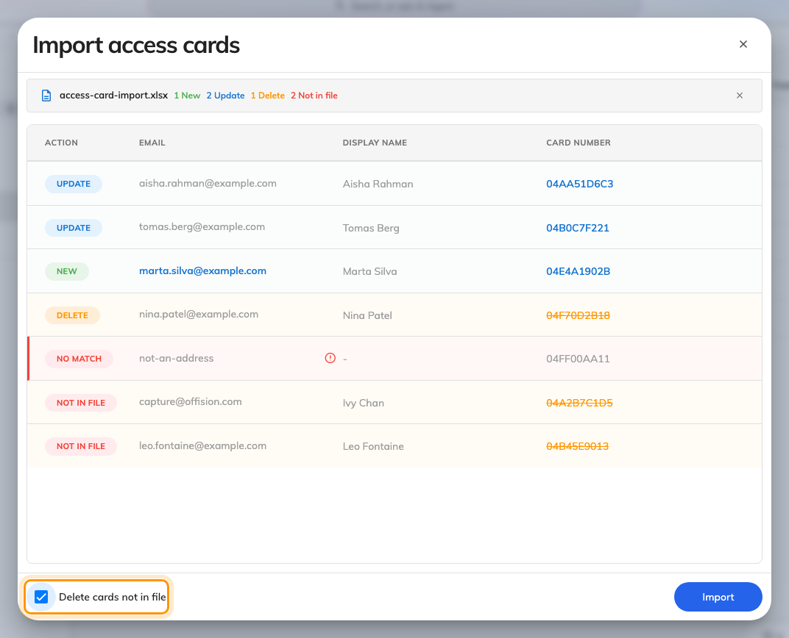
The same file with the checkbox on: two verdicts appear that were not there before.
- An empty card cell starts removing that person's card. With the checkbox
off, an empty cell does nothing at all.
- Everybody absent from the file who holds a card is marked Not in file
and will lose it.
That second one is why a partial file and this checkbox are a bad combination: a
spreadsheet holding one department, uploaded with Delete cards not in file
ticked, takes the cards off everybody else in the company. Leave it off unless the
file you are uploading is the complete list — and read the preview's Not in
file rows before you commit, because that is exactly what they are telling you.

5. Check it worked
Search two or three of the numbers on Access cards and confirm they came back
against the right people. Then tap one card at a panel: an import that wrote the
wrong column looks perfectly healthy in the list and fails at the wall.

