What a building's Google map location is used for
The Google map pin is a working value, not a picture. It sets the building's time zone, the link inside every booking and visitor email, and the centre of the GPS check-in area — and the address it stores is not the Address field above it.
2026-08-25 · https://offision.com/help/en/directory/how-the-google-map-location-is-used/
A building's Google map location is not a picture of where the office is.
Several other parts of Offision read it, and one of them refuses to work
without it.

The part that surprises people
Address and the Google map location are two separate values. On the
building's Basic page you type a free-text Address. Further down, under
Location, the map keeps its own Location name, Location address and
Location coordinate, taken from the place you searched for.
Nothing keeps the two in step.
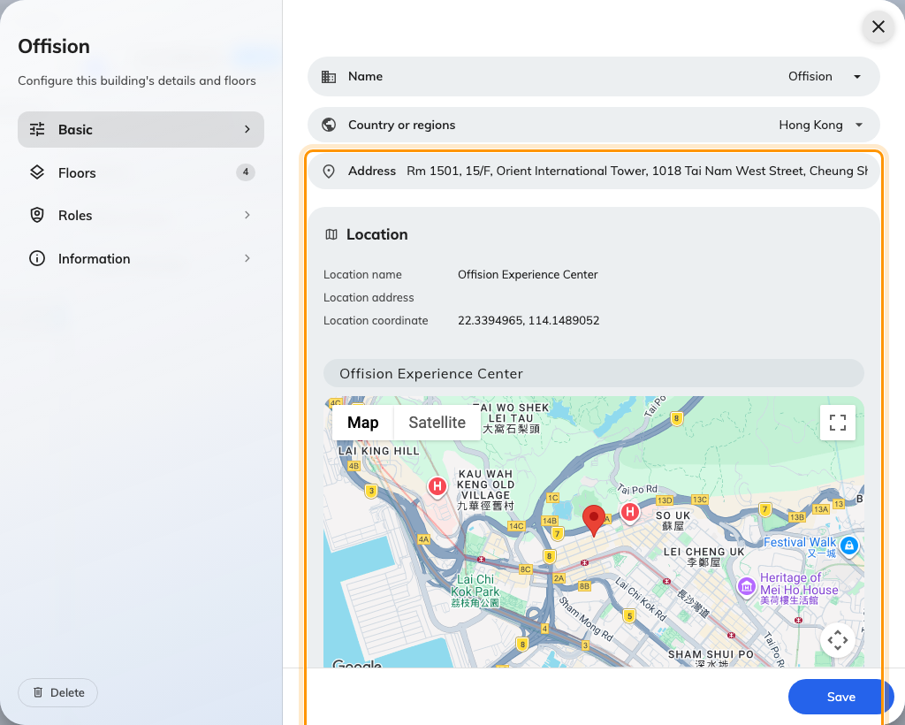
Two addresses on one page. The typed one, and the one the map holds.
It matters most in email. In a booking or visitor invitation, the address the
reader sees is the typed one — the map's address fills in only when that
field is blank — while the link behind it always opens the pin. A building whose
typed address is out of date therefore sends mail that reads one address and
opens another, and neither the sender nor the recipient has any way to notice.
Keep them saying the same thing, or leave Address blank and let the map fill
it in.

What the map block holds
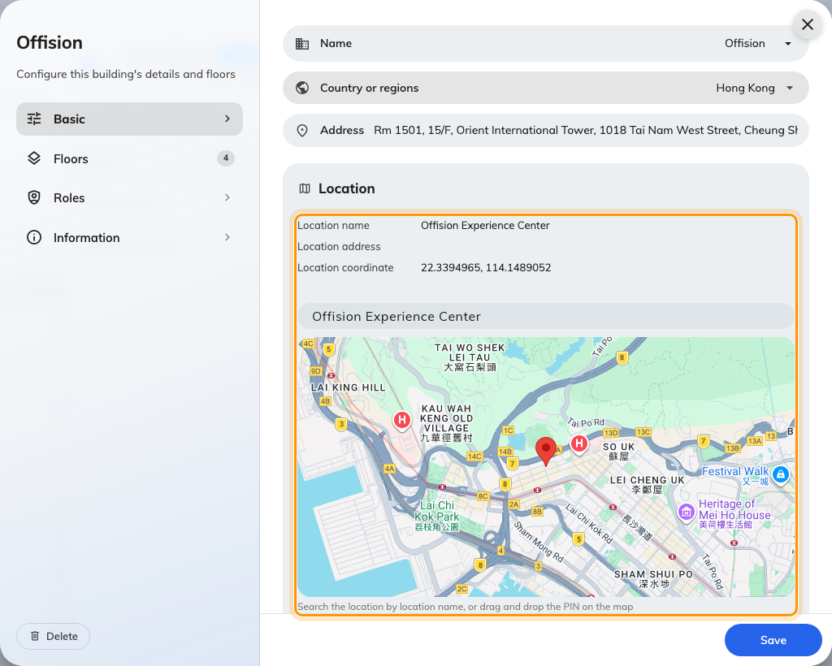
The map block: what it stores, and the two ways to change it.
The three rows above the map are a read-out, not fields. There are exactly two
ways to change them:
- Search the place by name. This is the one to use. It stores the venue's
own name in Location name, its address, its coordinates, and the local
spelling of the city and country for anyone reading in another language. It
also fills in the building's Country or regions for you.
- Drag the pin. This clears Location name and replaces the address with
whatever the map reads back at the new spot. Use it to nudge a pin that landed
on the wrong side of a courtyard — not to move a building to a different
place, or you will lose the venue name and have to search for it again.
Coordinates cannot be typed in. If the map cannot find the venue, search for the
nearest address it does know and then drag the pin the short distance.

Where the location is used
The first two below break when it is missing. The rest simply get quieter and
less useful.

GPS check-in — the one that fails outright
Allowed distance on a resource policy is measured from the building's
location. There is no centre stored on the policy, so a building with no pin has
no centre, and every check-in for every resource in it is refused. The person at
the door is told they are too far away.
So that it is not invisible to you as well, the policy's GPS check-in page
counts the resources whose building has no location and names them on the spot.
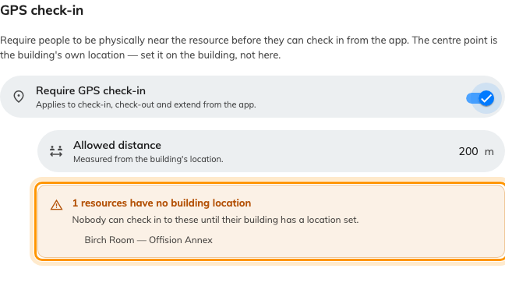
Allowed distance is measured from the building's location, and the page names the resources whose building has none.
Before turning GPS check-in on:
Pin every building the policy's resources sit in. The rule is enforced from the
moment you save it.

The building's time zone
Worked out from the coordinates, and shown on the building with Detected from
the map location underneath it. There is no time-zone field to correct it with.
A building pinned on the wrong side of a city border keeps working. A building
pinned in the wrong country runs every booking in it on the wrong clock, and
nothing on screen looks broken.
Select the building in the list and its panel says the same thing, so a site's
zone can be checked without opening the editor. A business hour overrides it for
the rooms it covers, and a building with no pin and no business hour falls back
to the system zone — see
Which time zone applies.

On room panels and signage
A room panel takes its clock from the building its room is in. A screen takes
its weather from the building it stands in.
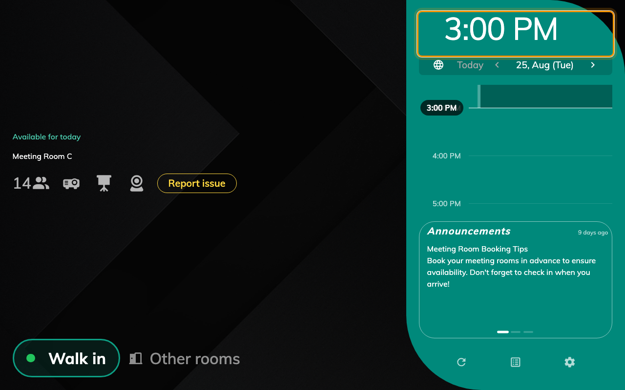
The clock on a room panel is the building's time, not the device's.
Without a pin both fall back to the device: the panel shows whatever clock the
hardware is set to, and the screen shows the weather for the city its network
appears to be in. That is usually right, which is exactly what makes it hard to
notice when it is not.

On a visitor's badge
A visitor's badge lists the buildings they are expected at. Under each one is
the map's Location name, and beside it a View map link.
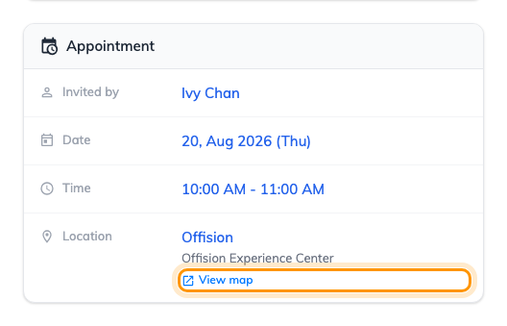
A visitor's badge. View map opens the pin, not a text search for the address.
This is the surface where the pin earns its keep most often: a visitor standing
at the wrong entrance of a large site opens the map and walks. It is also why
pinning the venue rather than the street matters — the link opens the place you
chose, so a pin on the tower lobby sends them to the lobby and a pin on the
street sends them to the street.
The same link is on the pre-registration confirmation the visitor sees after
registering.

In email and calendar invitations
Booking confirmations, changes and cancellations. Visitor invitations, approval
results and cancellations. The visitor badge mail, and event registration and
reminder mail. All of them carry a location line whose address is a link, and the
link opens the pin.
The same link is written into the calendar invitation itself, so it survives into
Outlook and Google Calendar and is still there when someone opens the meeting on
a phone.

At an event
An event's location is one of your rooms, one of your buildings, or a place that
is not yours at all. Where it is one of your buildings, the map link on the event
page and in the registration mail is that building's pin. An outside venue
carries a pin of its own, set on the event rather than here.

On the building card
Clicking a building's name — in a list, on a booking, on a visiting record —
opens a card carrying Google map location name and a link out to the map. In
the user app that card embeds the map itself.
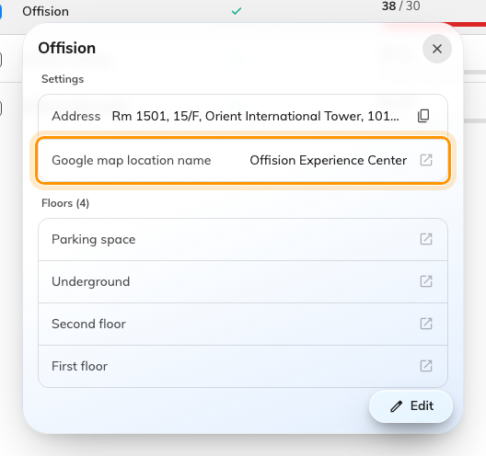
The building card. Google map location name is the map's value, not the typed address.

What it does not control
The floor plan. Show on map on a floor opens the drawing people click to
find a room. That is a picture you upload, and it has nothing to do with the
building's coordinates.
Attendance geofences. Clock-in areas are
a separate list on the working schedule,
each with its own centre and radius, and the building's pin is not one
of them. They also behave the other way round: a working schedule with no
geofences allows clocking in from anywhere, where GPS check-in with no pin
allows nowhere.
Whether a room can be booked. Nothing in this block restricts who may book,
when, or for how long. Those live on the resource policy.
Where in Offision: admin app → directory/location (Locations)

