How sign-in security works
Two screens decide how people get in — the password policy and security profiles. Which rules bind an Offision password, and which bind everyone including Microsoft 365 and Google sign-ins.
2026-08-17 · https://offision.com/help/en/directory/how-sign-in-security-works/
Two screens under Security decide how people get into Offision. Global
password policy sets the rules for Offision passwords and what happens when
someone gets one wrong. User security profiles set where a person may sign in
from, whether they need a second factor, and from which IP addresses.
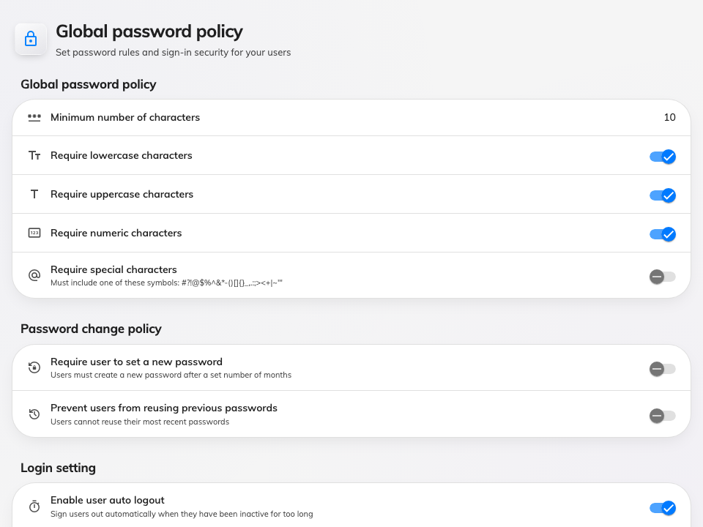
Global password policy — the rules for Offision passwords.

The part that surprises people
Signing in with Microsoft 365 or Google skips the password policy entirely.
No lockout after failed attempts, no expiry, no reuse check, no two-factor prompt.
The same is true of an LDAP or Active Directory sign-in.
That is not an oversight. There is no Offision password in those sign-ins to hold
to a rule — the identity provider checked the credentials before Offision ever saw
the person, and it is the one enforcing lockout and multi-factor. Setting
Maximum failed login attempts to 3 does nothing for a company that signs in
entirely through Microsoft 365, and the place to set that rule is Microsoft's
console, not this one.
So the password policy is worth setting when some or all of your people sign in
with an Offision password. Where everyone uses single sign-on, it is inert.

What binds everyone
Three things apply to every person, however they signed in.
IP restriction on a security profile is recorded, but nothing applies it
yet: a person outside the range still signs in. Treat the field as a note of
intent until a release says otherwise — a network that must be closed to
outsiders is closed at the firewall or the VPN, not here.
The platform toggles — desktop browser, mobile browser, the mobile app, the
Outlook and Teams add-in — are checked by the app itself when it opens, not by
the server. Someone on a blocked platform is told why and signed out.
Auto logout ends a session after that many minutes without touching the
keyboard or screen. It runs in the app, so it applies wherever the person came
from.
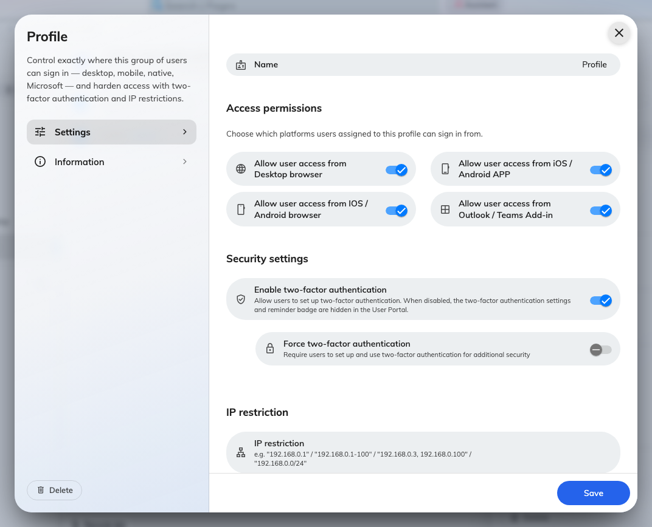
A security profile: where these people may sign in from, two-factor, and IP restriction.
Security profiles are assigned per person, and one profile is the default that new
people get.

What it does not control
None of this ends a session that is already running. Changing the password
policy, adding an IP restriction, or turning a platform off governs the next
sign-in and the next request — a person already signed in stays signed in until
their device is signed out. That is Login devices,
and it is a separate job.
Who may see or do what is permissions, not security. A profile decides where
someone signs in from, never what they can reach once inside.
The Windows app follows the Desktop browser toggle from 4.5.9. Before
that it was not covered by any of them, so a profile that blocked desktop
browsers still let the Windows app in.
Where in Offision: admin app → directory/password-policy (Global password policy)

