How access cards work
A card number is a name Offision knows a person by, and it belongs to one person across the whole account. What the seven card types are, which of them you issue and which arrive on their own, and what a card never decides.
2026-09-04 · https://offision.com/help/en/directory/how-access-cards-work/
A card number is simply a second name Offision knows somebody by. Tap a card at a
panel and the panel reads a number off it; if that number is stored against a
person, everything that follows happens as that person.
The surprising part is what the number is. On an ordinary MIFARE, NTAG or DESFire
card there is nothing printed on the card that Offision will ever see — what
the reader sends is the chip's UID, in hexadecimal. Only an HID Global card read
by an iAdea panel supplies its own encoded number, which is the one on the front.
Enrol one card, tap it, and read what was accepted before you type in five
hundred.
Where in Offision: admin app → directory/access-card (Access cards)

One number, one holder
A card number belongs to one person across the whole account, and Offision will
not let two people hold the same one — a second attempt is refused with Card
number already exists. Upper and lower case do not matter, so a number enrolled
either way still matches.
That rule is per number, not per person: one person may hold several cards, and
giving somebody's existing number to a different slot on the same record moves it
there rather than duplicating it.

The types
Every card is one of seven types, and the list shows them all together.
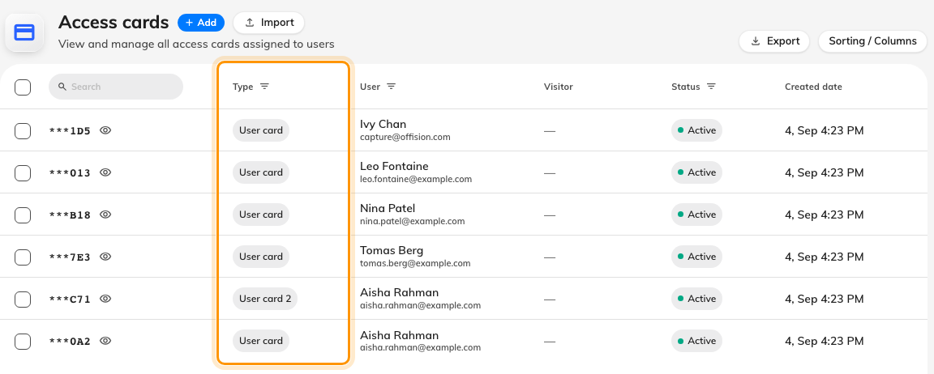
Every card in the account, whoever it belongs to and whatever issued it.
Type | Where it comes from
User card, User card 2, User card 3 | You issue them — three plastic cards per person
User mobile pass | Created when somebody adds their pass to Apple or Google Wallet
External sync card | Written by an outside system; read-only on the person's record
Visitor mobile pass | Issued with a visitor's badge, and shown against the Visitor column
Visitor card | Legacy. Nothing issues one today

The person's own record calls the first three User card 1, User card 2 and
User card 3; the list calls the first one just User card. Same slot.

Active, expired, and what is on screen
Status is worked out from the Expired date, not stored: a date in the past
reads Expired, and a card with no date stays Active for good. Nothing on
this page sets that date — it arrives with the badge or pass that created the
card.
Card numbers are masked to their last three characters in the list, with a reveal
control on each row, so the page can be shown on a projector without handing out
credentials.
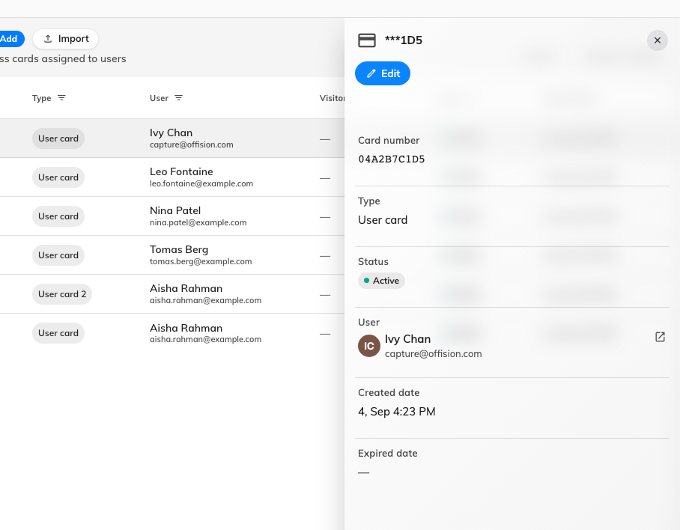
One card: its number, its type, who holds it, and when it was created.

What a card does not decide
- Which doors open. A card says who you are; what that person may open comes
from them and their groups. Offision does not push card numbers to a
door-control system.
- Whether a panel accepts cards at all. That is a check-in method, set in
Booking — see Check in by tapping a staff card.
- What anyone may book. A card gets somebody into a booking they already have.
- Signing in. Cards are read by panels. Nobody signs in to Offision with one.
Deleting a card leaves no record:
A deleted card is gone: there is no recycle bin for one and nothing about it
reaches the audit trail. The only evidence a card ever existed is the Created
date on the row while it is still there — so take the number down before you
delete it.

