Create a user group and add people to it
Group people so permissions, room access and quotas are set once instead of per person. Covers naming, the permissions a group grants, and the two ways to add members. About five minutes.
2026-08-17 · https://offision.com/help/en/directory/create-a-user-group/
Before you start:
You need an account that can manage users, and the people you want to group
should already exist — see Add people to Offision.
A user group is how one decision covers many people. Permissions, which rooms a
team may book, how much quota they share, which doors open for them, who receives
an announcement — every one of those can be pointed at a group instead of at a
list of names you maintain by hand.

1. Open the group list
Directory › User groups. The list carries the four things worth knowing
about a group at a glance: its Category, its Permissions, its Users,
and its name.
Where in Offision: admin app → directory/user-group (User groups)
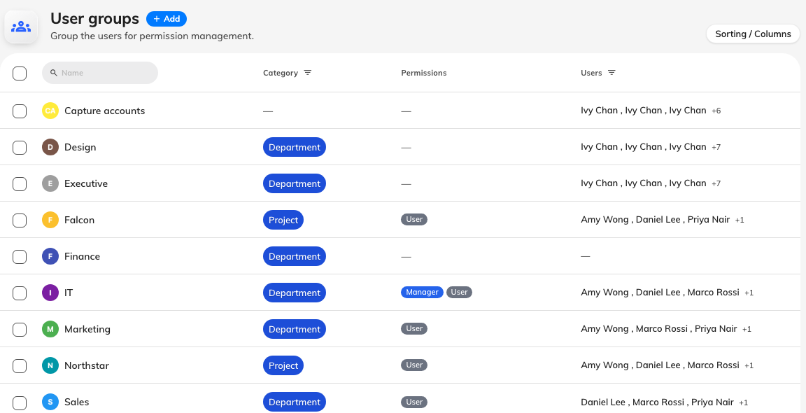
One row per group, with the permissions it grants and who is in it.

2. Add the group
Add opens a dialog with Basic, Permissions and Information down
the left.
On Basic, only the name really matters. Two things about it:
- Name it after something that outlives its members. "Finance", "Reception",
"Floor 12" survive reorganisation; "Amy's team" does not.
- The name must be unique, and it is checked as you type rather than on save.
User group categories is optional and can be left alone for now — it sorts
groups and decides whether people ever see this one in the Offision app. That is
Sort user groups into categories. It is
the field behind the list's Category column.
Branch management appears here only where branches are enabled, and scopes
the group to one branch of the organisation.
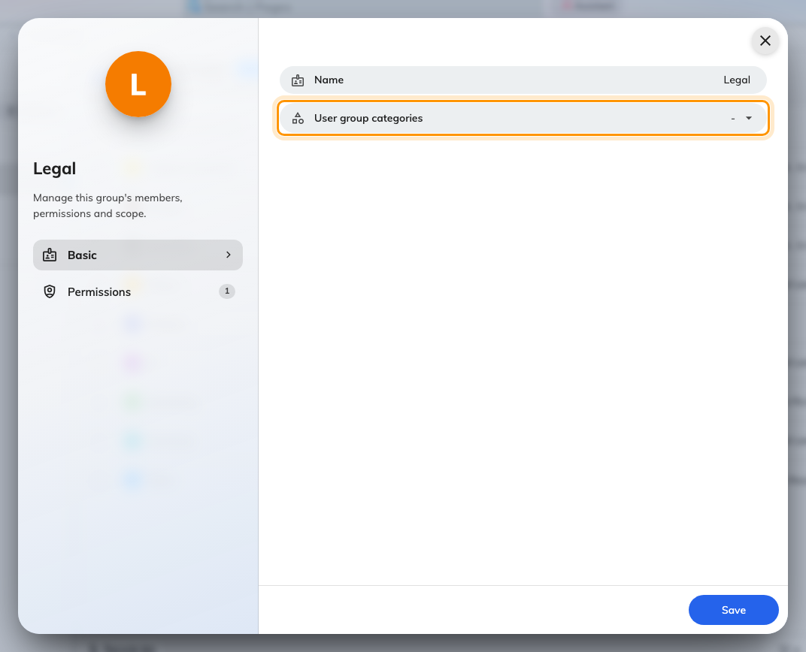
The Basic page. Category is optional; the name is not.

3. Decide what the group grants
The Permissions page is the part with consequences, and it splits in two.
User Portal access right is the single switch User — permission to book
resources through the app and the door panels. It is on by default, and it is
the right answer on its own for most groups, including every group that exists
only to name a department.
Management console access right is everything else, listed with a Read
and a Write column, so a group can be given sight of a module without the
ability to change it. A group cannot grant Global administrator; that one is
only ever set on a person.
The thing that catches people out is that permissions add up. A person keeps
whatever they were given directly, and gains everything from every group they
belong to. There is no way for a group to take a permission away.
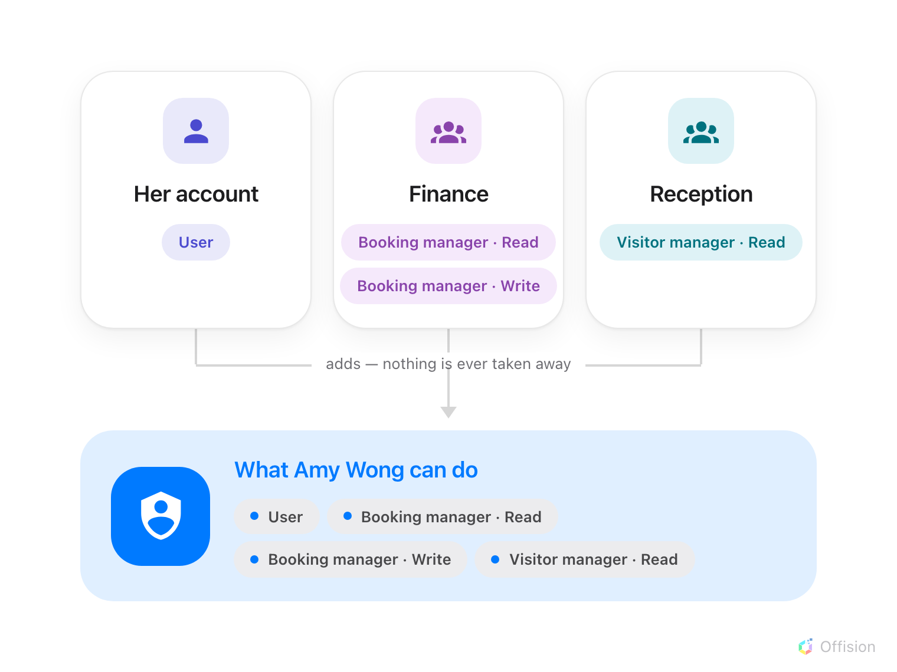
A person's permissions are their own plus every group they are in — so taking a permission away means finding every group that grants it.
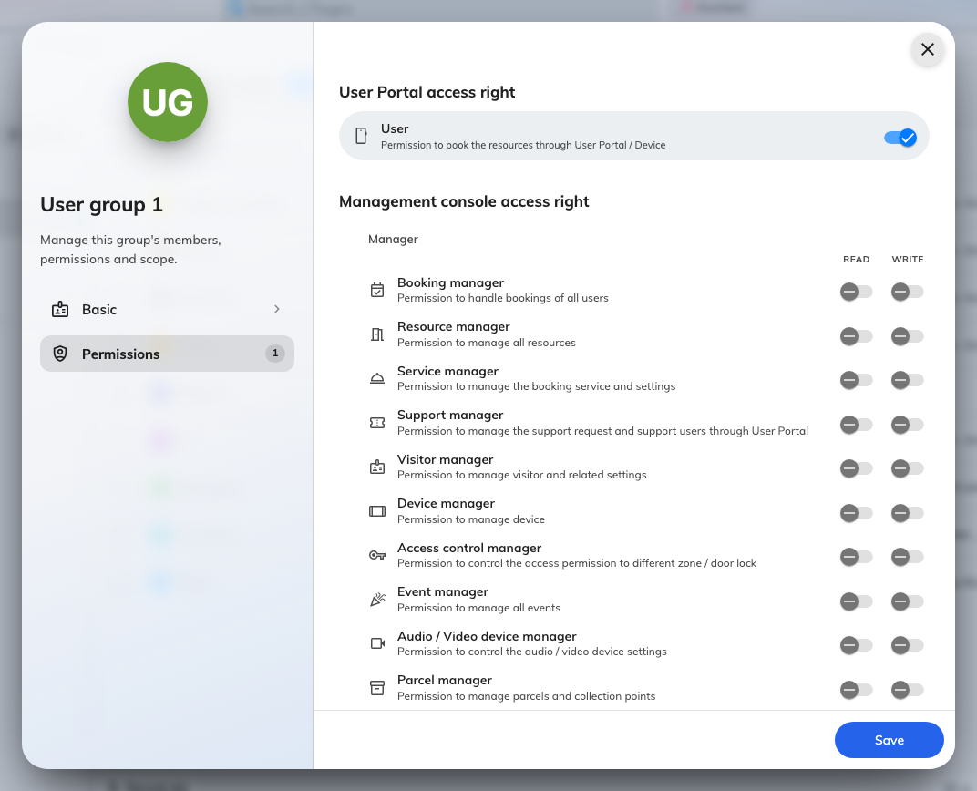
Most groups need only User. Manager roles come in Read and Write pairs.

4. Put people in it
Two ways in, and they write the same thing — use whichever matches what you are
holding.
Many people into one group. Select the group in the list, then click the
Users row in the panel on the right. Batch set users searches by name,
email or card number, and what you leave selected when you save is the
membership — anyone you clear is removed.
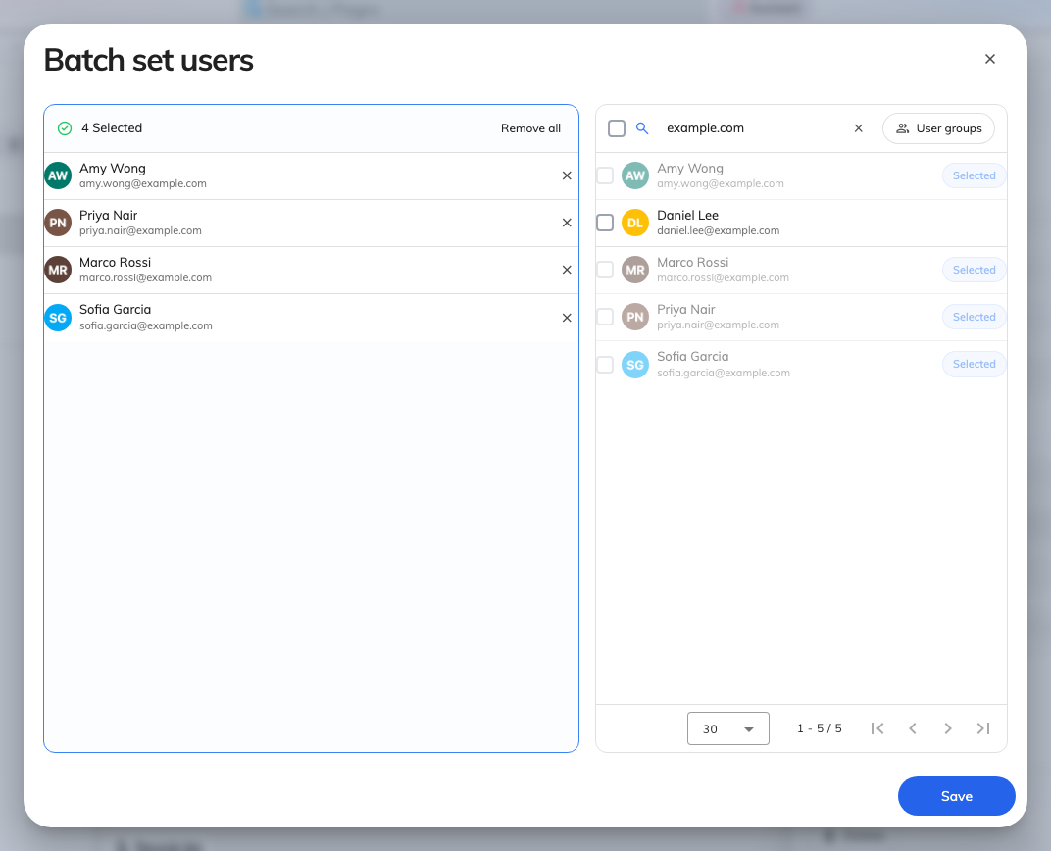
Batch set users. The selection you save replaces the whole membership.
One person into many groups. Go to Directory › Users, select them,
and click the User groups row in their panel. This is the one to reach for
when somebody moves teams.
Where in Offision: admin app → directory/user (Users)
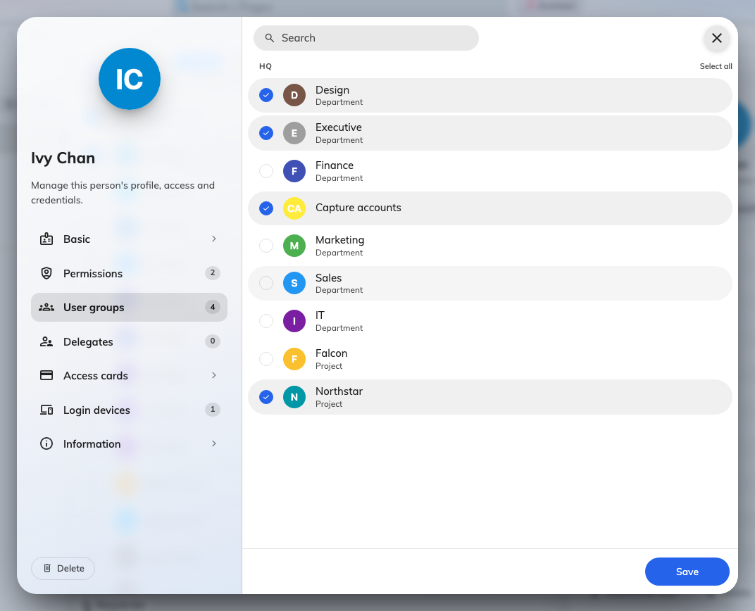
The same membership from the person's side, when someone changes team.

5. Point something at the group
A group on its own does nothing but hold permissions. It earns its keep when
other screens reference it:
- Rooms only one department may book — a team space naming the group. See
Give a department its own rooms.
- A shared booking allowance — a user group quota policy spends from one pool
for the whole group rather than per person.
- An audience — announcements, activities and lobby boards all take groups
where they ask who something is for.
- New starters, automatically — if you sync people from Microsoft 365 or
Google Workspace, the default native user group is the group every newly
synced account joins. See
Sync people from Microsoft 365.

6. Check it worked
Reopen the group and read the Users count in the panel — it should match what
you selected. Then ask one member to sign in: if the group grants a manager
permission, the module appears in their menu; if it only grants User, the
change is invisible to them, which is correct.
Note:
A group never decides whether someone can sign in, only what they can do once
they are in. Sign-in is the password policy and security profiles — see
How sign-in security works.

