Add a building and its floors
Create the building your rooms and desks will sit in, then list its floors. The time zone comes from the map pin, not from a field. About five minutes.
2026-08-25 · https://offision.com/help/en/directory/add-a-building-and-its-floors/
Before you start:
Nothing has to exist first — a building is the bottom of the stack. Adding more
than one building depends on your licence, so if Add is missing on a tenant
that already has a building, that is why.

1. Open Locations
Buildings and floors live under Directory, not under Booking.
Where in Offision: admin app → directory/location (Locations)

2. Fill in the building
Add opens an editor with its pages down the left: Basic, Floors and
Information, plus Roles if your tenant assigns any. Everything in this
step is on Basic.
Name takes one value per language your tenant has enabled. Fill in every one
of them. A name left blank in Japanese falls back to English, so the building
shows up in English inside an otherwise Japanese screen — which reads as a bug
long before anyone thinks to look here.
Country or regions and Address are what they look like. Branch
management is optional and only appears if your tenant uses branches.
Access ID sits last, deliberately. It is the handle a spreadsheet uses to
name this building on import — leave it blank if the building should not be
importable, and note that it has to be unique across the tenant.

3. Drop the map pin
This is the step worth slowing down for. Under Location you place the
building on a map, and underneath the map a line appears reading the time zone
followed by Detected from the map location.
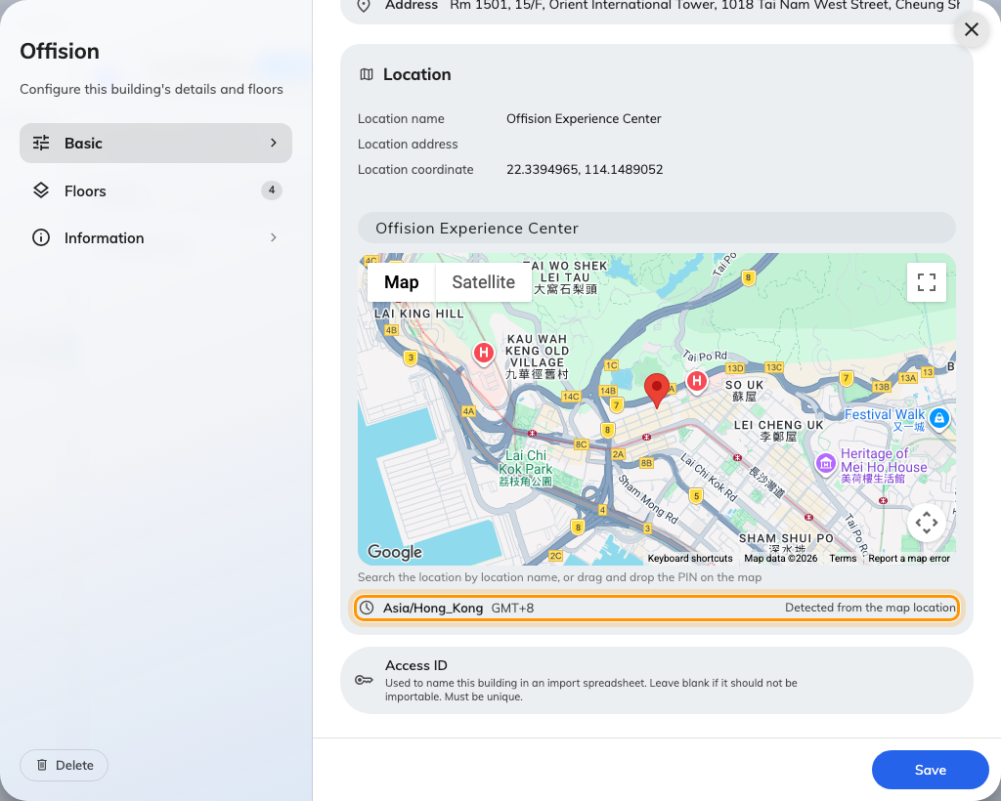
Under the map: the time zone the pin produced, and where it came from.
There is no time-zone field, and the read-only line is not a suggestion. It
is the building's actual time zone, worked out from where the pin is. Move the
pin and it changes. Leave the pin off and the building has no time zone at all,
and falls back to the system one.
So a building on the wrong side of a city border keeps working, but a building
pinned in the wrong country quietly runs every booking in it on the wrong clock.
Place the pin properly rather than approximately.
The time zone is not the only thing reading it — the pin is also the centre of
the GPS check-in area and the link inside every booking and visitor email. What
the block stores, and everywhere it ends up, is in what a building's Google map
location is used for.

4. List the floors
Open Floors. It is a single list — one row per floor, with the floor's
position on the left and its name on the right, and Add floor at the bottom.
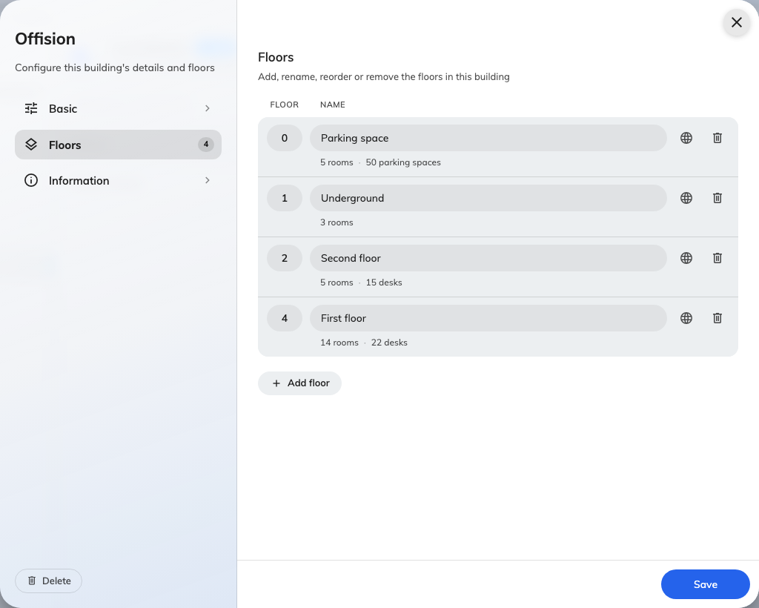
One row per floor: position on the left, name on the right.
Three things about that list are not visible on it:
- The number on the left is what orders the floor, not the name. Ground
floor, 1/F, 2/F sort by the numbers you type, so a mezzanine or a basement goes
where you number it rather than where it sorts alphabetically.
- Two floors may share a number, and the row says so — Shares order 3 with
another floor. It is a warning, not an error, and it will save. Renumber
anyway, or the two floors come back in an arbitrary order everywhere else.
- A row left blank is dropped when you save, rather than blocking the save.
If you added three rows and only named two, you get two floors and no warning.
The globe button on a row opens the floor's other languages — the same rule as
the building name applies, and floor names are short enough that there is no
excuse for skipping them.
Under each existing floor is a line saying what is on it — 14 rooms · 22
desks, or Nothing on this floor. Read it before deleting a floor: that is the
only warning you get about what the floor is carrying.
Save when you are done. One save covers Basic and Floors together.

5. Check it worked
Go and add a room, or open one you already
have, and look at its Location field. The new building should be offered
there with its floors underneath it.
Where in Offision: admin app → booking/room (Standard Rooms)
If the building appears but has no floors under it, the floor rows were blank
when you saved.

What this does not cover
A floor plan is not a floor. The floors here are a list of names; the drawing
people click on to find a room is made separately under Map — see
Create a map for a floor. A floor works
perfectly well without one; you simply cannot place a resource on a picture until
the picture exists.
The building's time zone is not the system time zone, and which of the two
applies depends on what you are looking at — see
Which time zone applies.

