What Offision drives on each panel
The light bar, the card reader and the remote reboot, panel by panel — what Offision itself does with the hardware, which is not the same list as what the hardware has.
2026-08-30 · https://offision.com/help/en/devices/what-offision-drives-on-a-panel/
Which booking panel hardware Offision supports
is the hardware. This is the software: what the panel has, and what Offision
actually does with it. The two are not the same question — a Crestron panel has
no light bar in the box, and a Qbic panel's built-in card reader only reads a
card when the panel is running the Offision Android app rather than showing the
panel in a browser.

What each panel can do
Panel | Light bar | Card reader | Reboot
Crestron TSS / TSW | Accessory | USB reader | —
Qbic, Offision app | Seven colours | Built-in NFC | Yes
Qbic, browser | Seven colours | USB reader | Yes
IAdea, Offision app | Seven colours | Built-in NFC, HID Global | Yes
IAdea, browser | Seven colours | USB reader | Yes
Neat Pad | Green, red, one custom | USB reader | —
Cisco Room Navigator | Five of seven | USB reader | —
Android tablet, Offision app | — | Built-in NFC, if the tablet has it | —
iPad, Windows, browser | — | USB reader | —

A Neat Pad is the only panel that opens its own device settings from the
Offision console. Everywhere else, brightness and the network are the vendor's
own settings screen.
The two rows Qbic and IAdea each get above are one panel set up two ways, and
the card reader is not the only thing that changes between them — uploaded
video and the label printer go the same
way. What that choice costs, per brand,
is in Qbic: app or browser and
IAdea: app or browser.
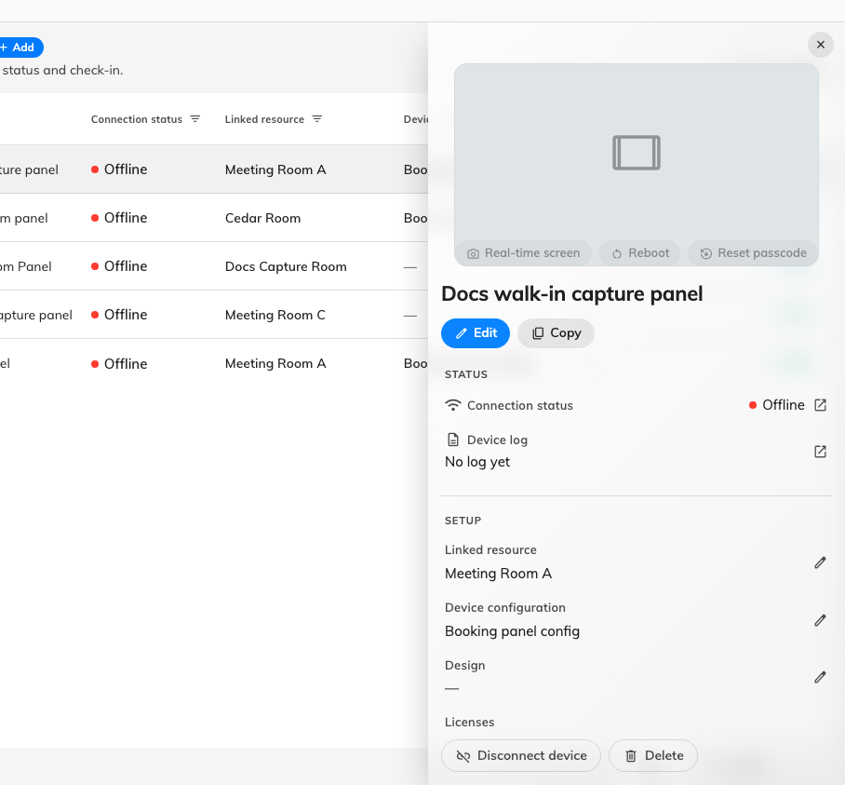
A paired panel's record: the room it shows, the configuration it follows, and the actions Reboot and Reset passcode.

What the columns mean
HID Global cards carry a facility code as well as a serial, and the two
vendors differ on what comes back. An IAdea panel decodes the facility code and
card number. Every other panel — a Qbic H model included — reads the card's
serial number instead, which is not the number printed on it. Enrol one card and
tap it before you import the rest.
Light bar is what Offision drives, not merely what the hardware has. Seven
colours means the panel reproduces the whole palette. Accessory means the
panel has no bar of its own and takes a Crestron light bar or hallway sign over
USB. A Cisco Room Navigator shows yellow where the palette says orange and blue
where it says cyan; a Neat Pad has one custom colour for everything that is
neither green nor red. See
What the panel colours mean for the colours
themselves.

