Let somebody take a free room at the panel
Somebody is standing at a free room and wants it now. Turning the Walk in button on takes a minute; what it then asks for, how long it grants, and the five reasons the button is not there are the rest of this page.
2026-08-18 · https://offision.com/help/en/devices/walk-in-at-the-panel/
A free room offers Walk in. Whoever presses it gets the room from now until
the length they pick, without opening anything — and because they are standing at
the door, a walk-in never needs checking into afterwards.
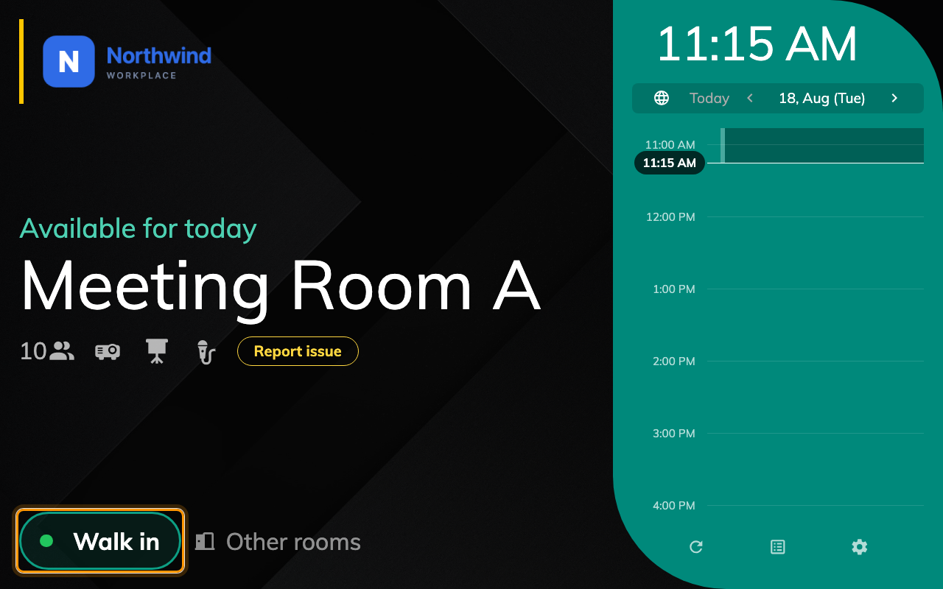
Walk in, on a free room. A room in use offers End now and Extend instead.
Before:
A room whose policy allows booking from the booking panel, a panel already paired
to it, and at least one identification method switched on.

1. Turn the button on
Show walk in button is in the panel configuration's Use a booking group,
on its Room booking panel page. It is
per configuration, so it lands on every panel sharing it — see
How a panel gets its settings.
Where in Offision: admin app → device/booking-panel/configuration (Panel configurations)
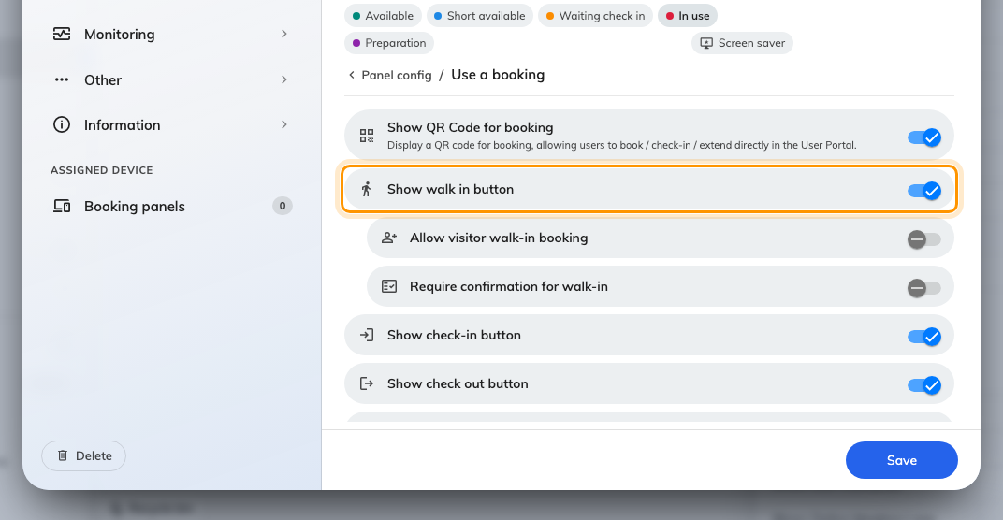
Show walk in button, with the two toggles that appear underneath it.
Two more appear underneath it once it is on:
- Require confirmation for walk-in — a last screen where the person can name
the meeting and say how many are coming. Turning it off makes the whole thing
one tap plus identity.
- Allow visitor walk-in booking — lets somebody who is not a member of staff
take the room, by identifying as a visitor rather than a user. Needs the
Visitor management licence.

2. Decide how long a walk-in may hold the room
This is not a panel setting — it is the resource's policy, and it is worth doing
before anyone finds the button. Three rows there shape a walk-in:
- Limit the booking time length for walk-in booking — a separate, usually
shorter pair of limits than the room's normal ones.
- Disable booking approval for walk-in booking — so somebody at the door is
not left waiting for an approver.
- Walk-in Only, as a booking type — the room cannot be booked in advance at
all. Right for touchdown desks and phone booths.
All three are documented in
Resource policy settings.

3. What the person at the door sees
Tapping Walk in opens the duration picker: a column of lengths, each showing
the time it would end at, with a Duration / Time switch above them. It
only ever offers what the room can actually give — the list stops at the next
booking, and the row underneath says when that is.
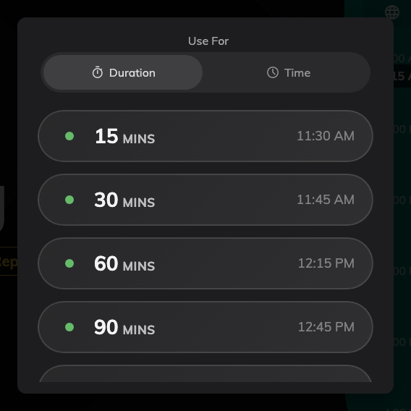
The lengths the room can give, ending before whatever is booked next.
The panel then asks who they are. What it asks for is its own subject —
How somebody proves who they are at the panel —
and it is also where the option of asking for nothing at all lives.
Last comes the confirmation screen, if you left Require confirmation for
walk-in on. Anything not filled in here is left alone: the booking is titled
Walk in booking and counted as one attendee.
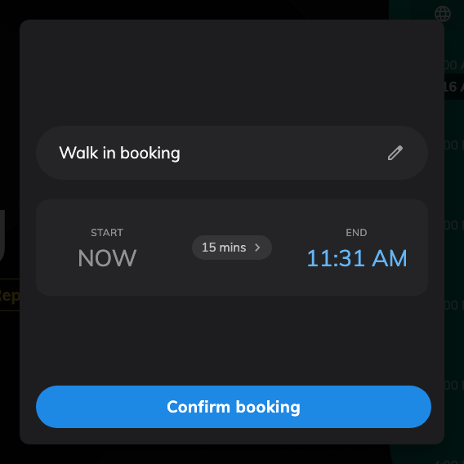
The confirmation screen. With the toggle off, this step does not appear at all.
Rooms that ask for terms and conditions put that screen before the identification
step, and a walk-in cannot skip it.

4. Try it
Stand at a free room, tap Walk in, take fifteen minutes. The panel should go
straight to in-use — no check-in step — and the booking should appear in the room's
calendar under your name, or with no organiser if you identified as nobody.

When the Walk in button is not there
Five different things remove it, and only the first is a panel setting:
- Show walk in button is off on that panel's configuration. So is
Touch screen mode, which hides every button on the panel at once.
- The resource policy has Allow booking from booking panel and signage off.
- The resource policy requires booking at least a day ahead. A room nobody may
book for today cannot be walked into today.
- The next booking starts within five minutes. The button disappears rather
than offering a room somebody is about to walk into.
- The room is not free. Walk in exists only in the free state; a room in use
shows End now and Extend, and a room waiting for somebody shows
Check in.
A busy room can still find you one:
Where the button is missing because the room is taken, Other rooms is the
answer instead — see Finding another room from the panel.

