Let people book at the panel without signing in
A phone booth nobody has to identify themselves to use. How to leave Allow anonymous as the only method on one panel, what the person then taps, and which actions still ask for a credential whatever the setting says.
2026-08-21 · https://offision.com/help/en/devices/use-directly-at-the-panel/
A phone booth is not worth signing in for. Somebody wants it for four minutes,
and asking them to find their phone, open the app and scan a code is how a room
ends up unbooked and occupied anyway.
A panel can be told to ask for nothing. Allow anonymous adds a Use
directly option, and where it is the only method left on that panel there is
nothing to choose between — the panel books the room without ever asking. What
remains is Walk in, a length, and the room is theirs.
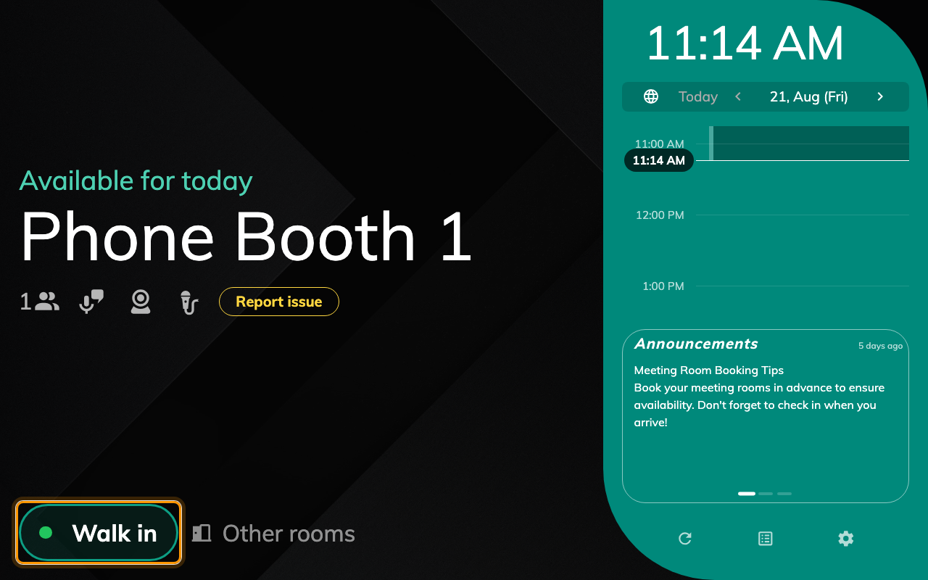
A free phone booth. One button, and nothing behind it that asks who you are.
Before:
A panel already paired to the room, and a resource policy that allows booking
from the booking panel.

1. Give these panels a configuration of their own
Anonymous suits a phone booth, a touchdown desk and almost nothing else — and a
panel configuration is shared by every panel assigned to it. Put the booths on
their own configuration before changing anything, or the meeting rooms stop
asking too. How a panel gets its settings covers
making one.
Where in Offision: admin app → device/booking-panel/configuration (Panel configurations)
Select the configuration in the list and open it; everything below is a page of
that one dialog.
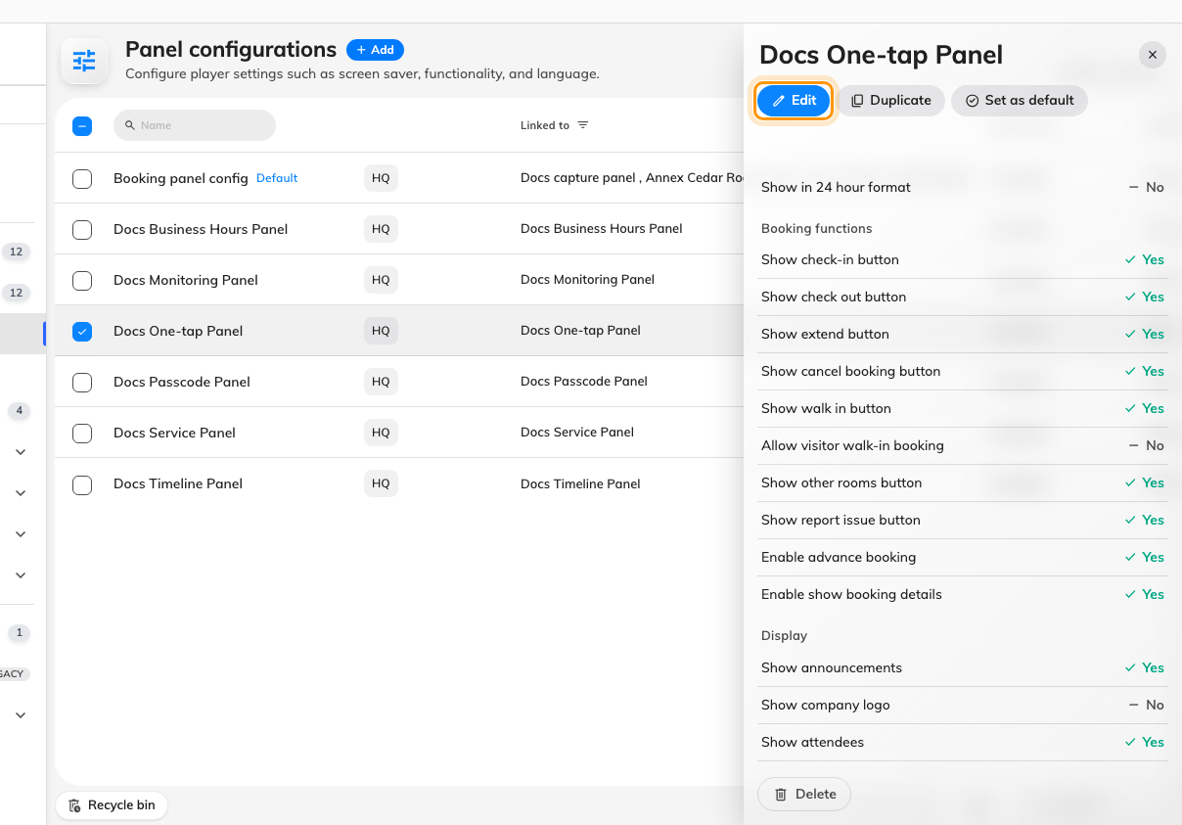
Selecting a configuration, and the action that opens it.

2. Leave Allow anonymous as the only method
Open the dialog's Check-in method page and turn on Override the system
user identification settings. Until that is on, the panel simply follows the
organisation-wide User identify settings, where there is no anonymous option
to find.
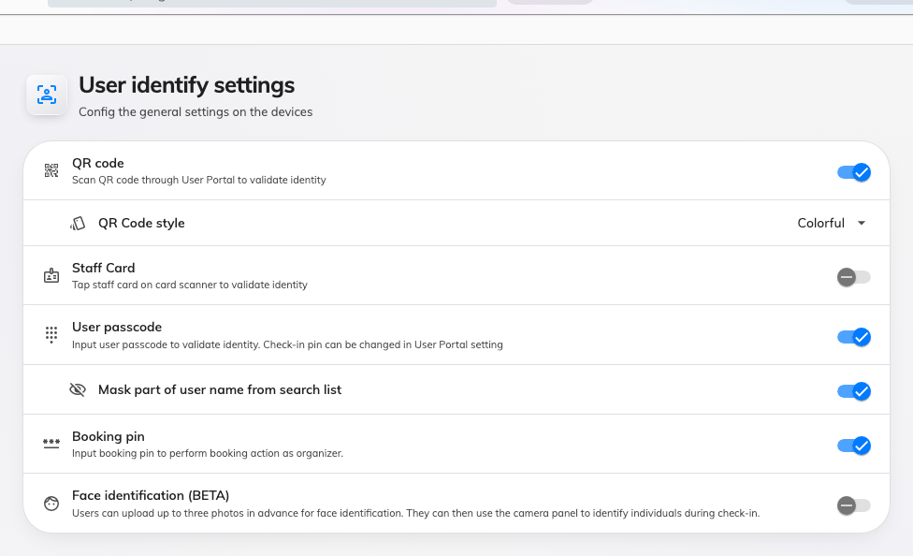
User identify settings — the organisation-wide default the override replaces.
Then turn every credential off — QR code, Staff Card, User passcode, Face
identification — and turn Allow anonymous on.
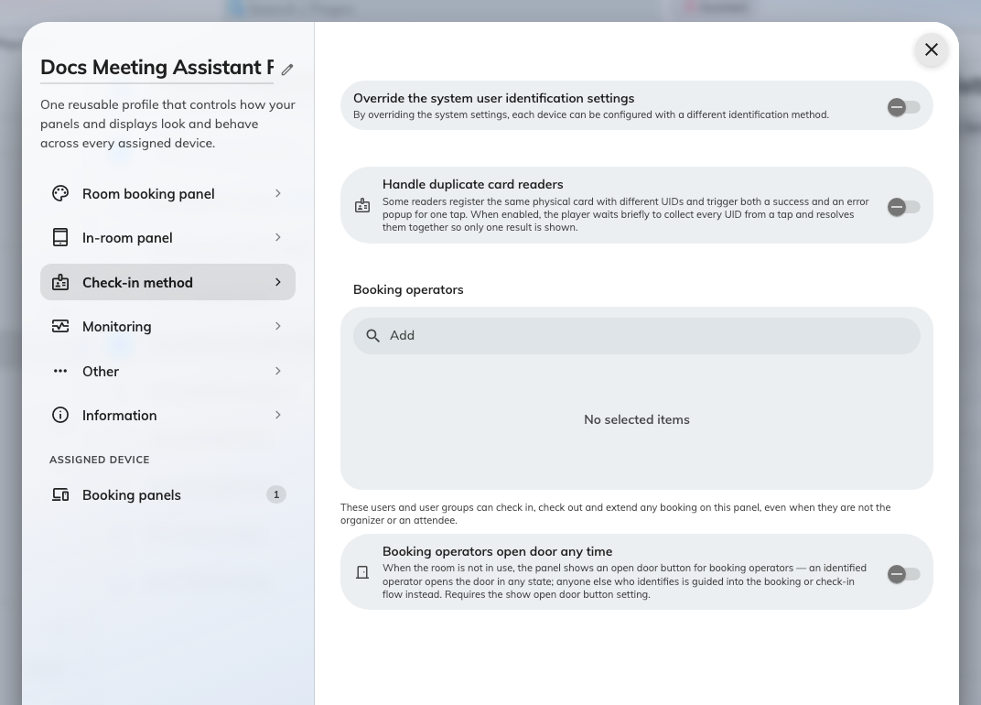
Nothing left but Allow anonymous, which is what removes the question entirely.
That last toggle is doing two jobs. It is what offers Use directly, and it is
also the only reason the panel still works at all: a panel with no method
whatsoever refuses the action and says so. Leave one credential on beside it and
the reader gets a chooser with two options instead of a room — which is fine, and
is what How somebody proves who they are at the panel
describes, but it is not one tap.
The screen's own reminder:
The page carries a line worth repeating: the user passcode and booking PIN are
configured in the user identity settings and cannot be overridden on an
individual device. Booking pin is not on this list at all — a panel takes it from
the organisation-wide screen whatever its configuration says.

3. Make the booking itself one tap
In the Use a booking group, Show walk in button puts the button on a free room.
Underneath it, turn Require confirmation for walk-in off: that screen is where
somebody names the meeting and says how many are coming, and neither question has
an answer when nobody is signing in.
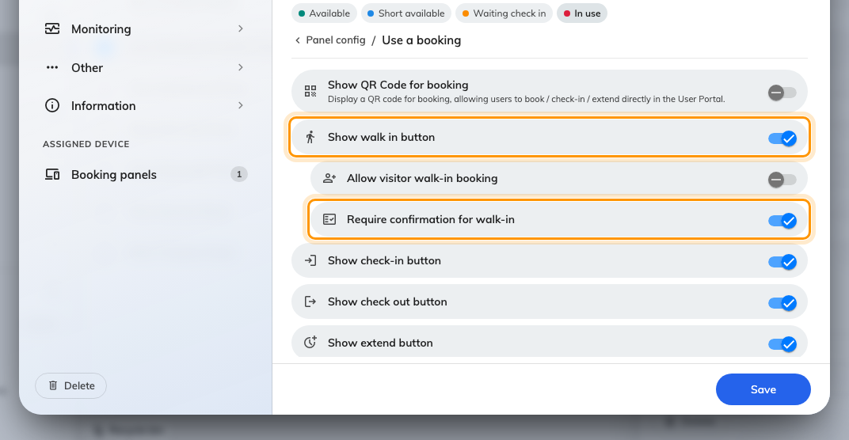
Show walk in button on, and the confirmation screen off.

4. Decide what the panel calls the booking
An anonymous booking has no organiser, and the panel has to print something where
the name goes. In the Booking details group, with Show Organizer on, Show
"Anonymous" when a booking has no organizer. chooses between the word
Anonymous and an empty space.
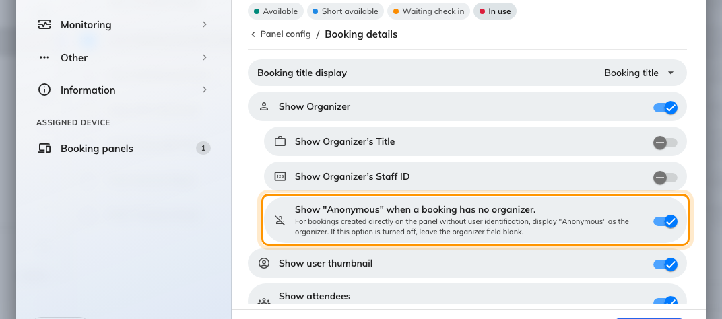
What the panel shows where an organiser would be.
Save. A shared configuration raises a confirmation listing every panel it lands
on — worth reading, since that is the list of rooms that stop asking.

5. Try it
Stand at a free booth and press Walk in. The only thing between the tap and
the room is the length:
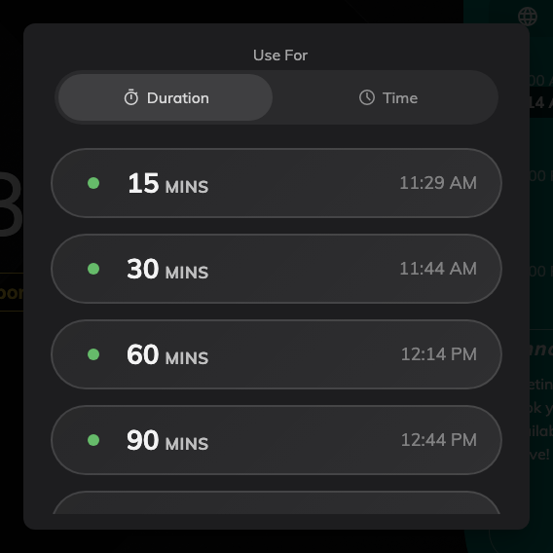
The lengths the room can give, ending before whatever is booked next.
Pick one, and the panel goes straight to in use. No identification screen appears
at any point, the booking is titled Walk in booking, and the organiser reads
Anonymous.
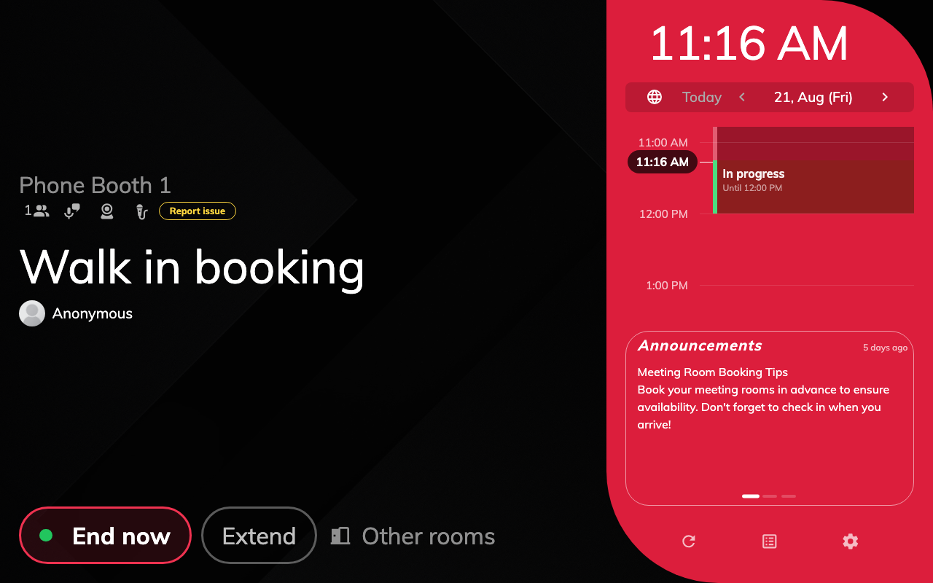
In use, with nobody's name on it.

What still asks for a credential
Allow anonymous applies to taking a room and nothing else. Walking in,
booking ahead from the panel, booking another room and taking a seat all offer
Use directly; checking in, checking out, extending, cancelling and opening a
door never do, because each of those acts on somebody else's booking.
This is worth knowing because the setting's own description says otherwise — it
reads "Allow booking, check-in, and check-out without user identification",
and check-in and check-out are precisely the two it does not cover. On a
one-tap booth it rarely matters: a walk-in is already checked in, and End now
is the button people reach for.
If you need those actions to skip identification too, that is a different
setting on the room's booking rules — Skip user verification in booking panel,
listed in Booking rules reference.

What this does not control
- Who may book the room. Identification and permission are separate
questions; a room nobody may book from a panel stays unbookable however little
it asks for.
- Which buttons the panel offers. That is the configuration's Room booking panel
page — see Let somebody take a free room at the panel.
- The door. Where a panel drives a lock, unlocking rides along with the
action; opening a door on its own still asks who is standing there.
- Any record of who took the room. There is none, and that is the trade. The
booking holds the room and names nobody, so nobody can be asked to give it back.

