The panel is too cramped on a small screen
An 8-inch panel draws the same layout as a 10-inch one, so the fix is showing fewer things rather than smaller ones. Five causes, starting with the schedule column that holds a third of the screen until somebody folds it away.
2026-08-25 · https://offision.com/help/en/devices/the-panel-is-too-cramped-on-a-small-screen/
Does the panel show a schedule down its right-hand side?:
The answer splits the page. Yes — the panel is on the standard layout, and the
first four solutions are all about giving that column's space back. No, it is one
column with no schedule anywhere — the screen is below the size at which the panel
changes layout, so go straight to solution 5, and expect the timeline settings to do
nothing there.
The panel is laid out in proportions of its own screen rather than in fixed sizes. An
8-inch panel and a 10-inch panel running the same resolution therefore draw
pixel-for-pixel the same screen — the 8-inch one is simply read from the same distance
at half the size. Nothing thins itself out for a smaller panel, so the only lever is
making it draw fewer things.
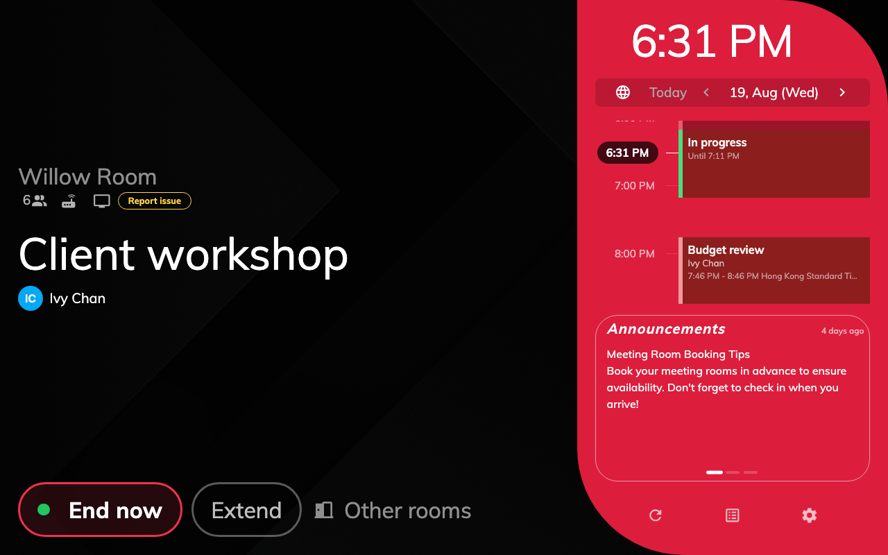
The standard layout. The schedule column holds about a third of the screen.
Solution 1 — The schedule column is taking a third of the screen (most common)
That column never drops below a quarter of the panel's width, and on a normal booking
screen it takes about a third. Everything the room actually has to say — its name, its
status, the buttons somebody came to press — is squeezed into what is left.
Turn on The timeline area is collapsed by default, the last switch in the
configuration's Timeline & clock group. The column folds into a narrow tap
rail, and the content pane widens from roughly two-thirds of the screen to
nearly all of it.
Where in Offision: admin app → device/booking-panel/configuration (Panel configurations)
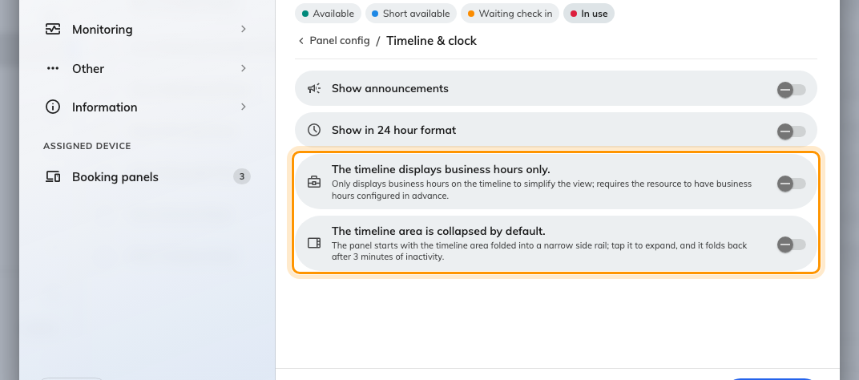
Timeline &amp; clock, with the two timeline switches at its foot.
Know what folds away with it. The clock survives, turned on its side in the rail, but
the language button, the announcements and the control bar go with the schedule. The
booking's own times are not lost — they move into the left pane while the column is
folded.
Anybody at the panel taps the rail to open it, and a chevron on its edge folds it back
by hand. Left alone it re-folds itself after three minutes without a touch, so a panel
somebody opened at nine is not still open at noon.
A panel mounted on its side does this without being asked: in portrait the column
starts folded whatever the switch says, because at that width it would be a sliver.
See Mount a panel in portrait.
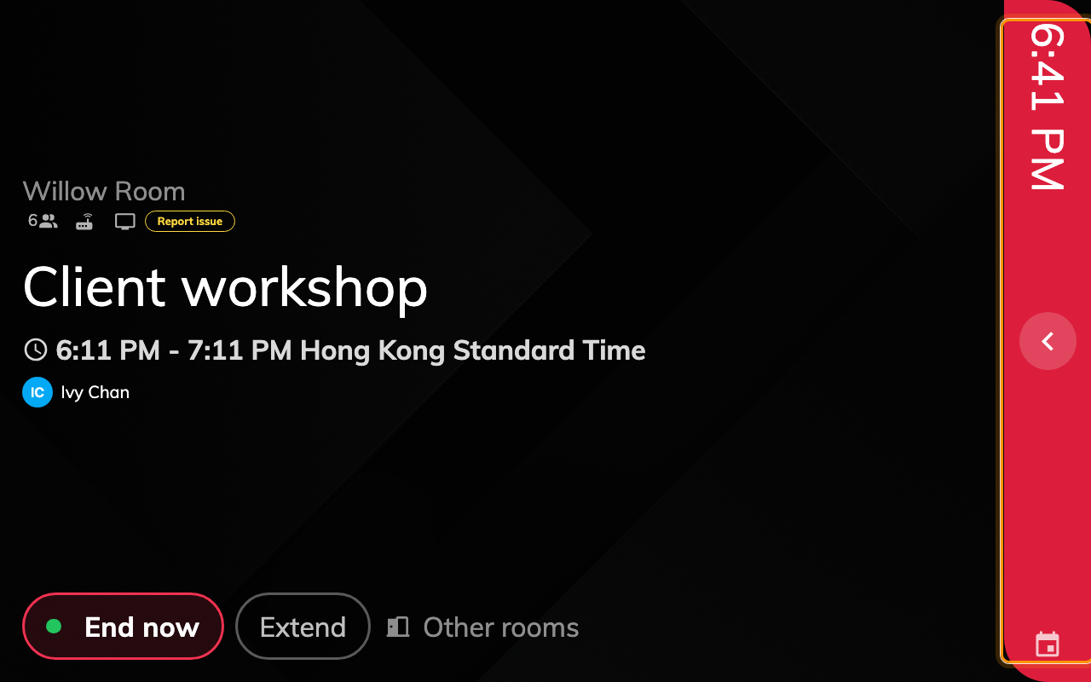
The same panel with the column folded into its tap rail.
Solution 2 — Every optional row is switched on (most common)
Room booking panel carries a switch for each thing the panel can draw, spread across
its Room details, Booking details and Timeline & clock groups, and they
arrive on: Show Organizer — with its own title and staff ID nested underneath —
Show attendees, Show user thumbnail, Show amenities and capacity, Show
Online Meeting Logo, Show announcements and Show company logo. Each is a
line the panel has to find room for whether or not anybody reads it.
Two of them cost more than their size suggests:
- Text size set to Large rather than Maximize holds the room's name at a
fixed size instead of letting it take the space it is given, which on a small panel
is how a long room name pushes everything below it down.
- Show QR Code for booking, over in Use a booking, pins a card to the corner
of the content pane and reserves its width permanently. The action buttons then wrap
onto a second row as soon as there are more than about three of them.
The button switches in Use a booking, Book from the panel and Door & extras
are the same trade — Show extend button, Show other rooms button, Show report
issue button and their neighbours each cost a button's worth of row. Turning off the
ones your rooms genuinely do not use buys back more room than any single display switch.
A configuration is shared, so this is not a choice you have to make for the whole
estate: leave the panels with space to spare on the configuration they are on, and give
the small ones one of their own.
Solution 3 — The schedule is drawing the whole day (common)
Left alone the column covers all 24 hours, so the working day occupies a third of it and
every booking in it is a thin band.
The timeline displays business hours only, immediately above the collapse switch
in Timeline & clock, narrows it to the hours the room is open, with an hour or two
of padding either side.
This one depends on something outside the panel: the resource has to have business hours
set. With none there is nothing to narrow to, and the switch changes nothing at all —
which is how it gets reported as broken. Set the hours on the room first, the same ones
that limit booking to business hours.
Solution 4 — The panel's display scale was set by hand (less common)
Change scale, in the manager console on the panel itself, magnifies the whole
interface on that one device. Set above the scale the panel chose for itself, a screen
that used to fit stops fitting, and because everything grows together it reads as a
layout fault rather than a zoom.
It is set on the device and not in the configuration, so this is the cause to suspect
when one panel is cramped and an identical one beside it is not. Open the manager
console on the panel and set the scale back to Auto, which carries a Recommended
badge and clears whatever was stored.
Auto is worth understanding, because it is not the same as 1. An Android panel reports a
display density of its own — a 1280 × 800 panel typically reports 1.5 — and at a scale of
1 the interface is laid out as though the screen were only 853 pixels wide, which is
narrower than the layout is designed for. Auto aims the long side at about 1280 pixels
instead, so the panel lays out at the resolution it actually has. Choosing 1 by hand on
such a panel is what causes the cramping rather than curing it.
Every row in the dialog states the layout resolution it resolves to, so the choice can be
read rather than guessed. The list runs below 100% as well as above it, down to the
panel's own 1:1 physical resolution — useful for fitting more on a dense screen. A panel
with no density headroom floors at 1 and offers the same list it always did.
Solution 5 — The screen is small enough to be a different layout (less common)
At 560 pixels wide or narrower, or under 480 tall, the panel stops drawing the standard
layout and switches to a compact one: a single column, one thing at a time, and no
schedule at all. Both timeline settings are inert there, because there is no column
left for them to act on.
That threshold is a screen size, not a physical one. An 8-inch panel running 1280 × 800
is nowhere near it and draws exactly the layout a 10-inch panel draws; the devices that
land on the compact layout are the small door plates and anything mounted in a frame
that narrow.
So when the complaint is that the 8-inch panels are cramped, this is not the cause —
solutions 1 and 2 are.
If none of these fit:
Collect these before opening a ticket. The first three separate a configuration problem
from a device one, which is the split that decides who can fix it:
- the panel's name and the configuration it is assigned to;
- the panel's screen resolution, and whether it is mounted landscape or portrait;
- whether the screen shows a schedule column at all;
- the display scale from the panel's manager console, and whether it is Auto or
was set by hand;
- a photograph of the panel as it stands, taken from where somebody reads it.

