The meeting assistant panel, inside the room
The panel on the table inside the room — what it shows during a meeting, how it differs from the booking panel by the door, and when a room wants both.
2026-08-21 · https://offision.com/help/en/devices/the-meeting-assistant-panel/
A meeting assistant panel looks like the booking panel by the door, but it
answers a different person. The panel by the door talks to people outside the
room — is it free, whose meeting is next, check me in. The meeting assistant
sits on the table and talks to the people already meeting — which is why it
shows no free/busy colour and keeps its light bar dark: nothing on it is meant
to be read from the corridor.

What the people in the room see
Most of the screen is the time you have left — a countdown that turns amber
fifteen minutes before the end and red at five, so a meeting running over is
noticed before the next group is at the door. Beside it, the rest of the room's
day. Along the bottom, a dock of the things people otherwise get up and leave
the room for: Controls for the room's lights and AV, Service, and
Report. Each appears only where the room has something behind it — a
controllable device, in-use services, problem reporting — so a room with none
of them shows a shorter dock, and a room with a door on it also offers
Open door. A QR code in the corner puts the same controls on an attendee's
own phone, where control by phone is enabled.
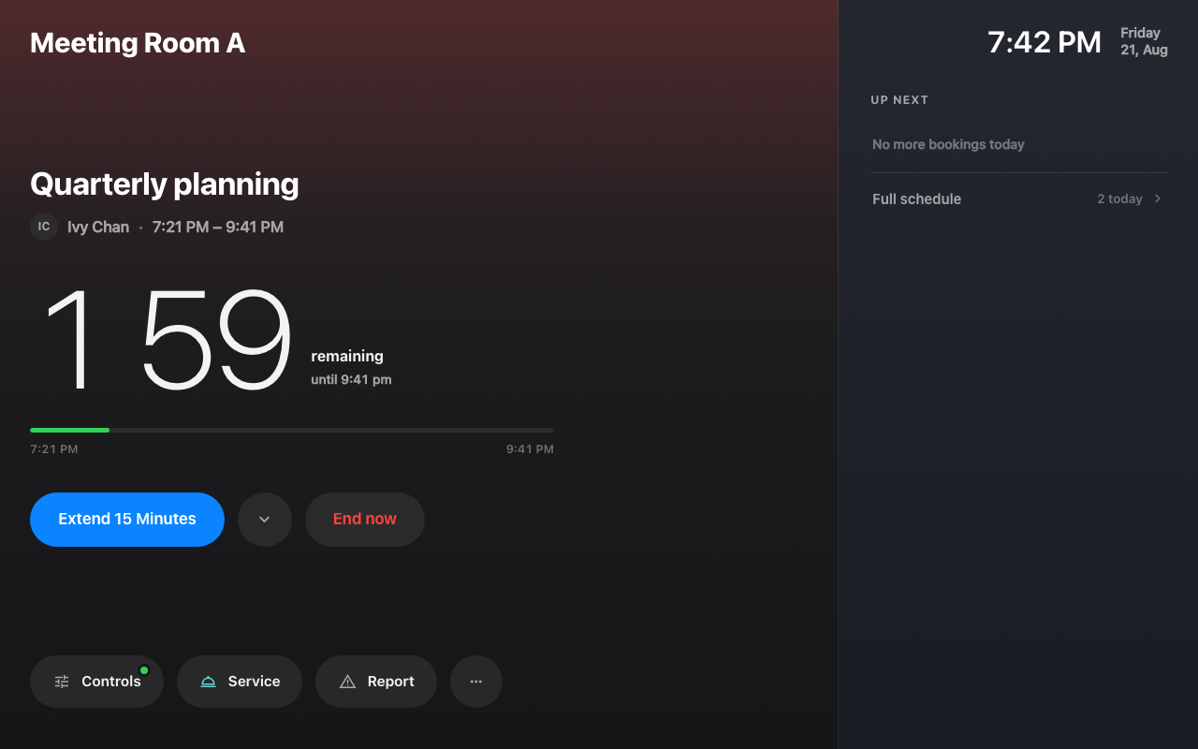
A meeting in progress: the countdown, the day ahead, and the dock.
The buttons on the booking itself cover the rest of a meeting's life:
Extend 15 Minutes when the discussion is running over, End now when it
finished early — the room is released for the next person straight away —
Move to Other Room and Rooms nearby when this one turns out to be
wrong, and Take attendance where attendance is taken. Between meetings the
panel offers Use Room Now, the same walk-in the door panel has.
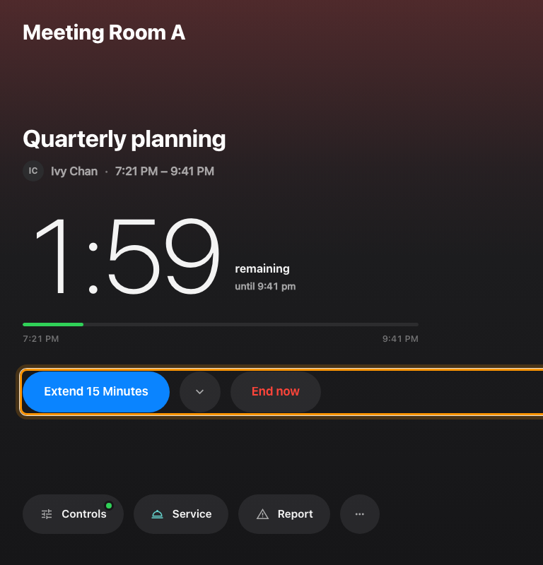
The booking's own buttons, under the countdown.
Fifteen minutes is the quick answer, not the only one — the chevron beside
Extend 15 Minutes opens a sheet with the longer options, and everything the
panel asks follows in a sheet on the same screen: nothing on it opens a second
page or needs a phone.
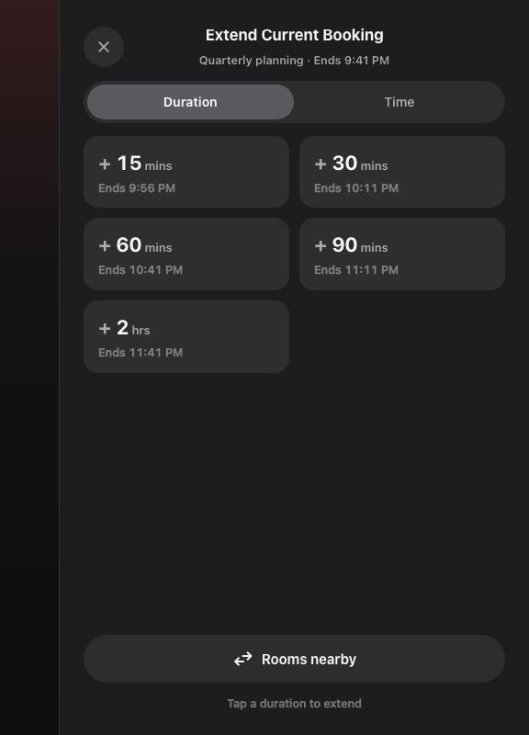
The extend options, in a sheet beside the meeting.

Not a different device
There is nothing extra to buy or connect. In the
connect wizard, the Design step's
Meeting assistant panel choice is all that makes one, and a room panel can
be turned into one afterwards from the Design row on its record — it is the
same panel, drawn differently. A room can carry both: the booking panel by the
door for the people trying to get in, the meeting assistant on the table for the
people already in.

It has a page of its own on the configuration
One booking-panel configuration drives two different panels, and since 4.5.11
they no longer share one set of settings. In-room panel is its own page on
the rail, holding only what this screen actually draws:
- Background & logo, Status colours, Booking details
- Use a booking and Door & extras — the buttons under the countdown
- Check-in method
- Idle — including whether the screen goes off, which used to sit inside the
door panel's screen-saver settings
Dark or light is set here too. It used to be decided by which skin a device
was paired with, so changing it meant re-pairing; it now belongs to the
configuration, which is what lets one configuration set it for twenty rooms at
once.
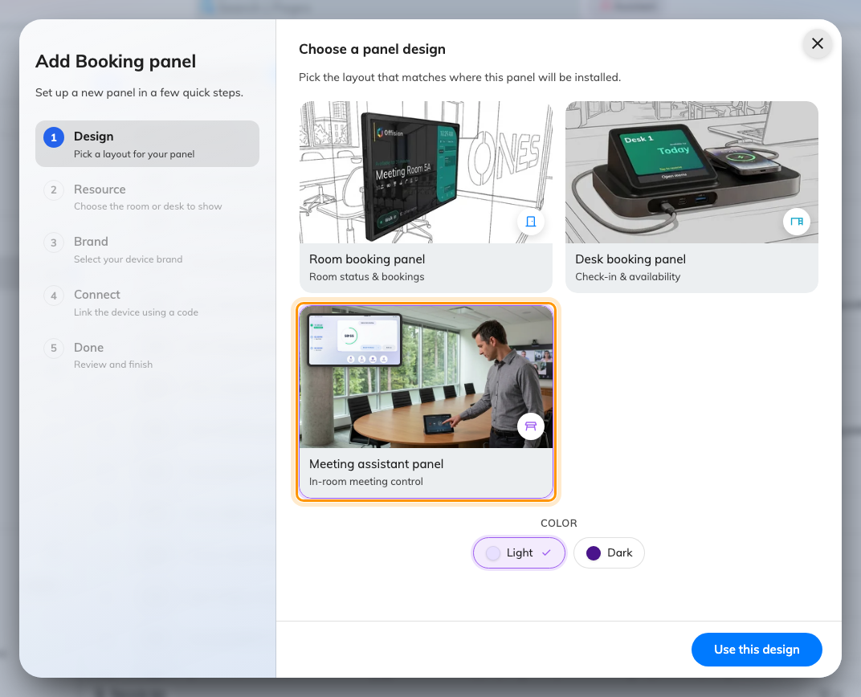
The wizard's kind step, with Meeting assistant panel picked.

What this does not control
Check-in windows, walk-in rules and energy saving follow the same panel
configuration and booking policy as every other panel; the one in-room-specific
sleep rule is covered in
Save energy on room panels. Service only
appears where the room has
in-use services, and
Report only where
problem reporting is set
up. And how it spends its status colour is in
What the panel colours mean.

