Which booking panel hardware Offision supports
Every certified room and desk panel, model by model — screen size, PoE, Wi-Fi and card reader as the vendor states them, what an end-of-life marker means, and which cards each reader actually reads.
2026-08-30 · https://offision.com/help/en/devices/supported-booking-panel-hardware/
Offision does not make hardware. It certifies it: the panels below are the ones
tested against every release, each with its own installation guideline in the
connect wizard, and each buyable from the partner rather than from Offision. A
panel that is not on this list is not blocked — it runs the browser player like
any other screen — it is simply not one Offision tests.
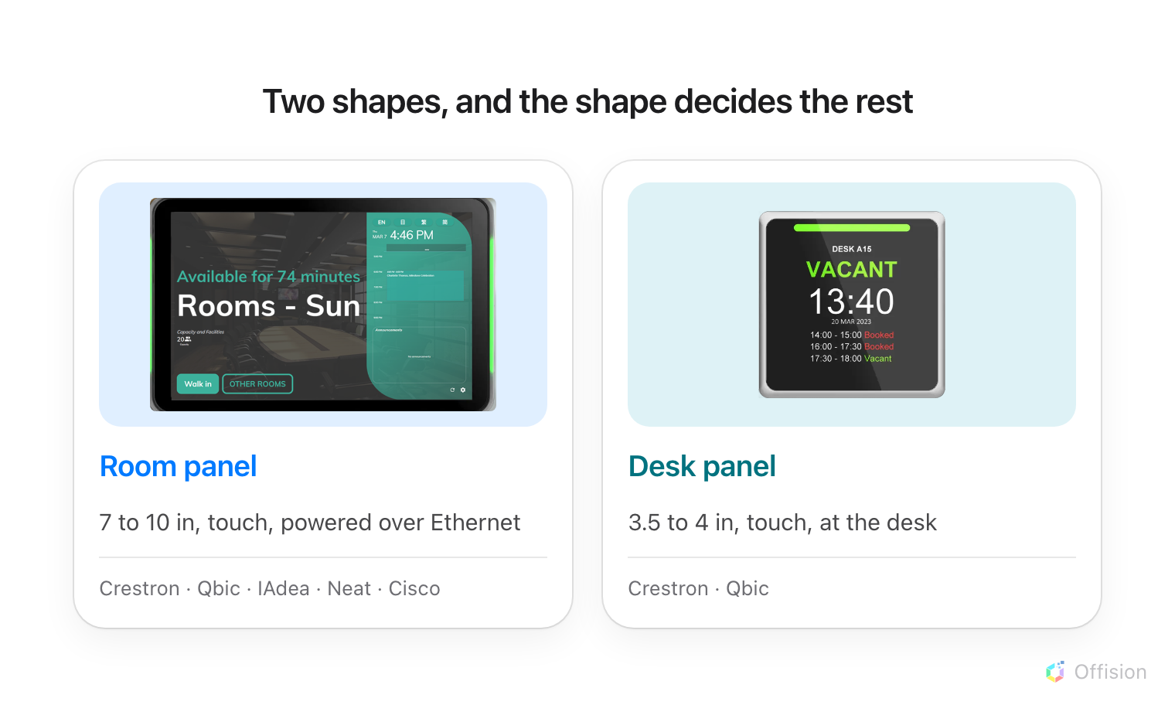
A panel is one of two shapes, and the shape decides the size, the power and where it hangs.
Where in Offision: admin app → device/booking-panel/device (Booking panel)

Room panels
The panel by the door. Every one of these is powered over its network cable, so
the practical question at install time is whether the switch port can supply
PoE+ rather than whether there is a socket in the wall.
Model | Screen | PoE | Wi-Fi | Card reader
Crestron TSS-1080 | 10.1 in, 1920 × 1200 | 802.3at PoE+, 30 W | Wi-Fi 6E, 802.11 a/b/g/n/ac/ax | USB reader
Crestron TSS-1070 / TSW-1070 | 10.1 in, 1920 × 1200 | 802.3at PoE+, 15 W | 802.11 a/b/g/n/ac | USB reader
Crestron TSS-770 / TSW-770 | 7 in, 1280 × 800 | 802.3at PoE+, 15 W | 802.11 a/b/g/n/ac | USB reader
Qbic TD-1050 Pro (end of life) | 10.1 in | PoE | 802.11 b/g/n | Built-in NFC, 13.56 MHz. HID only on the H model
Qbic TD-1060 Slim | 10.1 in, 1280 × 800 | PoE+ | 802.11 b/g/n/ac, optional | USB reader
Qbic TD-1070 | 10.1 in, 1920 × 1200 | PoE+, 25 W | 802.11 b/g/n/ac, optional | Built-in NFC, 13.56 MHz. HID only on the H model
Qbic TD-1070 Lite | 10.1 in, 1920 × 1200 | PoE+, 25 W | Wi-Fi 5, optional | Built-in NFC, 13.56 MHz. HID only on the H model
IAdea WRP-1000 | 10.1 in, 1280 × 800 | 802.3at PoE+ | 802.11 a/b/g/n/ac | Built-in NFC, 13.56 MHz. HID only on the H model
IAdea XDS-1078-A9 | 10.1 in, 1280 × 800 | 802.3at PoE+, 802.3af in eco mode | 802.11 b/g/n | USB reader
Neat Pad | 8 in, 1280 × 800 | 802.3af, class 0 | Yes | USB reader
Cisco Room Navigator | 10.1 in, 1920 × 1200 | Yes | — | USB reader

The card reader is an ordering option:
On Qbic and IAdea, the built-in reader and its HID support are chosen when you
order the panel — they are not always included and cannot be switched on later.
The standard version reads 13.56 MHz cards. The H version is the one that
reads HID, and it is a separate part number: a panel already on the wall cannot
be upgraded to it. If your staff cards are HID, order the H version, or budget
for a USB reader instead. Some Qbic models also offer an O version, which
reads a pass held in Apple Wallet — Offision does not use it, and an O
panel reads a 13.56 MHz card exactly as the standard version does.
Crestron's TSS-880 is announced but not yet shipping, and is not in the
connect wizard.

Desk panels
The small panel at the desk itself. Power is where these differ from each other:
the Crestron takes PoE like a room panel, while the Qbic models run off USB from
the desk — usually from the dock or the socket the desk already has, which is
what makes them cheap to add to a desk that is already wired.
Model | Screen | Power | Wi-Fi | Card reader
Crestron TSS-470E | 3.5 in, 480 × 320 | 802.3af PoE, 6.5 W | 802.11 a/b/g/n/ac | USB reader
Qbic TD-0350 (end of life) | 3.5 in, 480 × 320 | USB | 802.11 b/g/n, optional | Built-in NFC, 13.56 MHz. HID only on the H model
Qbic TD-0360 | 3.6 in, 480 × 480 | USB | Wi-Fi 5 | Built-in NFC, 13.56 MHz. HID only on the H model
Qbic TDD-1000 | 3.9 in, 480 × 480 | USB-C, also charges a laptop | Wi-Fi 5 | Built-in NFC, 13.56 MHz. HID only on the H model

The Qbic TDD-1000 is a dock as well as a panel: the same USB-C cable that powers
it charges the laptop plugged into it, which is why it appears at hot desks
where the point is that people bring their own machine.

Tablets and other devices
Under Certified devices in the connect wizard sits Other devices: an
iPad, an Android or Windows tablet, or a third-party screen with a web view.
Each runs the same panel and books the same rooms, and each gives up PoE, the
light bar, and — on everything but an Android tablet — the built-in card
reader. What each one needs, and what it costs you, is in
Use a tablet as a booking panel.
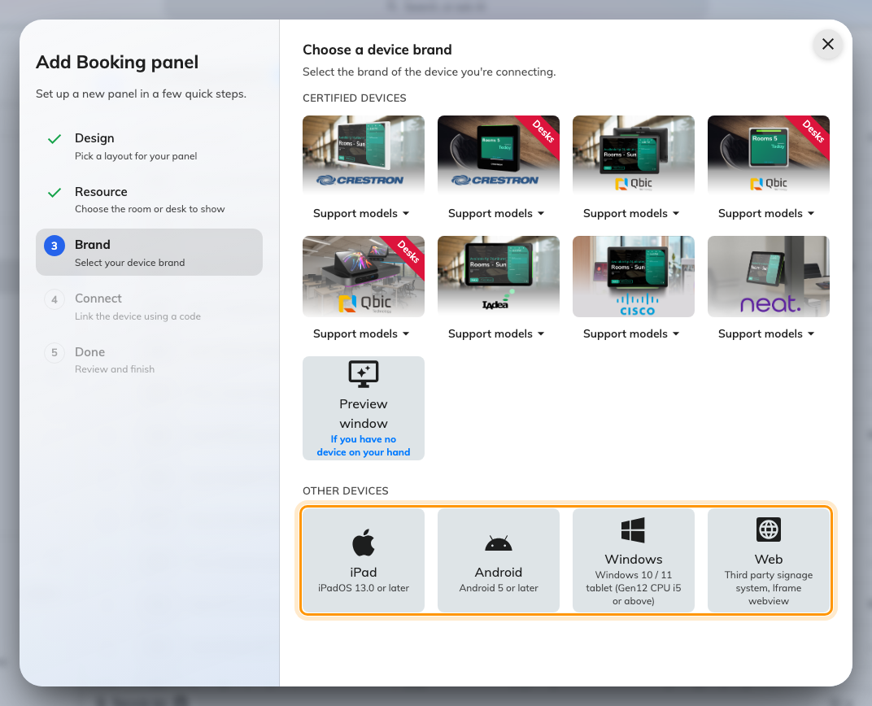
Other devices, under the certified tiles in the connect wizard.

What Offision drives on each one
The tables above are the hardware. What Offision actually does with it — the
light bar it can colour, how a card is read, and which panels it can reboot —
is a different question, and it is answered panel by panel in
What Offision drives on each panel.

What the columns mean
PoE is how nearly every room panel is powered, and PoE+ is not PoE: a
switch port that only meets 802.3af will bring up a Neat Pad and a Crestron
TSS-470E but not a Qbic TD-1070, which asks for 25 W. Check the port budget on
the switch, not just the standard printed on it.
Card reader splits two ways. Built-in NFC means the panel has its own
13.56 MHz radio behind its face and a card is tapped on the panel itself — bottom
centre on a TD-1050, bottom right on a TD-1070, bottom centre on a WRP-1000.
USB reader means a separate reader is plugged in, behaves as a keyboard, and is
where people tap instead.
Both end up in the same place; see
Check in by tapping a staff card.
End of life means Qbic no longer sells that model. A panel already on the
wall keeps working and is still tested against every release — the marker is
there so nobody orders one for a new install, or budgets for fifty and finds
they cannot be bought. Ask your supplier what replaces it.
Specifications come from the vendor:
Screen size, PoE, Wi-Fi and the card reader are the manufacturer's figures, and
several models ship in variants that differ on exactly these points — a Qbic or
IAdea panel's card reader is an ordering option, and Wi-Fi is optional on most
Qbic models. An em dash means the manufacturer does not state it, not that the
panel lacks it. Confirm the part number with your supplier before ordering a
hundred of them.

What this does not control
- Certification is not a licence. Connecting any panel needs Hardware,
whatever the brand.
- The brand you pick in the wizard does not change what the panel can do. It
decides which installation guideline you are shown; the capabilities are the
hardware's, and they are the tables above and in
What Offision drives on each panel.
- A panel not on this list still works. It runs the browser player, with no
light bar and no built-in card reader — the same profile as a tablet in a
browser.
- E-paper room and desk displays are not booking panels and are not covered
here. They run no player, take no touch and are driven as their own system —
see Connect Qbic e-paper tags.

