Show your company logo on a room panel
Put your logo on the booking panel outside a room. About five minutes: where the setting lives, what size the image has to be, and which panels it reaches.
2026-08-18 · https://offision.com/help/en/devices/show-your-logo-on-a-room-panel/
Before you start:
You need an account that can manage devices, and a PNG of your logo. The setting
belongs to a panel configuration, not to the whole system — so know which
configuration the panels you want branded are using.

1. Open Panel configurations
Go to Devices › Booking panel › Panel configurations.
Where in Offision: admin app → device/booking-panel/configuration (Panel configurations)

2. Open the Design page
Click the configuration your panels use. A detail panel opens on the right —
choose Edit there, then Background &amp; logo, the first group under the
left of the editor.
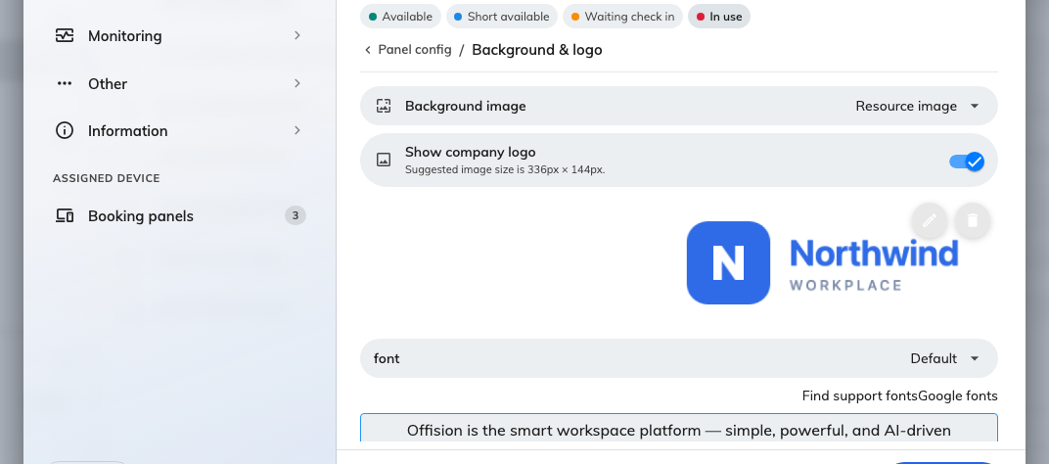
Background &amp; logo, the first group of a configuration's Room booking panel page.
Whatever you set here reaches every panel assigned to this configuration, and
no others. Where only some rooms should carry the logo, give them a
configuration of their own rather than editing the one everything shares.

3. Turn on Show company logo
Switch on Show company logo. The upload appears underneath only once the
toggle is on.
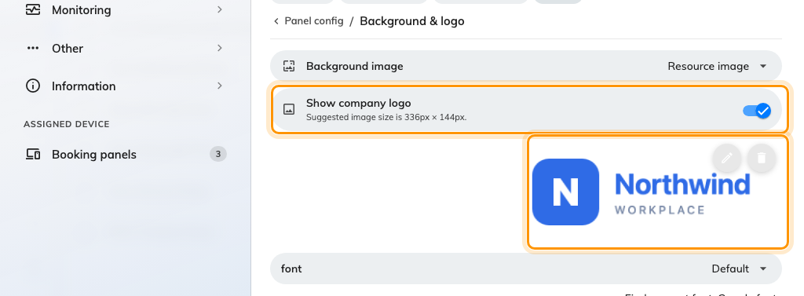
Show company logo, with the upload it reveals.
Upload the image and the crop window opens at the panel's own proportions —
336px × 144px, saved as PNG. A wide logo on a transparent background at
about that ratio comes through the crop untouched; a square or portrait mark has
to lose something, so decide what before you upload rather than in the crop
window.

4. Save
The save bar sits at the foot of the editor.

5. Check it worked
Look at a panel outside one of the rooms. The logo sits in the top corner
alongside the room name.
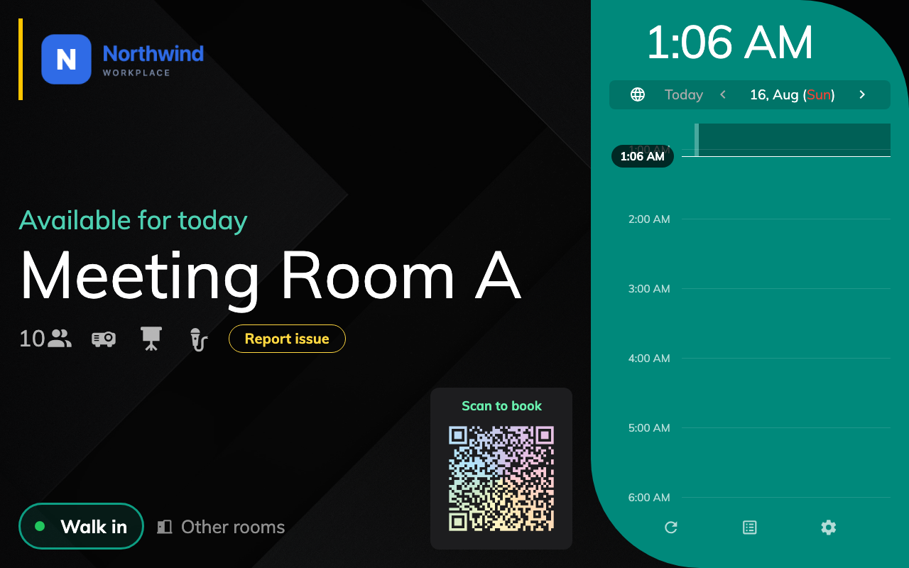
A room panel showing the logo.
If the panel looks unchanged:
Panels pick the change up on their next refresh, so give one a minute. A panel
running the mini skin has no room for a logo and will not show one — the modern
and in-room control skins do.

