Show signage on an iPad
An iPad plays signage through the Offision app's Panel mode — the same player a certified screen runs, paired with the same six characters. What to install, the two iPadOS settings that decide whether it stays up, and what it gives up.
2026-09-17 · https://offision.com/help/en/devices/show-signage-on-an-ipad/
An iPad shows signage through the Offision app. The app is the one staff use to
book a room, and it carries a Panel mode that hands the whole screen over to
the player — the same player a certified signage screen runs, playing the same
content and pairing with the same six characters.
What an iPad does not bring is the hardware around the screen. There is no PoE,
so the mount needs a socket, and iPadOS will sleep and lock the screen unless it
is told not to. Those two things, rather than Offision, are what decide whether
the screen is still showing content next week.
Before you start:
Do this at the iPad, not from your desk. The last step reads six characters off
its screen, and they are only valid while it stays awake and online.

What to have ready
- An iPad running iPadOS 13.0 or later — what the console lists under
Support models for this tile
- A power socket at the mount, and a network the iPad can reach Offision on
- In Offision, an account that can manage signage and devices, and a piece of
signage content already built
- About fifteen minutes

1. Install the app

2. Turn on Panel mode
Open the app and, without signing in, choose Panel mode at the top right.
Signing in first is the common wrong turn: an account signs a person in, and
what you are setting up is a device.
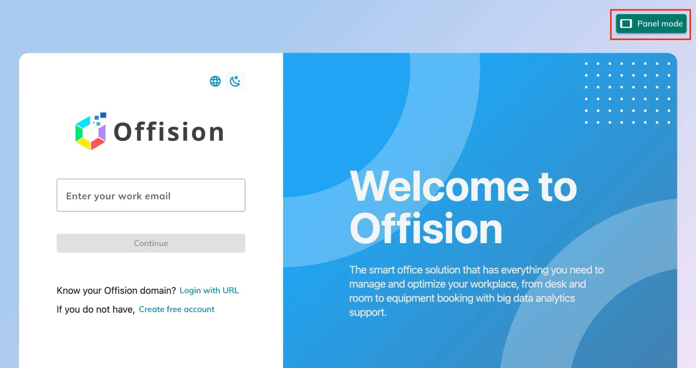
Panel mode, at the top right of the app before anyone signs in.
The screen turns over to the player and shows a six-character registration
code. Leave it there.
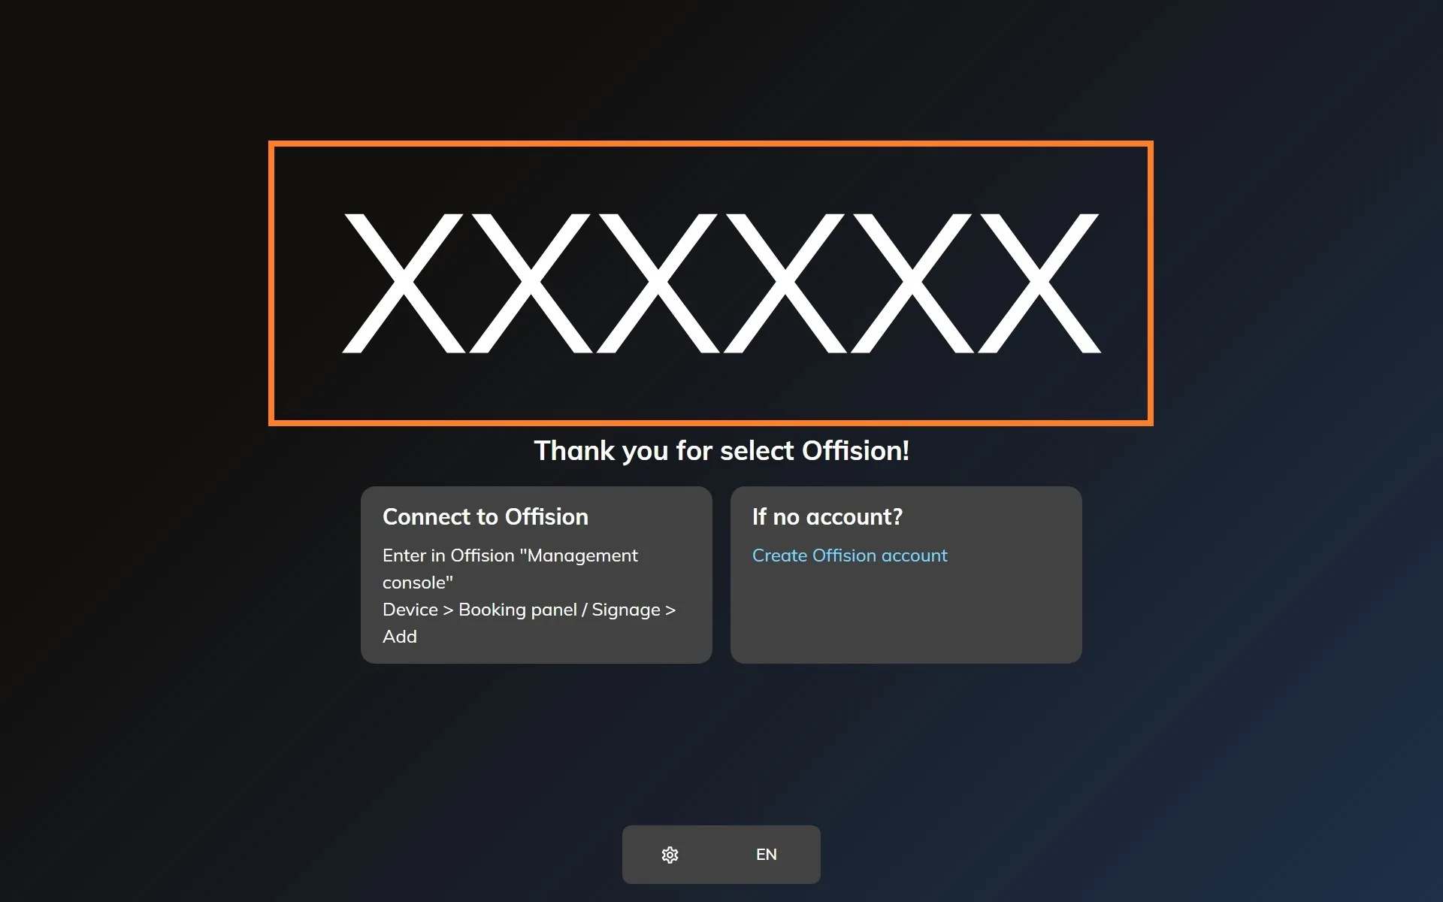
The player waiting to be claimed. The six characters are what the console asks for.

3. Add the device in the console
In the console, go to Devices › Signage › Devices and choose Add.
Where in Offision: admin app → device/signage/signage-device (Signage devices)
The wizard's steps — the content, the brand, the code and the location — are the
same for every screen, and are covered in
Connect a signage screen to Offision.
At the Brand step, take iPad, in the Other devices row under the
certified tiles.
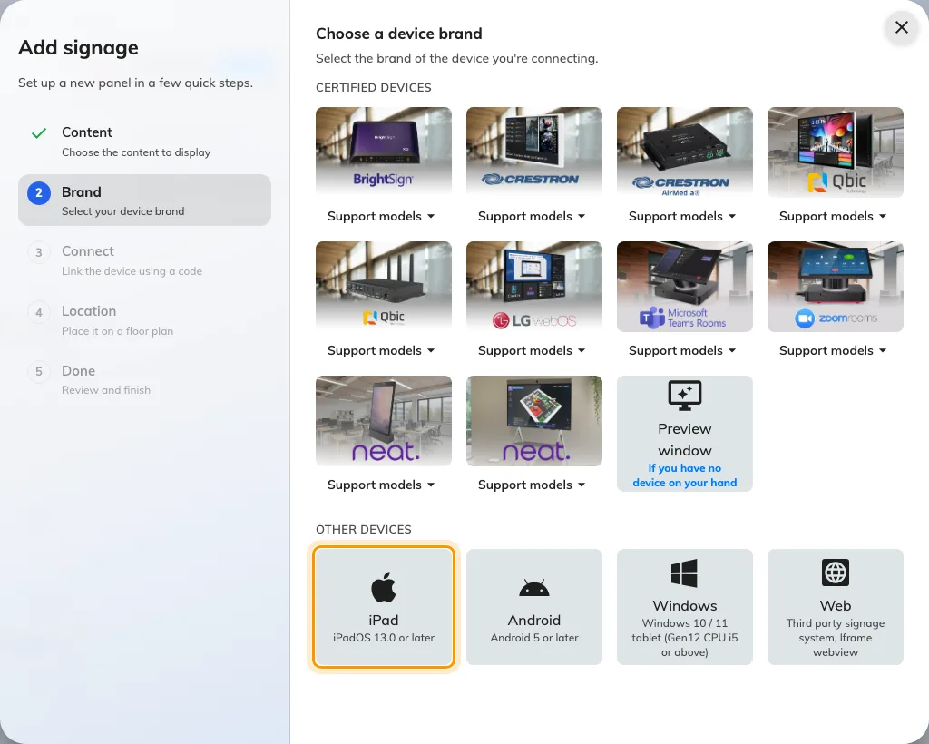
iPad, first in the Other devices row.

4. Claim it with the code
The tile's own short guideline opens beside the code field. Type the six
characters from the iPad; it submits itself on the last one.
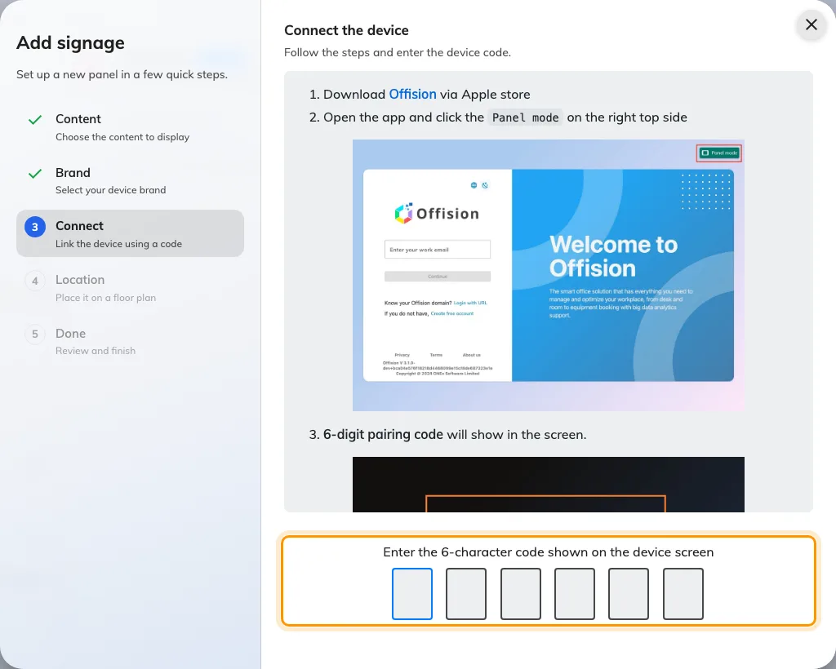
The iPad guideline, and the field that claims the screen.

5. Stop iPadOS taking the screen back
Two settings, both on the iPad, and a screen that skips them looks finished today
and is dark or sitting on the home screen by the end of the week.
- Auto-Lock to Never, so the display stays lit.
- Guided Access on the Offision app, so a passer-by cannot swipe out of it.

Check it worked
Within a few seconds the iPad stops showing the code and starts playing the
content. Then confirm both halves: the content is playing on the iPad, and the
screen appears in Devices › Signage › Devices and reports online.
Then lock and unlock the iPad, and leave it for longer than the old auto-lock
window. A signage screen is one nobody visits, so the setup worth trusting is the
one that is still playing when you come back to it.

When it goes wrong
What you see | Usual cause
A sign-in form with no Panel mode button | That is Offision in Safari, not the installed app. Panel mode exists only in the app
The code is refused | Read it off the iPad again rather than retyping what you noted down. The code lives on an open connection, so an iPad that has slept or lost the network since is showing a different one
The screen goes dark after a few minutes | Auto-Lock is still set. Put it to Never
The content is gone and the home screen is showing | Somebody left the app. Turn Guided Access on
It plays, but never picks up an edit | The iPad is off the network. The player reconnects on its own once it is back

What this does not do
- It does not give the screen any hardware. No light bar, no occupancy
sensor, no card reader — those come from a panel vendor's own bridge, and an
iPad has none.
- It is a signage screen, not a booking panel. It plays content; it does not
take a check-in at the door.
- It does not save a device licence. A paired iPad holds one exactly like any
other screen.
- It does not survive a power cut on its own unless the iPad is left charging
and set to stay on. There is no PoE here to bring it back.

