Show signage on an Android screen
An Android tablet or media box plays signage through the Offision app's Panel mode. Where to get the app when the device has no Play Store, and the two Android settings that decide whether the screen comes back after a power cut.
2026-09-17 · https://offision.com/help/en/devices/show-signage-on-an-android-screen/
An Android tablet, or a small media box wired to a television, shows signage
through the Offision app. The app carries a Panel mode that hands the whole
screen over to the player — the same player a certified signage screen runs,
playing the same content and pairing with the same six characters.
Because the app is installed, the screen keeps its content on the device rather
than fetching it as it plays: an uploaded video is downloaded once and then plays
from local storage, which is what lets a lobby loop survive a network outage.
Before you start:
Do this at the screen. The last step reads six characters off it, and they are
only valid while it stays awake and online.

What to have ready
- A device running Android 5 or later — what the console lists under
Support models for this tile
- A power socket at the mount, and a network the device can reach Offision on
- In Offision, an account that can manage signage and devices, and a piece of
signage content already built
- About fifteen minutes

1. Install the app
A tablet with the Play Store takes it from there. A media box or a locked-down
device often has no store on it, and then the package is installed directly —
allow installation from the file manager first, or push it with whatever tool
manages the fleet.

2. Turn on Panel mode
Open the app and, without signing in, choose Panel mode at the top right.
Signing in first is the common wrong turn: an account signs a person in, and
what you are setting up is a device.
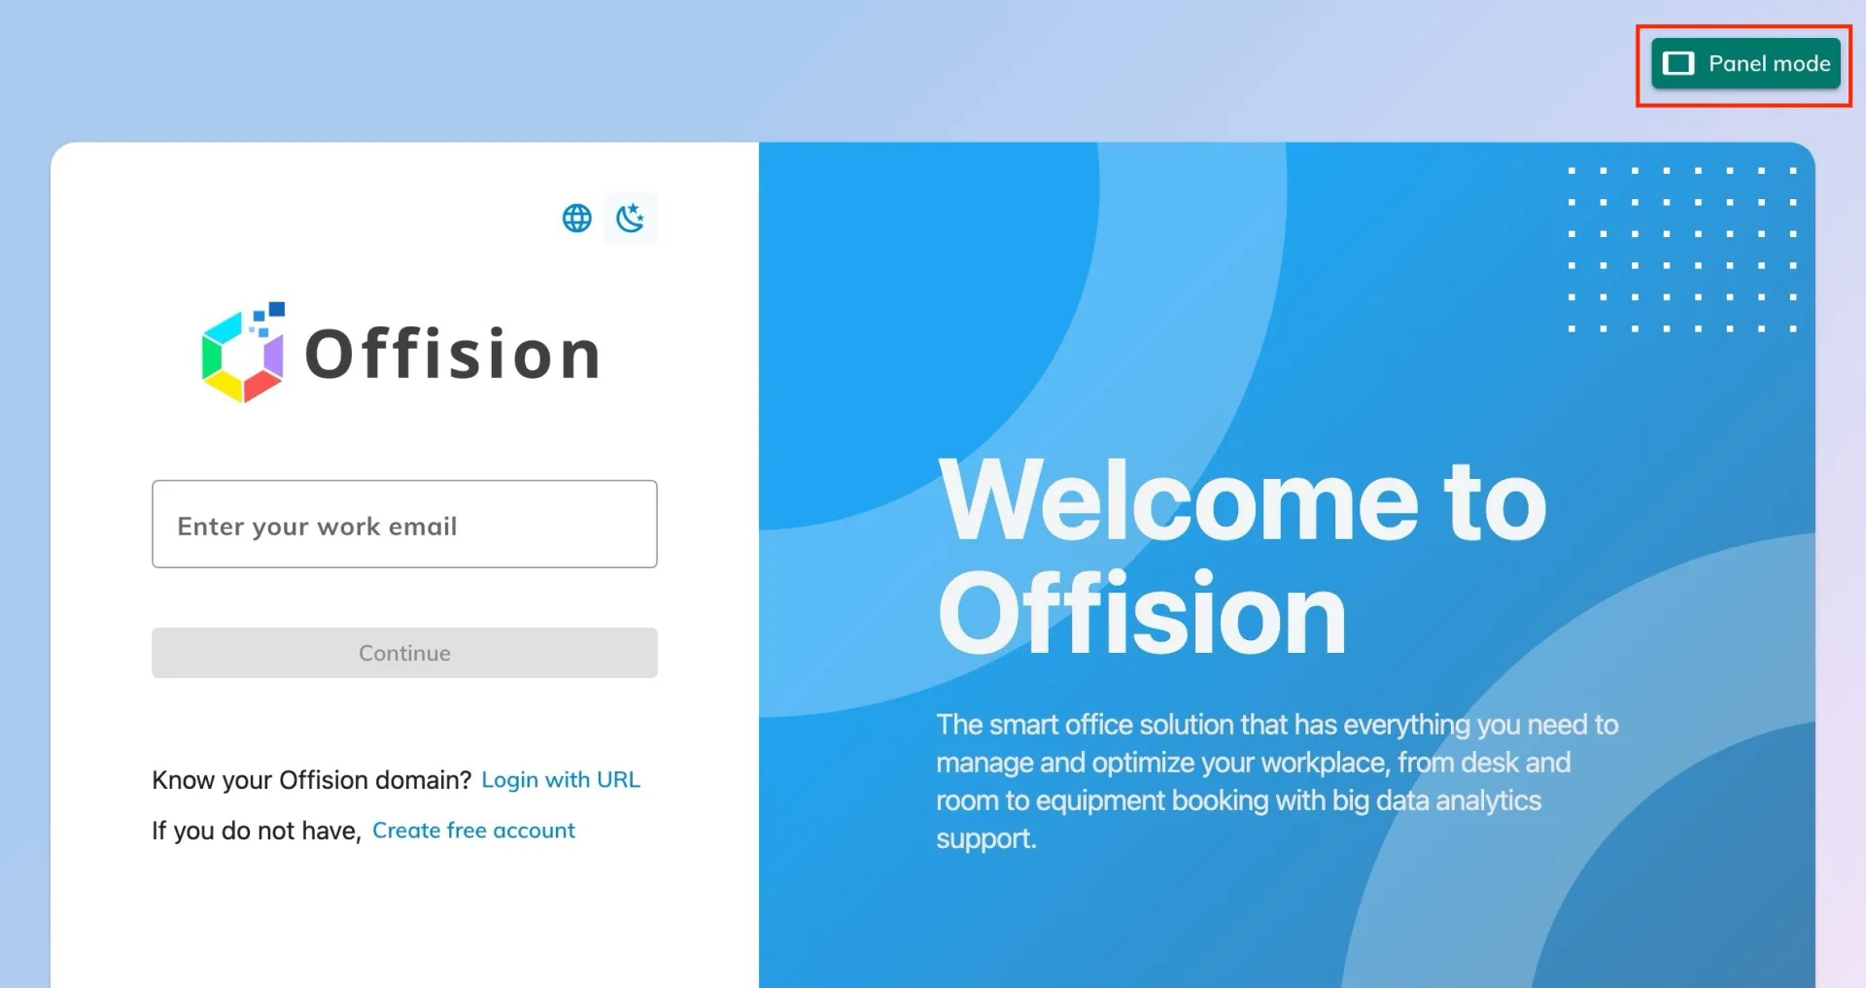
Panel mode, at the top right of the app before anyone signs in.
The screen turns over to the player and shows a six-character registration
code. Leave it there.
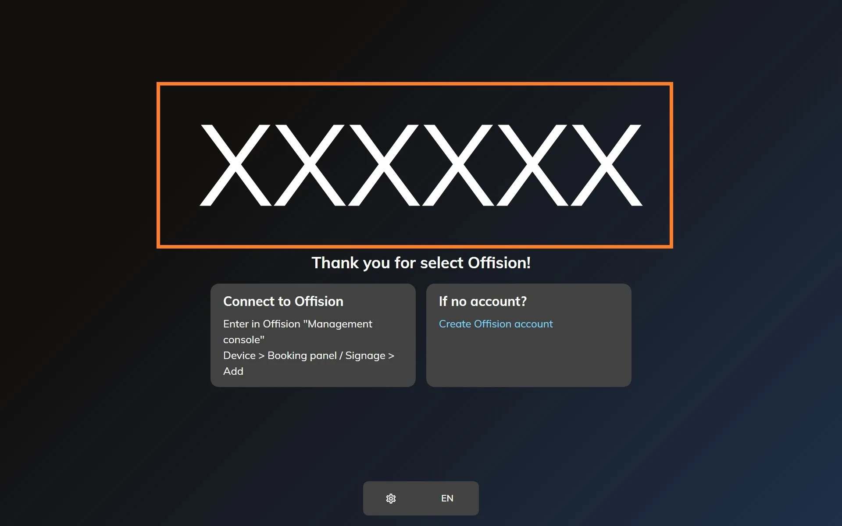
The player waiting to be claimed. The six characters are what the console asks for.

3. Add the device in the console
In the console, go to Devices › Signage › Devices and choose Add.
Where in Offision: admin app → device/signage/signage-device (Signage devices)
The wizard's steps — the content, the brand, the code and the location — are the
same for every screen, and are covered in
Connect a signage screen to Offision.
At the Brand step, take Android, in the Other devices row under the
certified tiles.
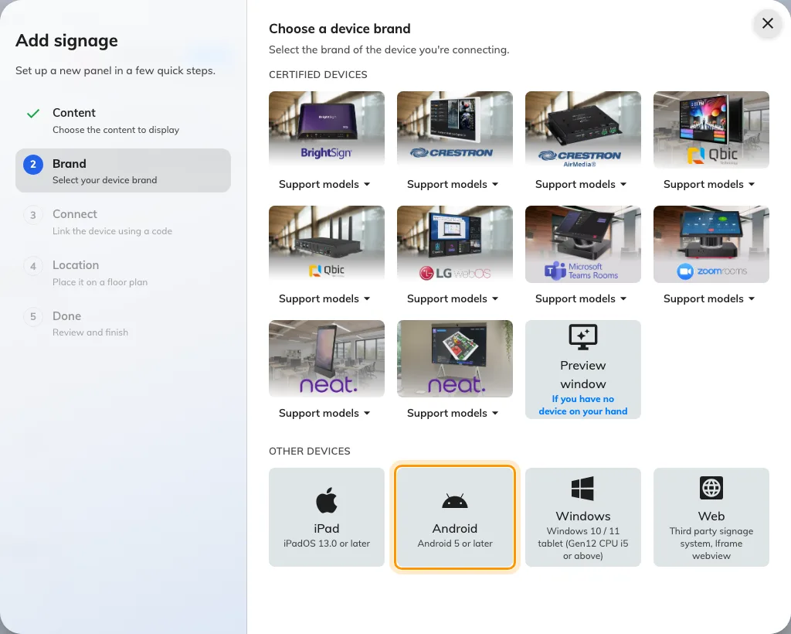
Android, second in the Other devices row.

4. Claim it with the code
The tile's own short guideline opens beside the code field. Type the six
characters from the screen; it submits itself on the last one.
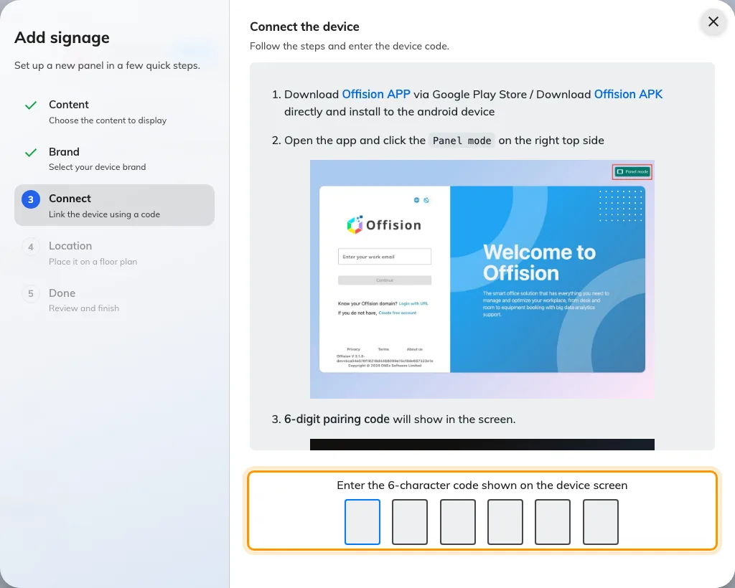
The Android guideline, and the field that claims the screen.

5. Make it come back by itself
Android will sleep the display and, after a power cut, come back to its own home
screen rather than to Offision. Both are settings on the device:
- Screen timeout to its longest value, or the device's own always-on setting
where it has one.
- Set the Offision app as the home app, so a reboot lands back on the player.
On a media box this is usually the only way a screen recovers without somebody
walking to it.

Check it worked
Within a few seconds the screen stops showing the code and starts playing the
content. Then confirm both halves: the content is playing, and the screen appears
in Devices › Signage › Devices and reports online.
Then pull the power and put it back. A signage screen is one nobody visits, so
the only setup worth trusting is one that returns to the content on its own, with
no code and no keyboard.

When it goes wrong
What you see | Usual cause
A sign-in form with no Panel mode button | That is Offision in the device's browser, not the installed app. Panel mode exists only in the app
The package will not install | Installation from unknown sources is off. Allow it for the file manager, then install
The code is refused | Read it off the screen again rather than retyping what you noted down. The code lives on an open connection, so a device that has slept or rebooted since is showing a different one
The display sleeps | Screen timeout is still at its default
After a power cut the home screen is showing | The app is not the home app. Set it, and the next reboot lands on the player

What this does not do
- It does not give the screen any hardware. No light bar, no occupancy
sensor, no card reader — those come from a panel vendor's own bridge, and a
general-purpose device has none.
- It is a signage screen, not a booking panel. It plays content; it does not
take a check-in at the door.
- It does not save a device licence. A paired screen holds one exactly like
any other.
- Offision does not push the app. It updates like any other app on the
device, through the store or the tool that manages the fleet.

