Show signage on a Microsoft Teams Rooms screen
A Teams Rooms device can fill its front-of-room display with Offision content between meetings. What it needs first is a Teams Rooms Pro licence — and there are several rooms this will not work in at all.
2026-08-20 · https://offision.com/help/en/devices/show-signage-on-a-teams-room-screen/
A Teams Rooms device already owns the screen at the end of the room, and since
Teams Rooms 5.1 it can fill that screen with a web page while nobody is
meeting. Give it Offision's address as its signage source and the room shows
today's bookings between meetings instead of a Teams home screen.
Read the next section before anything else. Signage is a Teams Rooms Pro
feature, and there are whole categories of room where Microsoft does not offer it
at all — which is cheaper to find out now than after the content is built.
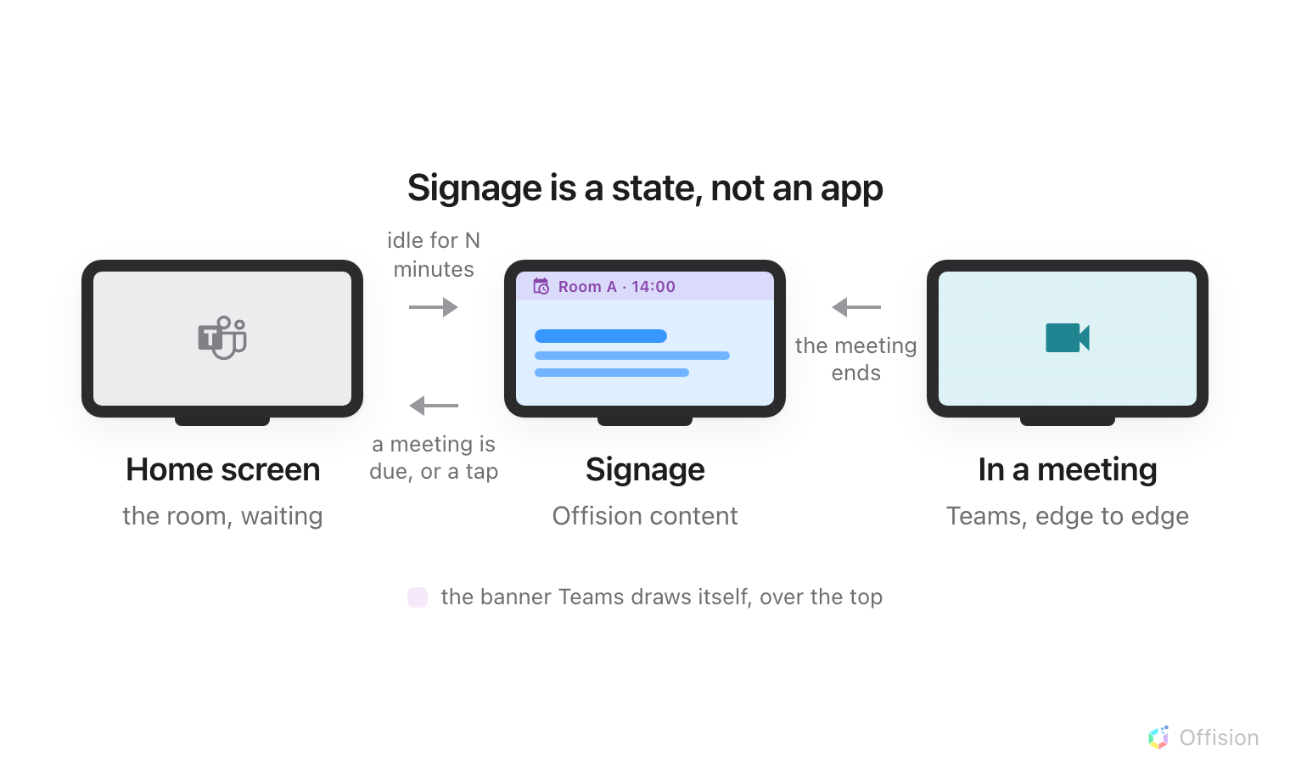
Signage is a state the device drops into when it has nothing else to do, and leaves the moment it does.
Before you start:
Signage is configured in the Teams Rooms Pro Management portal, not in
Offision and not on the device. You need an account with the digital signage
tenant management permission there — a Teams Rooms Pro Manager, or a role
somebody has granted it to.

What to have ready
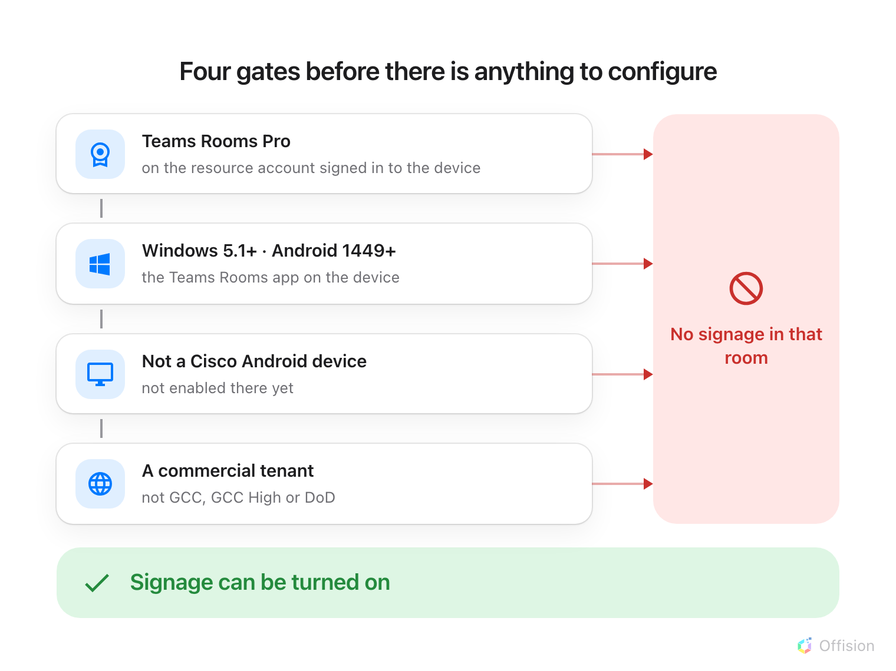
Four gates, and every one of them is Microsoft's. A room that fails any of them cannot show signage at all.
Every room you want signage in must clear all four:
- A Teams Rooms Pro licence on the resource account signed in to the device.
This is the one that catches people. Without Pro there is no digital signage
feature to configure, on any device.
- Teams Rooms on Windows 5.1 or later, or Teams Rooms on Android 1449 or
later.
- Not a Cisco device running Teams Rooms on Android. Microsoft has not
enabled signage there yet.
- A commercial tenant. Signage is not available through the multitenant
management portal, or in GCC, GCC High or Department of Defense environments.
Then, in Offision, an account that can manage signage and devices — and about
twenty minutes, most of it in Microsoft's portal.

1. Build the content
Signage content is a design, not a screen, and it exists before any hardware
does. Create it first — see
Build signage content for the whole of
this step.
Choose the Wireless sharing idle screen purpose. It skips the screen question
altogether because a front-of-room display is always a 43-inch landscape 16:9
wall, and it starts you with a schedule beside the content.
Where in Offision: admin app → signage/signage-content (Signage)
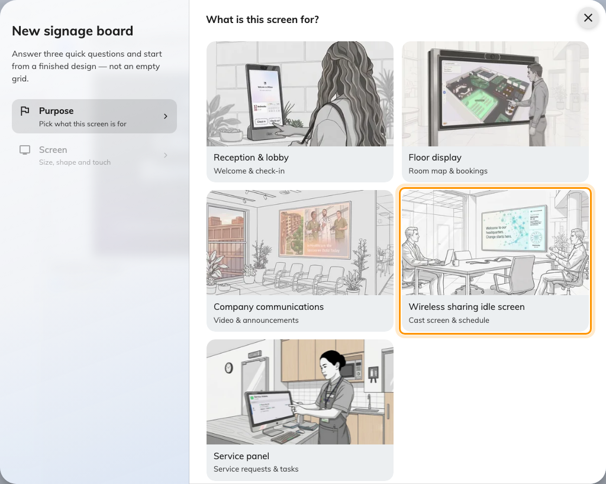
Wireless sharing idle screen, the fourth purpose.
Videos: use the YouTube widget:
Uploaded video files do not play on this screen — the device's built-in browser
cannot play the Video widget's file. Host the clip on
YouTube and add it with the YouTube widget instead.
Keep the top of the screen quiet:
Teams Rooms draws its own banner — the room name and a calendar preview — across
the top of the display while signage plays. Microsoft's guidance is to keep
the top 15% of the design clear of anything that matters.
Offision's Reserved area switch does not help here: it clears the bottom
strip, for a wireless-sharing box that paints its card down there. What helps on
this screen is where the bands sit — put the card row and any text bar along the
bottom edge on the content's Layout page, and leave the top to the banner.
See Change a layout.
The banner can also be turned off entirely, in the portal's signage
Preferences, which gives the content the whole screen.

2. Add Offision as a signage source
Everything in this step happens in the Teams Rooms Pro Management portal.
Microsoft's own setup document is
Deploy digital signage on Microsoft Teams Rooms.
- Go to Settings › Digital signage and turn Digital signage on for
the tenant.
- Choose Add source, name it, and choose Next.
- Choose Custom — not one of the third-party providers — and enter the
address below as the web URL.
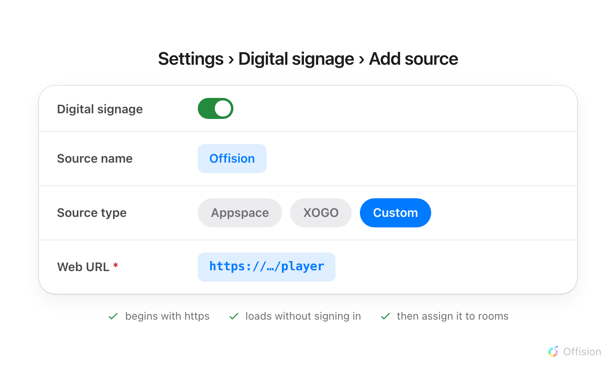
Custom is the option that takes an address of your own. The two named providers are separate subscriptions.
- Accept the terms, review and submit.
- Assign the source to the rooms that will use it — either from the source, with
Assign to rooms, or on one room at a time under Rooms › the room ›
Settings › Digital signage.
When the setting actually lands:
A room has to be online and signed in to the Teams Rooms app for settings to
apply. Choosing Apply now on a room that is in use does not interrupt it —
the change waits for the maintenance window instead. After a restart, allow ten
to fifteen minutes for the room's management agent to reconnect.
While you are in Preferences, the two timers are worth setting deliberately:
the activation timer is how many idle minutes before signage appears, and the
deactivation timer is how many minutes before a booked meeting it gets out of
the way. Low values are what make the content something people actually see.

3. Pair the screen
Once signage activates, the front-of-room display shows a six-character
registration code. That code is what claims the screen.
In the console, go to Devices › Signage › Devices and choose Add.
Where in Offision: admin app → device/signage/signage-device (Signage devices)
The wizard asks three things: the content this screen will play, the brand
of hardware, and then the code.
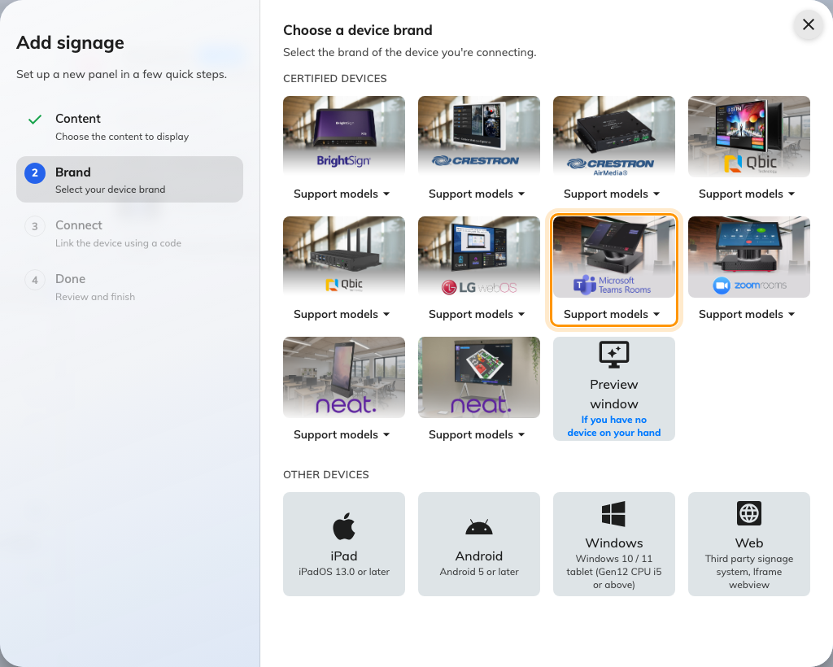
Microsoft Teams room device, in the certified devices grid.
Choose Microsoft Teams room device, then type the six characters from the
screen. It submits itself on the last one.
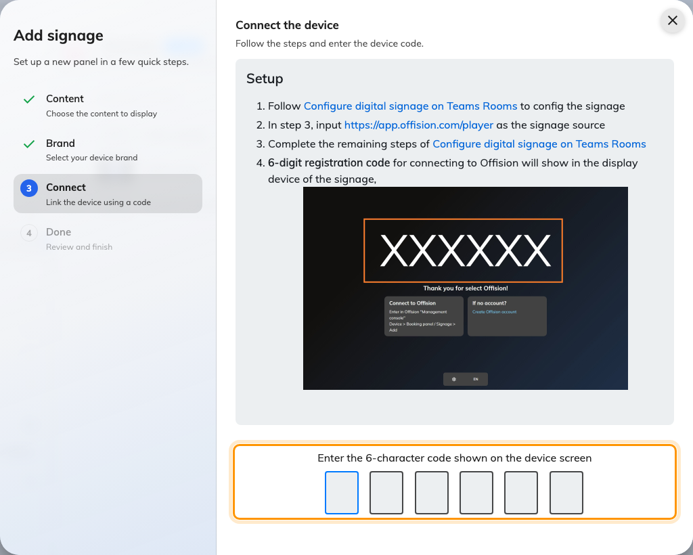
The brand's own guideline, and the field that claims the screen.
Waiting for the code is the awkward part of this brand: the device only shows it
once signage activates, which is after the activation timer has run. Setting that
timer to its lowest value while you install saves a lot of standing about.

4. Check it worked
Within a few seconds the screen stops showing the code and starts showing the
content. Then check both halves:
- In the console, the screen appears in Devices › Signage ›
Devices and is online.
- In the room, tap the touch console. Signage should give way to the Teams
home screen immediately, and come back on its own once the room is idle again.
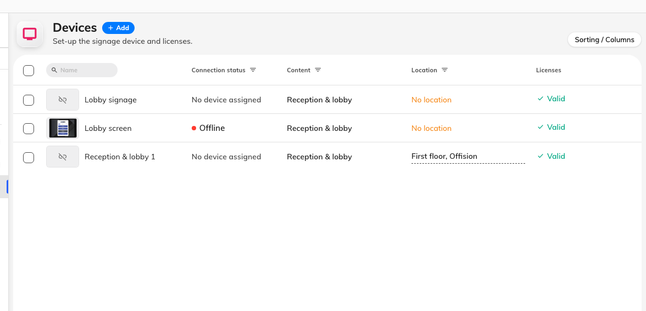
The signage device list. Connection status is where a paired screen reports in.

When it goes wrong
What you see | Usual cause
There is no Digital signage section in the portal | The account is missing the digital signage tenant management permission, or the tenant is one of the unsupported environments
The room stays on the Teams home screen and never shows signage | No Teams Rooms Pro licence on that room's resource account, the app is below the minimum version, or the source was never assigned to that room
The setting says it applied, but nothing changed | The room was in use, so it waited for the maintenance window. Push it again when the room is free
Signage appears, then the screen goes dark | The device is honouring the operating system's screen time-out. Turn off Allow screen timeout when device is idle in Preferences
Signage never appears on a Cisco device | Not supported yet on Cisco hardware running Teams Rooms on Android
A blank screen, and the portal reports nothing | There is no signage health signal for a custom web URL. Check the address, then check the screen itself for the registration code
A video on the content never plays | Uploaded video files are not supported on this hardware. Host the clip on YouTube and use the YouTube widget

What this does not do
- Offision does not manage the device. It is not enrolled, monitored,
restarted or updated from the console — the only thing Offision knows about it
is the screen that paired.
- Offision does not decide when signage shows. The activation and
deactivation timers are the device's, and so is the banner across the top.
- No health signal. Microsoft's digital signage health monitoring covers its
two named providers, not a custom web URL, so a screen that stops playing is
diagnosed at the screen.

