Show signage in a third-party system or web view
Point another signage system's web page zone at the Offision player address and claim it with six characters — no app installed. What a web view can and cannot play, why uploaded video never starts, and why some screens ask to pair again.
2026-09-17 · https://offision.com/help/en/devices/show-signage-in-a-third-party-system/
A signage system you already run, a room system, a kiosk shell — anything that
will load a web page and keep it on screen can show Offision. Nothing is
installed. The other system opens one address, the player appears inside it and
shows six characters, and the console claims it like any other screen.
This is the console's Web tile, and what it lists under Support models
says what it is for: Third party signage system, Iframe webview.
A web view is also the thinnest way to run the player. It has no storage of its
own, so what it can play is narrower than what an installed app can — and the
gap is silent rather than noisy. Read What a web view cannot play below before
you plan a screen around it.
Before you start:
You need to be able to edit the other system's page or zone, and to see the
screen while you do it. The last step reads six characters off the screen, and
they are only valid while it stays open and online.

What to have ready
- A system whose web view is Chromium-based and reasonably current. Offision's
floor is Chrome 72; below it the player shows an unsupported-browser page
rather than the content
- The zone or page in that system that you can point at an address, ideally full
screen
- In Offision, an account that can manage signage and devices, and a piece of
signage content already built
- About fifteen minutes

1. Point the zone at Offision
In the other system, set the page or zone to open this address:
Nothing else goes in the address — no tenant, no board, no token. The player
works out which tenant it belongs to from the pairing, not from the URL.

2. Read the six characters off the screen
The zone shows the player's registration screen: six characters, and a note of
where to claim them.
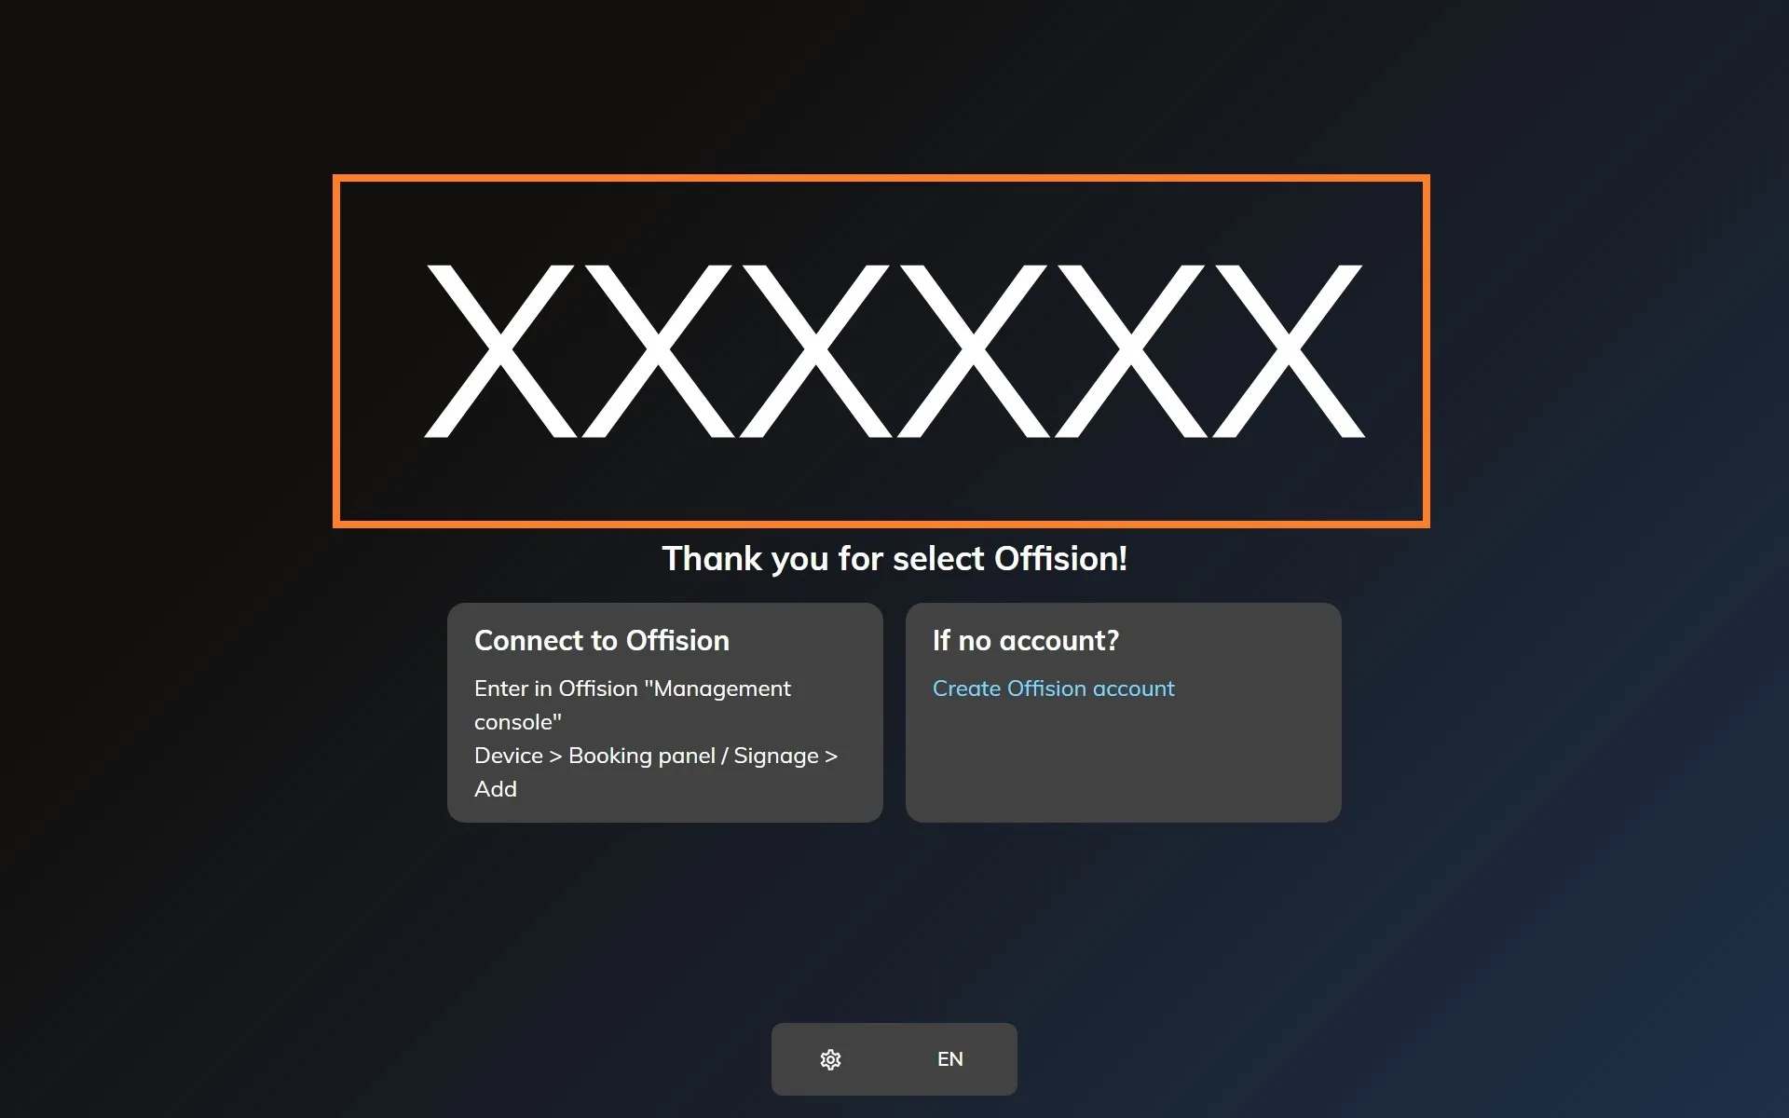
The player waiting to be claimed, running inside the other system's page.
Use the code on the real screen:
The wizard also offers a Preview window tile, which opens a player in a
browser tab so you can see a design before anything is mounted. That preview
shows a code of its own, and it is not your screen. Claim the characters showing
on the actual display.
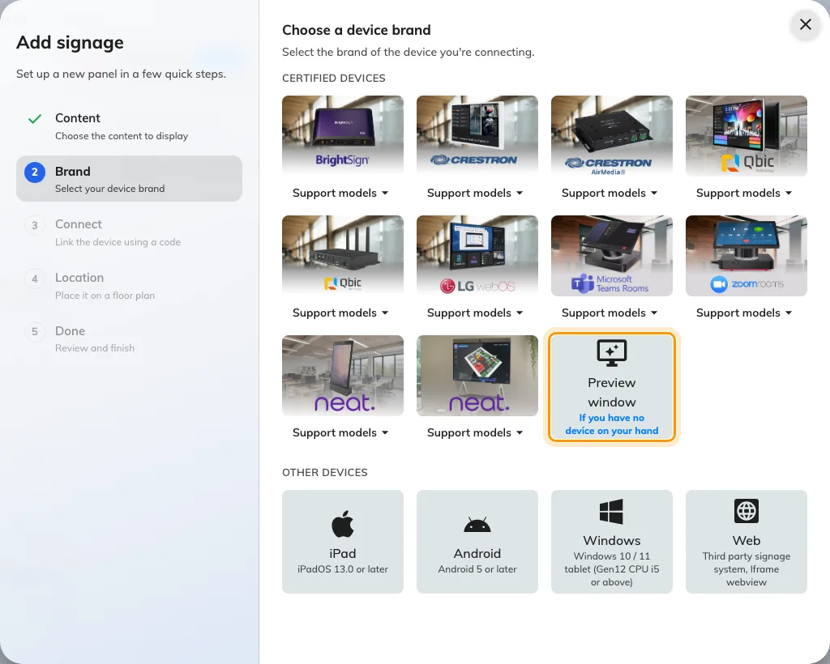
Preview window, after the certified brands — a player in a tab, with a code that is not the screen's.

3. Add the device in the console
In the console, go to Devices › Signage › Devices and choose Add.
Where in Offision: admin app → device/signage/signage-device (Signage devices)
The wizard's steps — the content, the brand, the code and the location — are the
same for every screen, and are covered in
Connect a signage screen to Offision.
At the Brand step, take Web, last in the Other devices row under the
certified tiles.
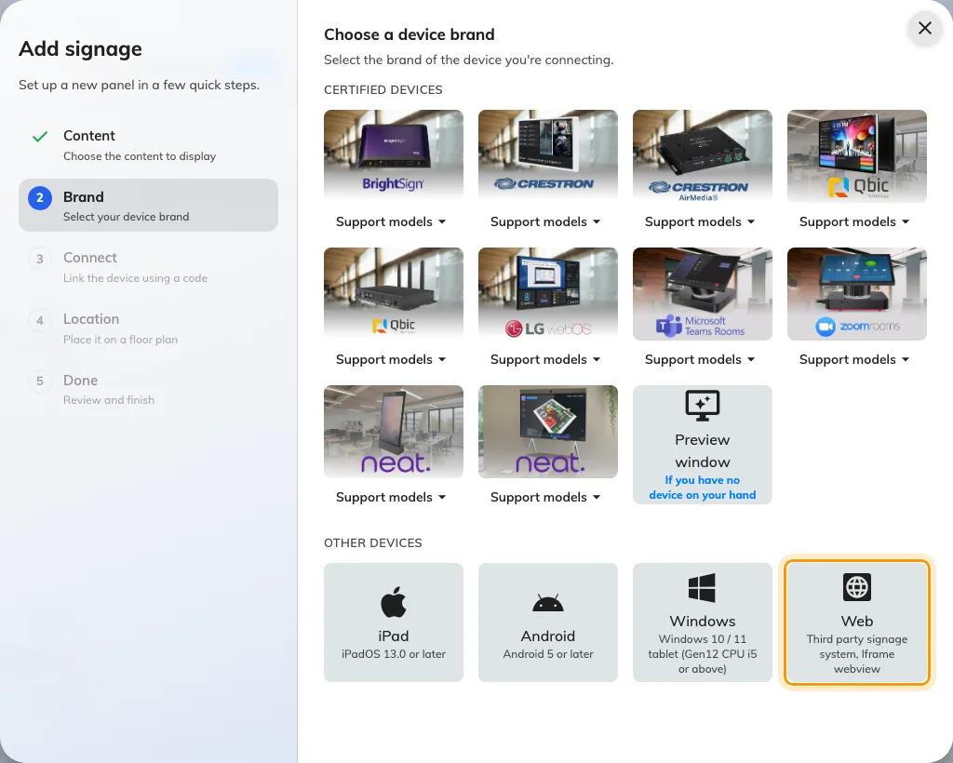
Web — third party signage system, iframe webview — last in the Other devices row.

4. Claim it with the code
The tile's own short guideline opens beside the code field, carrying the same
address. Type the six characters from the screen; it submits itself on the last
one.
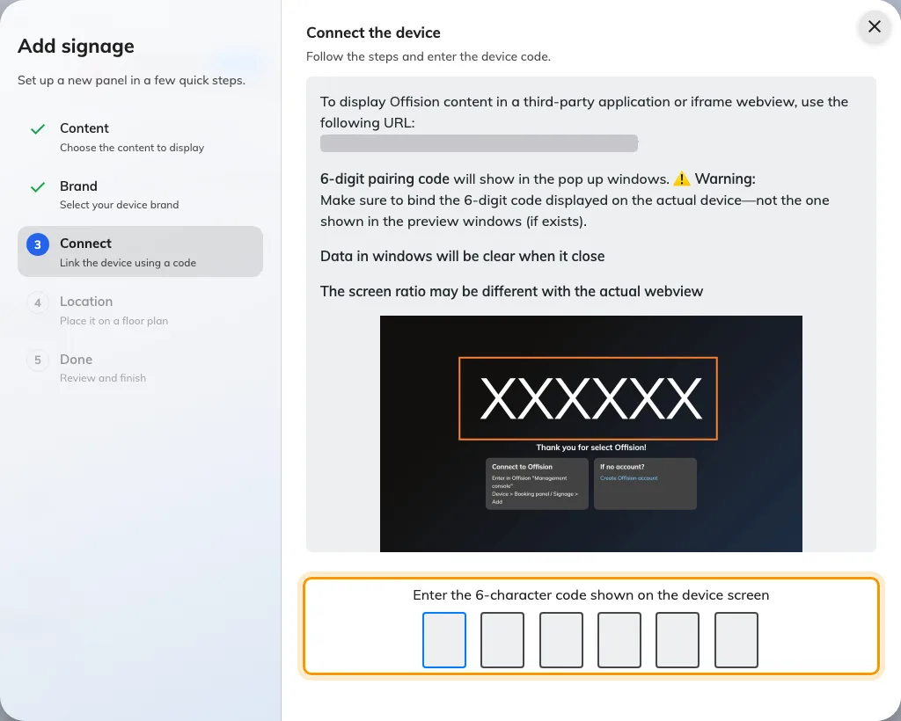
The Web guideline, and the field that claims the screen.

What a web view cannot play
The player keeps content on the device and plays the local copy, which is what
lets a screen keep running through a network outage. A web view has nowhere to
put a file, and the consequences are not errors — they are things that quietly
never happen:
- An uploaded video never starts. Its poster image stays up and the design
carries on around it. Nothing about this depends on the file, so re-exporting
it or making it smaller changes nothing. Put the clip on YouTube and use the
YouTube widget instead, which streams and plays either way.
- Sound never plays by itself. A browser will not unmute a clip that started
without somebody touching the screen.
- Images and PDFs still show, fetched from the cloud as they play rather than
from local storage — so a screen that loses the network loses the content until
it is back.
Where the content is a video loop, install the app on the device instead of using
its web view.

Check it worked
Within a few seconds the zone stops showing the code and starts playing the
content. Then confirm both halves: the content is playing on the screen, and it
appears in Devices › Signage › Devices and reports online.
Then restart the screen the way it will really restart — a power cycle, not a
page refresh — and watch what comes back. A web view that keeps its site data
returns straight to the content. One that clears it comes back asking to be
paired again, and that is the thing worth knowing on day one rather than in a
month.

When it goes wrong
What you see | Usual cause
A code again after every restart | The web view clears its site data on close. The pairing is kept there, so the screen comes back as a new device. Claim it onto its existing row rather than adding a second, or use a system that keeps site data
An unsupported-browser page, or a blank zone | The web view is older than Chrome 72
The code is refused | Read it off the screen again rather than retyping what you noted down. The code lives on an open connection, so a screen that has slept, reloaded or lost the network since is showing a different one
A video stuck on its poster image | Uploaded video does not play in a web view. Use YouTube, or install the app
The design is cut off, or letterboxed | The zone's shape is not the content's. The design is drawn to whatever the zone gives it — size the zone, or build the content to match
Two screens playing the same code's content | A preview window was claimed instead of the screen

What this does not do
- There is no board or content address to point at. The player address is the
only one that works. A board opened on its own answers that it can only be
displayed on a player device, and there is no share link to hand out.
- It does not save a device licence. A web view is a signage device like any
other and holds one while it is paired.
- No hardware reaches it. No light bar, occupancy sensor, card reader or
label printer, and no remote reboot — those come from a device vendor's own
bridge, and a third-party system has none.
- Full screen, kiosk and keeping the display awake are the other system's job.
Offision cannot take a screen full screen on its own.

