Set up a Neat Board as wayfinding signage
A Board is a wall-sized touchscreen, so it can show a whole floor at once and hand the route to somebody's phone. Enrol it through Neat Pulse, pair it as signage, and place it on the floor plan — which is where routes start from.
2026-08-25 · https://offision.com/help/en/devices/set-up-a-neat-board-for-wayfinding/
A Neat Board is a 50 or 65-inch touchscreen on a wall or a stand. At that size a
floor plan is readable from across a lift lobby, which is what makes it the
screen to put where people arrive and do not yet know where they are going.
Wayfinding on a Board is two halves. The screen shows the floor — which rooms
are free, where they are — and a Wayfinding QR code hands the route to the
visitor's own phone, so the directions walk with them instead of staying on the
wall. Routes are calculated from where the Board itself stands, which is why
placing it on the floor plan is a step here rather than an afterthought.
Before you start:
The floor this Board serves has a floor plan drawn, with its rooms and places on
it — see
Add a building and its floors.
You are an administrator of your organisation's Neat Pulse account.

What to have ready
- A Neat Board 50 or Neat Board Pro
- A Neat Pulse organisation with the Offision app available to enable
- Mains power at the wall — a Board draws far more than any panel and has no PoE
option
- A wall mount or stand. Neither is in the box; only the table stand is
- About thirty minutes, plus whatever the mount takes
Both are landscape, so build the content that way. And both take Ethernet,
which on a wall-mounted screen in a public area is worth using — a Board that
drops off WiFi is a blank wall in the busiest part of the building.

1. Build the floor content
Go to Signage › Content, choose Add, and pick Floor display.
Where in Offision: admin app → signage/signage-content (Signage)
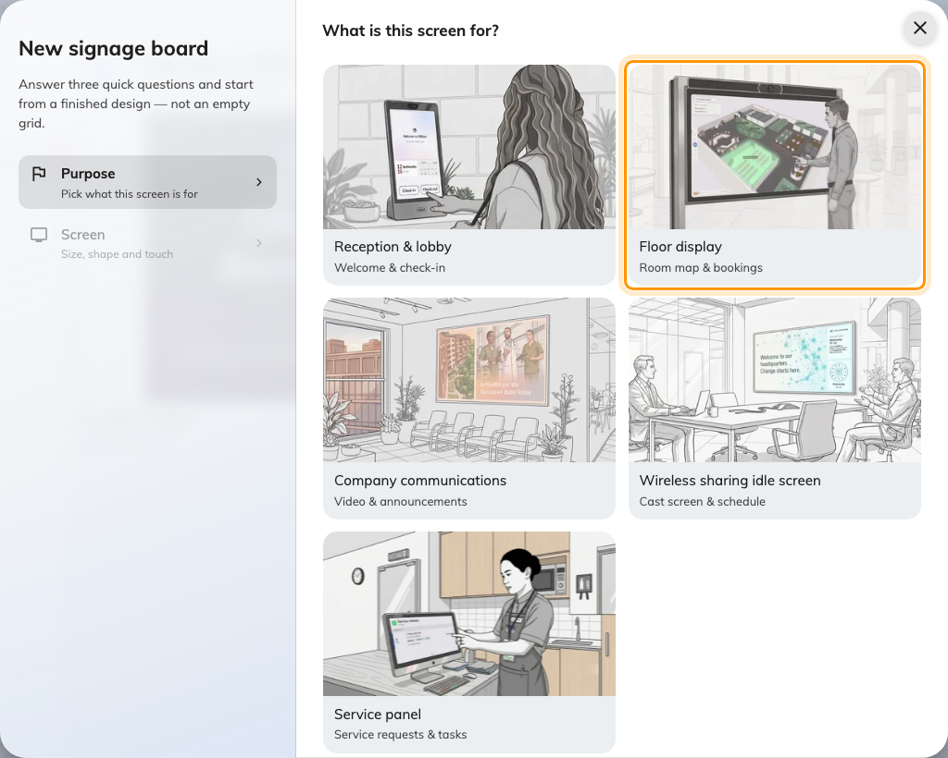
Floor display, the second purpose. It starts the design with the floor's availability map.
Answer the screen questions to match the Board — landscape 16:9, and Touch
screen on. A Board is a touchscreen, and saying so is what lets people work
the map with their hands rather than only reading it.
The purpose starts the design with the floor's availability map already placed.
Everything about the editor, and what else can go beside the map, is in
Build signage content; the map itself is
covered in Booking status map.

2. Add the wayfinding tiles
Two things turn a floor map into wayfinding, and both are added on the content:
- Wayfinding QR code — a tile in the Workplace category. Somebody scans
it and gets a search page on their phone, already routed from this Board's
position. This is the one that matters on a screen people walk past.
- Scan-to-go QR on route — a setting on the availability map itself. With it
on, a route drawn on the map carries a QR the visitor can pick up and keep.
Wayfinding is licensed per floor:
Each floor you want directions on needs a wayfinding licence assigned to it. A
floor without one still shows on the map and still shows what is free — it just
will not give directions. Licences are assigned per floor, so a building can run
wayfinding on its ground floor only.

3. Enrol the Board in Neat Pulse
A Neat device takes its apps from Neat Pulse rather than from an address you
type, and the enrolment is the same for every Neat device. It is explained once,
with the two codes it involves, in
Connect a Neat Pad room booking panel.
In short:
- In Neat Pulse, open the Apps tab, enable Offision and disable every
other app.
- Go to Devices › Add devices, name the device and choose
Continue. Pulse shows an enrollment code.
- Power on the Board and follow its on-screen setup until it shows the Neat
Pulse screen. Type the enrollment code.
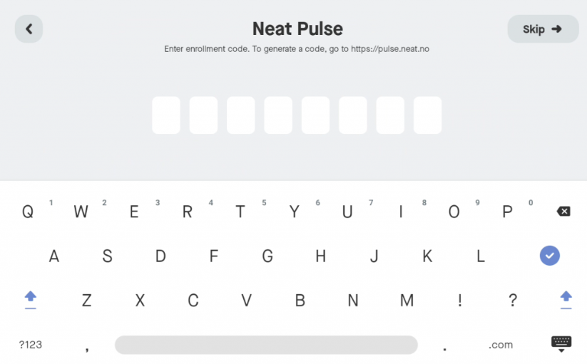
The Board asking for the Neat Pulse enrollment code. This is Neat's code, not Offision's.
Do this at desk height if you can. Everything up to the pairing code is easier
before the Board goes on the wall.

4. Let Pulse install Offision
Once the Board pairs with Pulse, choose Continue on the device. On the
Choose apps page, select Offision and choose Continue.
The Board downloads and launches the app, then shows a six-character pairing
code.
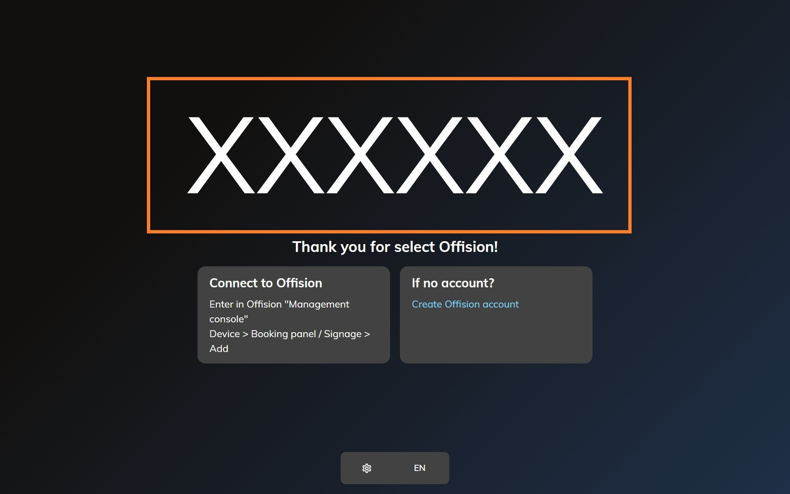
The Offision app on a freshly enrolled Neat device, waiting to be claimed.

5. Pair it as signage
In the console, go to Devices › Signage › Devices and choose
Add.
Where in Offision: admin app → device/signage/signage-device (Signage devices)
The wizard asks three things: the content this screen will play, the
brand of hardware, and then the code. Choose the floor content from step 1,
then Neat Board.
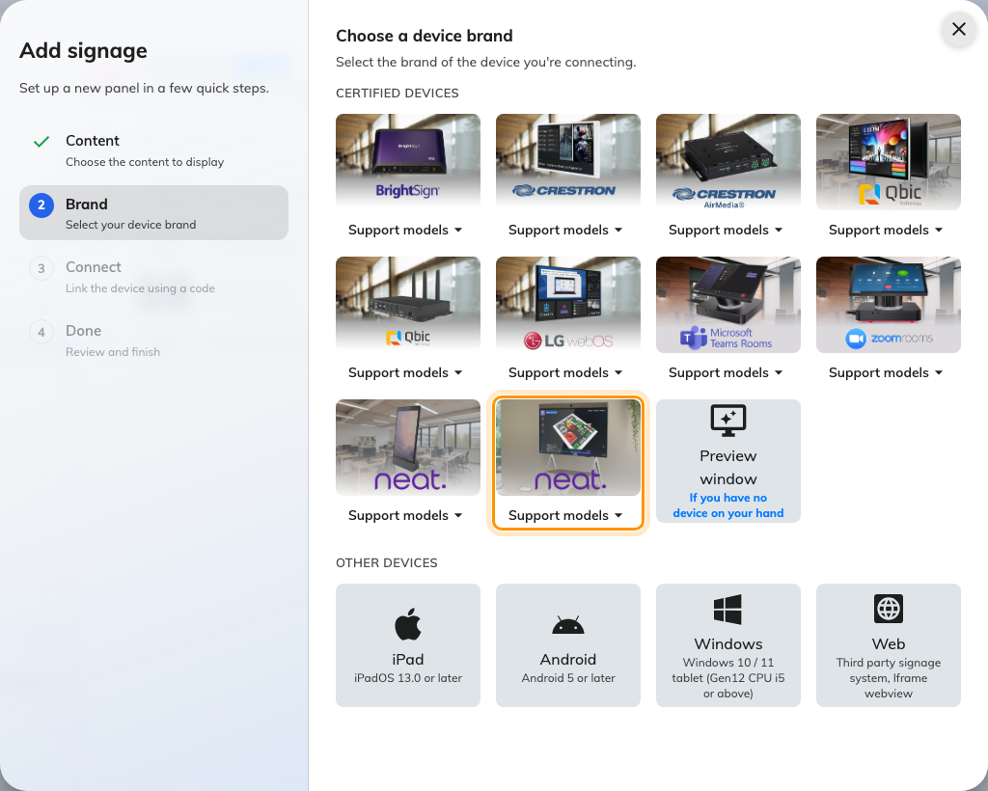
Neat Board, tenth in the certified devices grid.
Type the six characters from the Board. The field submits itself on the last
one.
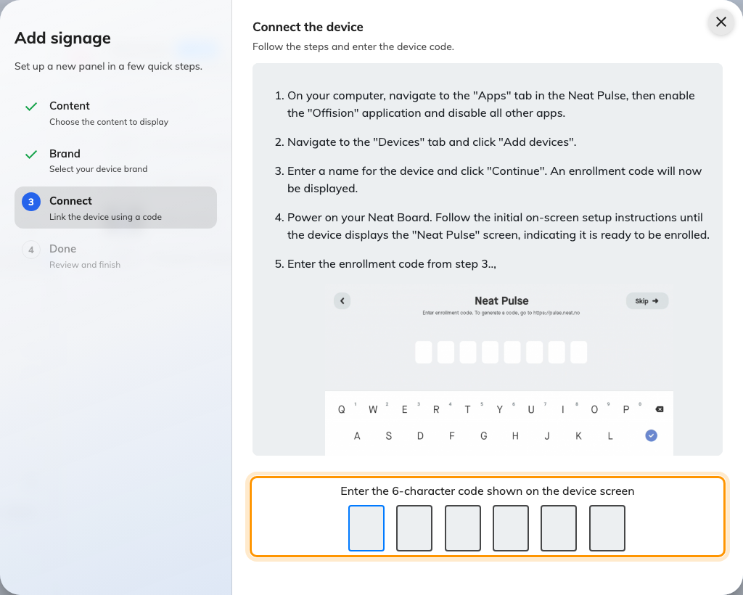
The Neat Board guideline, and the field that claims the screen.

6. Place it on the floor plan
Routes start from the Board, so the Board has to be somewhere. As the wizard
finishes, choose Set location and put the device where it physically stands —
by the lifts, inside the entrance, wherever it ended up. The same thing can be
done later from the device's own row.
A Board that is not placed still shows the floor. It just cannot route from
here, because there is no here.
The routes it follows are drawn on the floor itself, not on the Board — see
How wayfinding finds a path if this
Board shows the floor but never offers directions.

7. Check it worked
Within a few seconds the Board stops showing the code and starts showing the
floor. Then walk the thing people will actually do:
- On the Board, tap a room on the map. It should tell you about that room.
- With a phone, scan the wayfinding code, search for a room on another part
of the floor, and check the route it draws starts from where you are standing.

When it goes wrong
What you see | Usual cause
The map shows, but scanning gives no directions | That floor has no wayfinding licence assigned
Directions start from the wrong end of the building | The device is not placed on the floor plan, or is placed where it used to be. Set its location again
The floor is drawn but rooms are missing from search | Those places are not on the floor plan. Rooms are found by what the plan carries, not by what exists in the building
Nothing responds to touch | Touch screen was answered no when the content was created
Choose apps does not list Offision | The Offision app was not enabled in the Pulse Apps tab. Enable it, then restart the Board
The Board goes blank in the evening and stays blank | It is honouring a screen time-out or a schedule. Check the content's schedule before suspecting the hardware
The pairing code is refused | Read it off the Board again — a device that has restarted since is showing a different one
The Board shows a room or content, and no pairing code | It is still claimed by an earlier record. Disconnect it there first — see Reuse a panel that was set up for something else

What this does not do
- It does not draw your floor plans. The map is whatever the floor plan
carries. A route can only pass places that were drawn on it.
- It does not turn the Board into a room panel. A Board paired as signage
shows content. Booking a room from it is what the content's own widgets do,
not a panel mode. A Board that should be a room panel instead has to be
released from this record first — see
Reuse a panel that was set up for something else.
- It does not use the camera or microphones. Those belong to Neat's meeting
features; Offision only draws on the screen.
- It does not manage the device. Firmware and which app runs stay in Neat
Pulse. Sensor readings are a separate connection — see
Connect Neat Pulse.

